FOR IMMEDIATE RELEASE

JUNE 5TH, 2020

**“HOW MANY MOTHERS HAVE TO CRY? HOW MANY BROTHERS GOTTA DIE? HOW MANY TIMES?”**

**TREY SONGZ RELEASES POWERFUL NEW SINGLE “2020 RIOTS: HOW MANY TIMES”**

**IN LIGHT OF #*BLACKLIVESMATTER* PROTESTS ACROSS THE COUNTRY**

**LISTEN NOW** [**HERE**](https://nam04.safelinks.protection.outlook.com/?url=https%3A%2F%2Ftreysongz.lnk.to%2FHowManyTimes&data=02%7C01%7CAlyssa.Reddish%40atlanticrecords.com%7C29a7ecba93f6484b0deb08d8094f4ce6%7C8367939002ec4ba1ad3d69da3fdd637e%7C0%7C0%7C637269583476017898&sdata=k6jpOHkGRVLf7xc8Y3gq7qixbPyhTISgBLw3PqI%2BGXg%3D&reserved=0)

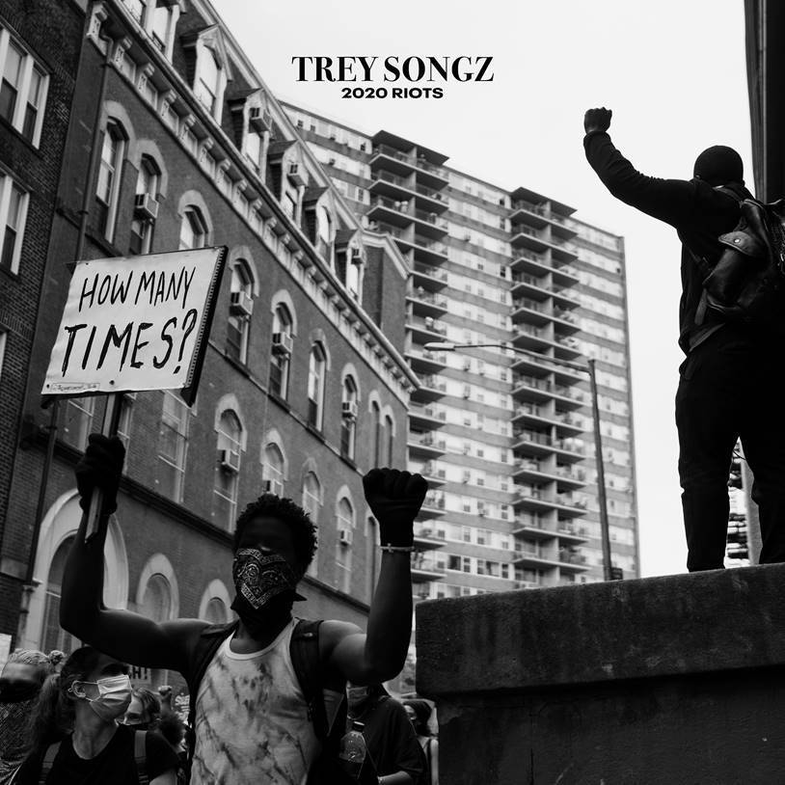

*(Photo Credit: Dane Isaac)*

Multi-platinum R&B superstar Trey Songz is using his voice to shed light on the injustices faced in the black community at the hands of police brutality and institutionalized racism with a striking single, “2020 Riots: How Many Times.” The compelling melody premiered earlier this week on D-Nice’s Instagram Live and was met with a round of praise from viewers. Listen now [HERE](https://nam04.safelinks.protection.outlook.com/?url=https%3A%2F%2Ftreysongz.lnk.to%2FHowManyTimes&data=02%7C01%7CAlyssa.Reddish%40atlanticrecords.com%7C29a7ecba93f6484b0deb08d8094f4ce6%7C8367939002ec4ba1ad3d69da3fdd637e%7C0%7C0%7C637269583476017898&sdata=k6jpOHkGRVLf7xc8Y3gq7qixbPyhTISgBLw3PqI%2BGXg%3D&reserved=0), via all digital retailers and streaming platforms. A portion of the proceeds from the release of this dynamic single will directly benefit both [Black Lives Matter](https://nam04.safelinks.protection.outlook.com/?url=https%3A%2F%2Fblacklivesmatter.com%2F&data=02%7C01%7CAlyssa.Reddish%40atlanticrecords.com%7Cc41dee6b8ce1493cc4f908d808e10d42%7C8367939002ec4ba1ad3d69da3fdd637e%7C0%7C0%7C637269109968407266&sdata=05r41D6RF26bZCWbaPvYC%2BFIkTvPmCriuM%2BXlRSIHjw%3D&reserved=0) and the Community Justice Exchange’s [National Bail Fund Network](https://nam04.safelinks.protection.outlook.com/?url=https%3A%2F%2Fwww.communityjusticeexchange.org%2Fnbfn-directory&data=02%7C01%7CAlyssa.Reddish%40atlanticrecords.com%7Cc41dee6b8ce1493cc4f908d808e10d42%7C8367939002ec4ba1ad3d69da3fdd637e%7C0%7C0%7C637269109968497209&sdata=Rrjf49%2FlsXCsxFDyt4NPUCOehkjaIbx6TgngWCwjVsE%3D&reserved=0).

Protesting on the frontlines ultimately gave Trey the inspiration that he needed to finish the song. *“Three or four nights ago I woke up in the middle of my sleep…I couldn’t sleep. My chest was hurting.  I got up and called my producer, Troy Taylor and I said ‘We’ve got to make music that really touches the soul, that really addresses what the world is feeling right now. Especially our people.’  So we came up with ‘2020 Riots: How Many Times.’ With the words in this song I just wanted to speak to everyone’s hearts and acknowledge the pain and anguish everyone is going through right now.”   “I know this ain’t usually my message and you’re not used to hearing this from me, but this is the person I’ve always been.” –Trey Songz*

- - -

The late Atlantic Records founder, Ahmet Ertegun, once hailed Trey Songz as one of “the most promising R&B artists we have had since we started the company 60 years ago” and he has undoubtedly proved him to be correct. Since making his recording debut in 2005, the GRAMMY® Award-nominated singer, actor, entrepreneur and Virginia native has patiently and artfully crafted some of the most acclaimed and compelling R&B music of the modern era, earning countless fans and cumulative sales well over 25 million singles and albums. Trey’s first two Songbook Entertainment/Atlantic albums, I GOTTA MAKE IT (2005) and TREY DAY (2007), yielded a trio of top 10 singles, including “Girl Tonight,” “Last Time,” and “Can’t Help But Wait.” He later followed up with READY (2009), PASSION, PAIN & PLEASURE (2010), the triumphant #1 RIAA gold-certified CHAPTER V (2012), TRIGGA (2014) – which debuted at #1 on the *Billboard* charts – and TREMAINE THE ALBUM (2017). Since his arrival, the R&B sensation has achieved three GRAMMY® Award nominations, landed back-to-back #1 debuts on the *Billboard 200* and staunchly carried a tradition of classic R&B into the 21st century. He has seduced sold out audiences everywhere around the globe, earning the nicknames “Mr. Steal Your Girl” and the man who “invented sex” by crooning with irresistible and inimitable passion. The multi-faceted entertainer has also taken over the big screen in blockbusters such as *Texas Chainsaw Massacre 3D*, *Baggage Claim*, and Lionsgate/WWE Studios/Codeblack Films’ *Blood Brothers*.

2019 saw Trey marking the 10th anniversary of his landmark third album, READY, with a very special deluxe edition. READY: 10 YEAR ANNIVERSARY is available now at all music retailers and streaming services. Currently boasting worldwide streams in excess of 640 million, READY reached #3 on the overall SoundScan/*Billboard 200* upon its August 31st, 2009 release and was eventually certified platinum by the RIAA for sales exceeding 1 million. Named among the “Best Contemporary R&B Album” nominees at the 52nd Annual Grammy Awards, the album includes a stunning series of singles, including “[I Need A Girl](https://nam04.safelinks.protection.outlook.com/?url=https%3A%2F%2Fwww.youtube.com%2Fwatch%3Fv%3Dwu0OhvncLXU&data=02%7C01%7CAlyssa.Reddish%40atlanticrecords.com%7Cc41dee6b8ce1493cc4f908d808e10d42%7C8367939002ec4ba1ad3d69da3fdd637e%7C0%7C0%7C637269109968497209&sdata=J8%2B52oFTQXSIcXq5pQ9CYSrdoO3zlWutx83ZYDXQXZ0%3D&reserved=0),” Trey & Drake’s gold certified “[Successful](https://nam04.safelinks.protection.outlook.com/?url=https%3A%2F%2Fwww.youtube.com%2Fwatch%3Fv%3Dj5DySYu5Bfw&data=02%7C01%7CAlyssa.Reddish%40atlanticrecords.com%7Cc41dee6b8ce1493cc4f908d808e10d42%7C8367939002ec4ba1ad3d69da3fdd637e%7C0%7C0%7C637269109968507204&sdata=YwcJkIrfsXRFafzkQpVkN7vtKBPTPodiGm4MCbZgcJg%3D&reserved=0),” “[LOL :-) (Feat. Gucci Mane and Soulja Boy Tell ‘Em)](https://nam04.safelinks.protection.outlook.com/?url=https%3A%2F%2Fwww.youtube.com%2Fwatch%3Fv%3DR427mJDwQ_k&data=02%7C01%7CAlyssa.Reddish%40atlanticrecords.com%7Cc41dee6b8ce1493cc4f908d808e10d42%7C8367939002ec4ba1ad3d69da3fdd637e%7C0%7C0%7C637269109968507204&sdata=I3Yc44ElD83i3A4LYs1tpbOV9UhGf5oR1PXhONNNJoo%3D&reserved=0),” “[Neighbors Know My Name](https://nam04.safelinks.protection.outlook.com/?url=https%3A%2F%2Fwww.youtube.com%2Fwatch%3Fv%3DE98IYokujSY&data=02%7C01%7CAlyssa.Reddish%40atlanticrecords.com%7Cc41dee6b8ce1493cc4f908d808e10d42%7C8367939002ec4ba1ad3d69da3fdd637e%7C0%7C0%7C637269109968517201&sdata=8LY49kvvZNCM1e9angfwvhEsvQeRMyhKp9Cl3YdBil8%3D&reserved=0),” the top 10, 2x platinum favorite, “[Say Aah](https://nam04.safelinks.protection.outlook.com/?url=https%3A%2F%2Fwww.youtube.com%2Fwatch%3Fv%3DZ__FHAG1Jk8&data=02%7C01%7CAlyssa.Reddish%40atlanticrecords.com%7Cc41dee6b8ce1493cc4f908d808e10d42%7C8367939002ec4ba1ad3d69da3fdd637e%7C0%7C0%7C637269109968517201&sdata=ouqF4pHQZjTk0uD2ljCJg0oxBbvnxYs4PtNsFfyXb%2Fg%3D&reserved=0),” and the #1 smash, “[I Invented Sex (Feat. Drake)](https://nam04.safelinks.protection.outlook.com/?url=https%3A%2F%2Fwww.youtube.com%2Fwatch%3Fv%3D7sOZEJvkq3Q&data=02%7C01%7CAlyssa.Reddish%40atlanticrecords.com%7Cc41dee6b8ce1493cc4f908d808e10d42%7C8367939002ec4ba1ad3d69da3fdd637e%7C0%7C0%7C637269109968517201&sdata=Oqy8LvNqmzq15HNACw%2BxOQp83cCvDLOurM9wbW97ixo%3D&reserved=0).” Most were joined by classic companion videos, streaming now via YouTube [HERE](https://nam04.safelinks.protection.outlook.com/?url=https%3A%2F%2Fwww.youtube.com%2Fchannel%2FUC7DpParfqYQEbFGt5eTX5pQ&data=02%7C01%7CAlyssa.Reddish%40atlanticrecords.com%7Cc41dee6b8ce1493cc4f908d808e10d42%7C8367939002ec4ba1ad3d69da3fdd637e%7C0%7C0%7C637269109968527195&sdata=9Zgkf5%2BIP88ZwDGI4NokrYcabSZYKZD%2FIXmh0UNXGd8%3D&reserved=0).

# # #

CONNECT WITH TREY SONGZ

[TREYSONGZ.COM](https://nam04.safelinks.protection.outlook.com/?url=http%3A%2F%2Fwww.treysongz.com%2F&data=02%7C01%7CAlyssa.Reddish%40atlanticrecords.com%7Cc41dee6b8ce1493cc4f908d808e10d42%7C8367939002ec4ba1ad3d69da3fdd637e%7C0%7C0%7C637269109968527195&sdata=JuZQ0yuKLLz2jEfAttA0fBB6sr05rumacYRQdfAMUeE%3D&reserved=0)

[TWITTER](https://nam04.safelinks.protection.outlook.com/?url=http%3A%2F%2Fwww.twitter.com%2FTreySongz&data=02%7C01%7CAlyssa.Reddish%40atlanticrecords.com%7Cc41dee6b8ce1493cc4f908d808e10d42%7C8367939002ec4ba1ad3d69da3fdd637e%7C0%7C0%7C637269109968537188&sdata=qFRbrojbopCJiOzeg324yVv6CO7UuIRoyJO2tyIHil0%3D&reserved=0)

[FACEBOOK](https://nam04.safelinks.protection.outlook.com/?url=http%3A%2F%2Fwww.facebook.com%2FTreySongz&data=02%7C01%7CAlyssa.Reddish%40atlanticrecords.com%7Cc41dee6b8ce1493cc4f908d808e10d42%7C8367939002ec4ba1ad3d69da3fdd637e%7C0%7C0%7C637269109968537188&sdata=NdNfRblcNOugJkeXnJ6VbUWhJTI4pM%2FvC%2FmICh5H9wk%3D&reserved=0)

[YOUTUBE](https://nam04.safelinks.protection.outlook.com/?url=http%3A%2F%2Fwww.youtube.com%2FTreySongzVideos&data=02%7C01%7CAlyssa.Reddish%40atlanticrecords.com%7Cc41dee6b8ce1493cc4f908d808e10d42%7C8367939002ec4ba1ad3d69da3fdd637e%7C0%7C0%7C637269109968547181&sdata=zoIdhJon2jfZ3ZE9ERKUzvA76zapahVeejfGjQKlU50%3D&reserved=0)

[INSTAGRAM](https://nam04.safelinks.protection.outlook.com/?url=https%3A%2F%2Fwww.instagram.com%2Ftreysongz%2F&data=02%7C01%7CAlyssa.Reddish%40atlanticrecords.com%7Cc41dee6b8ce1493cc4f908d808e10d42%7C8367939002ec4ba1ad3d69da3fdd637e%7C0%7C0%7C637269109968547181&sdata=p1Qq%2BxPNTgkMMhSsdH62b1J%2BqRIagCOrAwN5GvaiJ6g%3D&reserved=0)

[ATLANTICRECORDS.COM](https://nam04.safelinks.protection.outlook.com/?url=http%3A%2F%2Fwww.atlanticrecords.com%2F&data=02%7C01%7CAlyssa.Reddish%40atlanticrecords.com%7Cc41dee6b8ce1493cc4f908d808e10d42%7C8367939002ec4ba1ad3d69da3fdd637e%7C0%7C0%7C637269109968557179&sdata=9yu6yYijLJbUuHL2xCJCvq94Trfpbx2EhqLqncKGWP8%3D&reserved=0)

FOR ALL INQUIRIES

[SYDNEY.MARGETSON@ATLANTICRECORDS.COM](mailto:SYDNEY.MARGETSON@ATLANTICRECORDS.COM)