FOR IMMEDIATE RELEASE:

**R&B SUPERSTAR TANK GETS VULNERABLE WITH**

**THE RELEASE OF NEW SINGLE**

**“CAN’T LET IT SHOW”**

**NEW ALBUM ON ITS WAY THIS SUMMER 2021**

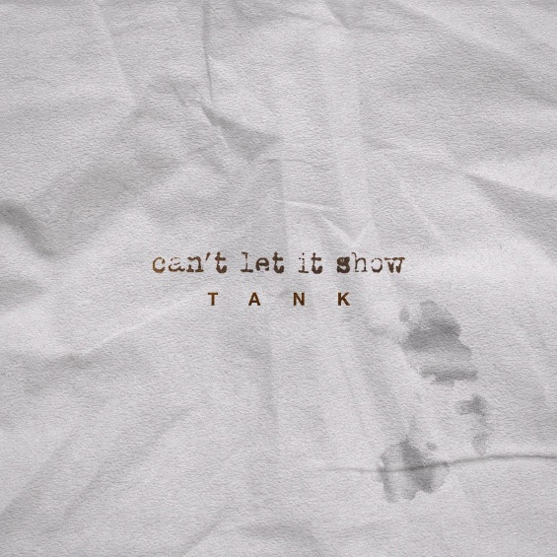

(February 26, 2021) R&B Superstar **Tank** has always made fans fall to their knees with memorable and sensual hits like *“When We,” “Dirty,”* *“I Can't Make You Love Me,”* *“One Man,”* and *“Maybe I Deserve.”* Today is no different with the release of ***“Can't Let It Show”*** via R&B Money/Atlantic Records. Written and produced by Tank, the single samples Kate Bush's *"This Woman's Work"* that had a resurgence in 2001 by Maxwell. Now, Tank brings forth a fresh iteration sparking nostalgia, so it will soon become a classic. *“Can't Let It Show”* is ripe with passion and arouses intense emotions and vulnerability that fans will swoon over. Tank's previous albums Savage and Elevation produced the #1 platinum-selling singles *“When We”* and *“Dirty.”* “Can't Let It Show” comes off the heels of Tank's 2020 EP releases, While You Wait and Worth The Wait, that left fans eager for more. His new LP is loaded with his signature romantic appeal and is scheduled for a summer 2021 release.

[**CLICK HERE TO BUY/STREAM "CAN'T LET IT SHOW"**](https://tank.lnk.to/CantLetItShow)

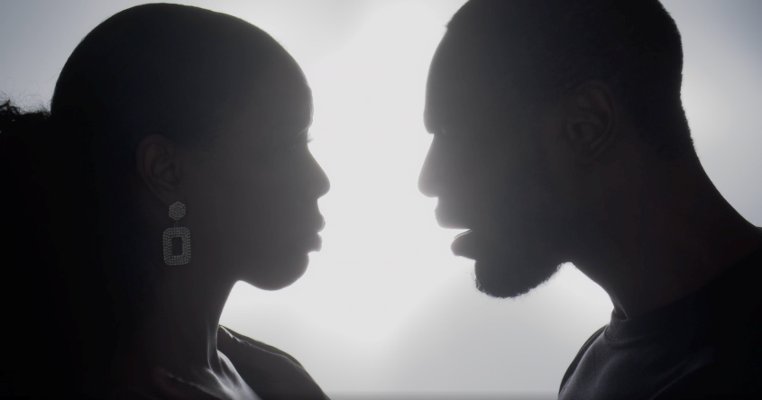

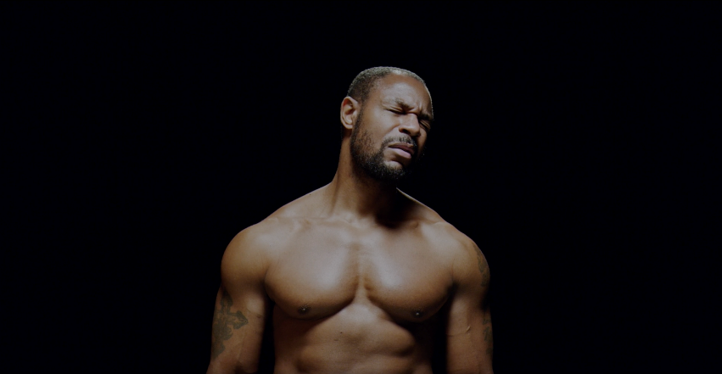

While putting the finishing touches on his new album, Tank flexed his acting chops and made a movie while building his R&B Money empire. Premiering on **Lifetime**, **Saturday, April 17**, at **8 pm ET/PT**, fans can catch Tank starring in **Lust: A Deadly Sins Saga**. The film is part of the **Seven Deadly Sins anthology** based on books in **Victoria Christopher Murray**'s series, Lust and Envy, and is executive produced by **Bishop T.D. Jakes**. The movie also stars Keri Hilson, Tobias Truvillion (Empire), Ms. Juicy, and Letoya Luckett.

Last year Tank launched two successful projects: **"R&B Money Podcast"** and the YouTube reality show **"Babbs to the Bone."** Partnering with his long-time manager and friend J Valentine, the podcast features interviews with notable personalities, discussions on current events, entertainment, and pop culture. "Babbs to the Bone" is a family affair featuring his wife Zena Foster-Babbs and their children. Tank and Zena peel back the curtains in this unscripted series and give fans a peek into their lives beyond the flashing lights, events, and concerts.

**FOLLOW TANK:**

IG: @therealtank

TW:@therealtank

FB:@therealtank

###