FOR IMMEDIATE RELEASE
JANUARY 8, 2019

“THE GREATEST SHOWMAN – ORIGINAL MOTION PICTURE SOUNDTRACK” EARNS TOP SPOT AS THE #1 BEST-SELLING ALBUM GLOBALLY FOR ALL OF 2018 WITH SALES NEARING 6 MILLION ALBUMS WORLDWIDE

RIAA 2x PLATINUM CERTIFIED AND 2x GRAMMY® AWARD NOMINATED SOUNDTRACK HAS PROVEN A WORLDWIDE PHENOMENON – AMASSING 4 BILLION GLOBAL STREAMS AND COUNTLESS MULTI-PLATINUM CERTIFICATIONS

ALBUM ALSO RECLAIMS #1 SPOT ON BILLBOARD’S TOP ALBUM SALES CHART – ONE YEAR AFTER FIRST REACHING #1 ON THE SAME CHART

“THE GREATEST SHOWMAN – REIMAGINED” ALL-STAR COMPANION ALBUM ANOTHER CHART-TOPPING GLOBAL SENSATION, APPROACHING 500 MILLION STREAMS IN LESS THAN TWO MONTHS

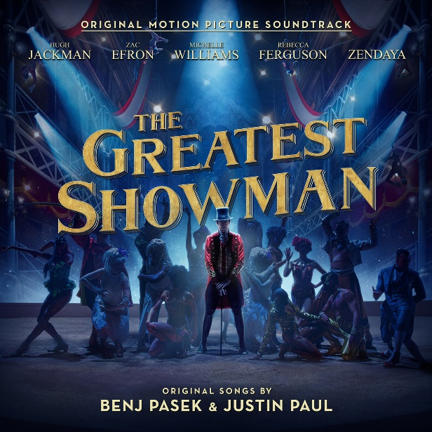

“THE GREATEST SHOWMAN – ORIGINAL MOTION PICTURE SOUNDTRACK” – Atlantic Records’ RIAA 2x platinum certified, 2x GRAMMY® Award-nominated soundtrack to 20th Century Fox’s blockbuster musical film – has earned the title of 2018’s best-selling album in the world, in terms of total consumption. Since its release in December of 2017, the soundtrack has proven to be an unquestionable worldwide sensation, with over 4 billion global streams and countless certifications.

In addition to earning RIAA 2x platinum certification in the US, the album has earned 4x platinum certification in the United Kingdom and South Korea; 3x platinum in Ireland and Singapore; 2x platinum in Australia, Taiwan, and Hong Kong; platinum in Canada, New Zealand, Japan, China, the Philippines, and Indonesia; and gold in Mexico, Russia, and Norway.

Among its many other historic chart successes, the album has also reclaimed its spot atop Billboard’s Top Album Sales chart this week (wk ending 1/3/19). This feat comes exactly a year after the album originally hit #1 on the very same chart (wk ending 1/4/18). At that time, the album spent five weeks at #1, the first soundtrack to do so since 2014’s “Frozen: Original Motion Picture Soundtrack.” The album also spent 31 weeks among the top 10 on the SoundScan/Billboard 200 – Including two weeks at #1, the most weeks atop the chart for a live-action theatrical film musical soundtrack since 2007’s “Dreamgirls: Music From The Motion Picture.”

The soundtrack – featuring all songs written by GRAMMY®, Tony®, and Academy Award-winning duo Benj Pasek & Justin Paul (La La Land, Dear Evan Hansen) – was recently honored with 2 GRAMMY® nominations for the 61st Annual GRAMMY® Awards: “Best Compilation Soundtrack for Visual Media” and “Best Song Written for Visual Media” for the soundtrack’s 3x RIAA platinum certified version of “This Is Me,” performed by Keala Settle & The Greatest Showman Ensemble (and boasting 800 million global streams).

These nominations follow countless other accolades, including “This Is Me” winning “Best Original Song – Motion Picture” at the 75th Golden Globe Awards and nominated for “Best Original Song” at the 90th Academy Awards, as well as the album’s nomination for “Favorite Soundtrack” at the American Music Awards.

In November, Atlantic Records released an unprecedented all-star companion album – “THE GREATEST SHOWMAN – REIMAGINED” – which sees songs from the film covered by a remarkable cast of artists. The album immediately ascended into the #1 position on iTunes “Top Albums” chart, with a staggering 90,000 units sold in the first week alone and global streams now approaching 500 million. The album had already amassed an incredible 100m streams via individual tracks and videos unveiled prior to the album’s official release. Among those were “Rewrite the Stars” featuring multi-platinum artists Anne-Marie and James Arthur, Panic! At the Disco’s rework of “The Greatest Show” and multiple GRAMMY® Award-winner Kelly Clarkson’s stunning take on “Never Enough.” “THE GREATEST SHOWMAN – REIMAGINED” also came accompanied by P!nk’s chart-topping version of “A Million Dreams” and the “A Million Dreams (Reprise)” performed by her daughter Willow Sage Hart. P!nk’s version of “A Million Dreams” also proved to be a smash – reaching #2 on the iTunes overall “Top Songs” chart.

Last month, Atlantic Records unveiled the inspiring companion visual for “This Is Me (The Reimagined Remix),” performed by Keala Settle, Kesha, and the legendary Missy Elliott. The moving video stars Antoni, Tan, Bobby, and Jonathan from Netflix’s Queer Eye alongside three extraordinary high school students (watch here). The video was released in support of the VH1 Save The Music Foundation, with viewers encouraged to help kids, schools, and communities realize their full potential through the power of making music by donating here.

“The Greatest Showman – Original Movie Soundtrack” is produced by Benj Pasek & Justin Paul, GRAMMY® Award-winning (and 5x nominee) Atlantic Records President, West Coast Kevin Weaver (Furious 7, Suicide Squad, The Fault in Our Stars, The Fate of the Furious) and GRAMMY® Award-winning Atlantic Records President, A&R Pete Ganbarg (Twenty One Pilots, Hamilton: Original Broadway Cast Recording, Dear Evan Hansen: Original Broadway Cast Recording).

20th Century Fox’s The Greatest Showman is a bold and original musical that tells the story of P.T. Barnum – a visionary who rose from nothing to create a mesmerizing spectacle that became a worldwide sensation. The Greatest Showman was directed by Michael Gracey and stars Academy Award-nominee Hugh Jackman alongside Academy Award-nominee Michelle Williams, Zendaya, Zac Efron, and Rebecca Ferguson.

For press inquiries, please contact sheila.richman@atlanticrecords.com

