“THIS IS ME” FROM THE GREATEST SHOWMAN RECEIVES PRESTIGIOUS ACADEMY AWARD NOMINATION FOR BEST ORIGINAL SONG

ALBUM SPENDS THIRD WEEK AT #1 ON BILLBOARD TOP ALBUMS CHART
& BREAKS RECORD FOR ALL-TIME TOP STREAMING WEEK FOR A SOUNDTRACK

20TH CENTURY FOX’S The Greatest Showman in theaters now

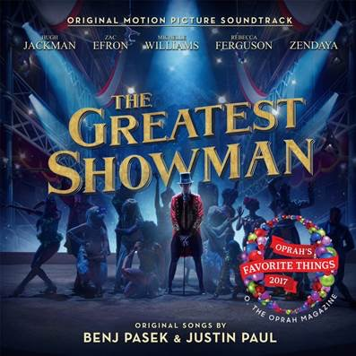

STREAM THE GREATEST SHOWMAN: https://Atlantic.lnk.to/TheGreatestShowman

“The Greatest Showman – Original Motion Picture Soundtrack” (available now via Atlantic Records) is spending a third consecutive week at #1 on the Billboard Top Albums chart, becoming the first soundtrack to top the chart for three consecutive weeks since Frozen in 2014. A streaming success, the album broke Suicide Squad: The Album’s record (33 million) twice-over for all-time top streaming weeks for a soundtrack with 39.6 million streams last week (up from 37.4 million the week prior). The album reached #1 on iTunes in 73 countries, in addition to charting at #1 for two consecutive weeks in Australia and the UK.

The 20th Century Fox musical film, in theaters now, received an Academy Award nomination for Best Original Song for “This Is Me” (performed by Keala Settle, lyric video: http://Atlanti.cr/thisismelyricvideo). The anthem recently saw a triumphant win at the 75th annual Golden Globe Awards, taking home the award for Best Original Song - Motion Picture. The Greatest Showman received three total Golden Globe nominations, also including Best Motion Picture - Musical or Comedy and Best Performance by an Actor in a Motion Picture - Musical or Comedy (Hugh Jackman).

The Greatest Showman is a bold and original musical that celebrates the birth of show business and the sense of wonder we feel when dreams come to life. Inspired by the ambition and imagination of P.T. Barnum, The Greatest Showman tells the story of a visionary who rose from nothing to create a mesmerizing spectacle that became a worldwide sensation. The Greatest Showman is directed by exciting new filmmaker Michael Gracey, with songs co-produced and written by Tony and Academy Award winning and GRAMMY®-nominated duo Benj Pasek & Justin Paul (La La Land, Dear Evan Hansen), co-produced by GRAMMY®-nominee Greg Wells (Twenty One Pilots, Adele, Katy Perry) and executive produced by Tony and GRAMMY® Award winner Alex Lacamoire (Hamilton, Dear Evan Hansen). The film stars Academy Award nominee Hugh Jackman alongside Academy Award nominee Michelle Williams, Zendaya, Zac Efron, and Rebecca Ferguson.

“The Greatest Showman – Original Motion Picture Soundtrack” has been overseen at Atlantic Records by GRAMMY® Award winning (five time nominee) Atlantic Records West Coast President Kevin Weaver (“Furious 7,” “Suicide Squad,” “The Fault in Our Stars,” “The Fate of the Furious”) and GRAMMY®-nominated Atlantic Records President, A&R Pete Ganbarg (“Hamilton – Original Broadway Cast Recording,” “Dear Evan Hansen – Original Broadway Cast Recording,” Twenty One Pilots).

For more information on The Greatest Showman, please visit www.foxmovies.com/movies/the-greatest-showman
For press inquiries, please contact sheila.richman@atlanticrecords.com

