THE GREATEST SHOWMAN SOUNDTRACK IS A GLOBAL SMASH

ALBUM HITS #1 ON BILLBOARD 200 CHART

REACHED #1 ON ITUNES IN OVER 60 COUNTRIES
+ 9 SONGS CHARTING ON SPOTIFY TOP 200 GLOBAL CHART

“THIS IS ME” TAKES HOME GOLDEN GLOBE FOR BEST ORIGINAL SONG

20TH CENTURY FOX’S The Greatest Showman in theaters now

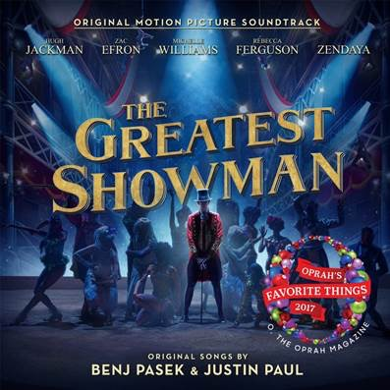

STREAM THE GREATEST SHOWMAN: https://Atlantic.lnk.to/TheGreatestShowman

“The Greatest Showman – Original Motion Picture Soundtrack” (available now via Atlantic Records) reaches new heights, hitting #1 on the Billboard 200 albums chart, reaching #1 on iTunes in over 60 countries and having 9 songs chart on the Spotify Top 200 Global chart (holding 5 of the top 6 spots on the Global and US Viral Chart). The album marks the first theatrically released non-sequel original music soundtrack to reach #1 on the Billboard 200 since 2009’s Hannah Montana: The Movie. Basking in critical acclaim, USA Today raved “‘The Greatest Showman’ is chock full of amazing and catchy tunes you’ll be humming after the credits roll.”

Last night saw a triumphant win at the 75th annual Golden Globe Awards, with “This Is Me” (performed by Keala Settle) taking home the award for Best Original Song - Motion Picture. The 20th Century Fox musical film, in theaters now, received three total Golden Globe nominations, also including Best Motion Picture - Musical or Comedy and Best Performance by an Actor in a Motion Picture - Musical or Comedy (Hugh Jackman).

The soundtrack also includes standout songs “Rewrite The Stars” (performed by Zac Efron and Zendaya) and “The Greatest Show” (performed by Hugh Jackman, Keala Settle, Zendaya, Zac Efron, and ensemble). The collection was named to Oprah’s Favorite Things List 2017, which declared the soundtrack to be “a celebration of imagination,” noting “‘This Is Me’ should be everyone’s theme song.” “This Is Me”, also recently covered by GRAMMY®-nominated superstar Kesha, was called “an anthem for outcasts” by Variety.

The Greatest Showman is a bold and original musical that celebrates the birth of show business and the sense of wonder we feel when dreams come to life. Inspired by the ambition and imagination of P.T. Barnum, The Greatest Showman tells the story of a visionary who rose from nothing to create a mesmerizing spectacle that became a worldwide sensation. The Greatest Showman is directed by exciting new filmmaker Michael Gracey, with songs co-produced and written by Tony and Academy Award winning and GRAMMY®-nominated duo Benj Pasek & Justin Paul (La La Land, Dear Evan Hansen), co-produced by GRAMMY®-nominee Greg Wells (Twenty One Pilots, Adele, Katy Perry) and executive produced by Tony and GRAMMY® Award winner Alex Lacamoire (Hamilton, Dear Evan Hansen). The film stars Academy Award nominee Hugh Jackman alongside Academy Award nominee Michelle Williams, Zendaya, Zac Efron, and Rebecca Ferguson.

“The Greatest Showman – Original Motion Picture Soundtrack” has been overseen at Atlantic Records by GRAMMY® Award winning (five time nominee) Atlantic Records West Coast President Kevin Weaver (“Furious 7,” “Suicide Squad,” “The Fault in Our Stars,” “The Fate of the Furious”) and GRAMMY®-nominated Atlantic Records President, A&R Pete Ganbarg (“Hamilton – Original Broadway Cast Recording,” “Dear Evan Hansen – Original Broadway Cast Recording,” Twenty One Pilots). “This project has been a labor of love since we took our first meeting with the film makers and Fox well over two years ago” said Weaver. “Being able to work so closely with Stacey Snider, Emma Watts, Jenno Topping and everyone at Fox and TCG has been an incredible experience for me, Pete and all of us at Atlantic. We have also had an incredible experience working with Benj Pasek and Justin Paul on ‘Dear Evan Hansen’ and we couldn’t be more pleased to continue our successful relationship with them by sharing in the #1 album in the country this week.”

For more information on The Greatest Showman, please visit www.foxmovies.com/movies/the-greatest-showman
For press inquiries, please contact sheila.richman@atlanticrecords.com

