FOR IMMEDIATE RELEASE
OCTOBER 24, 2018

“THE GREATEST SHOWMAN – REIMAGINED” AVAILABLE FOR PRE-ORDER BEGINNING TODAY

WITH A STUNNING VERSION OF “A MILLION DREAMS” PERFORMED BY P!NK
AND THE “A MILLION DREAMS (REPRISE)” FROM HER DAUGHTER WILLOW SAGE HART

HEARTWARMING BEHIND THE SCENES VISUAL COMPANION OF THE TWO TOGETHER
IN THE STUDIO AVAILABLE HERE

ALL-STAR COMPANION ALBUM TO FEATURE NEW VERSIONS OF SONGS ORIGINALLY
FOUND ON CHART-TOPPING SOUNDTRACK

OTHER CONTRIBUTING GLOBAL SUPERSTARS INCLUDE KELLY CLARKSON, PANIC! AT THE DISCO, MISSY ELLIOTT, KESHA, JAMES ARTHUR, ANNE- MARIE, PENTATONIX, ZAC BROWN BAND, TY DOLLA $IGN, SARA BAREILLES AND MORE

“THE GREATEST SHOWMAN-REIMAGINED” FEATURING ALL SONGS WRITTEN BY
GRAMMY®, TONY, and ACADEMY AWARD-WINNING DUO BENJ PASEK AND JUSTIN PAUL –
DUE EVERYWHERE NOVEMBER 16TH

“THE GREATEST SHOWMAN – ORIGINAL MOTION PICTURE SOUNDTRACK: SING-A-LONG EDITION”
AVAILABLE NOW HERE

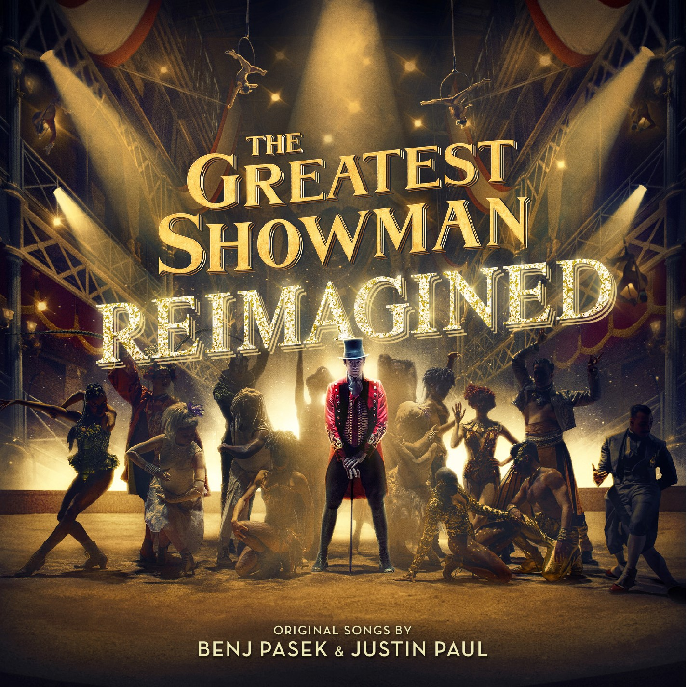

(New York, NY) The pre-order for Atlantic Records’ highly anticipated “THE GREATEST SHOWMAN – REIMAGINED” arrives today and is available HERE. The unprecedented new companion to Atlantic’s RIAA 2x platinum certified soundtrack to 20th Century Fox’s blockbuster musical film, will arrive everywhere on Friday, November 16th.

THE GREATEST SHOWMAN-REIMAGINED pre-order comes accompanied by P!nk’s stunning version of “A Million Dreams,” as well as the “A Million Dreams (Reprise)” performed by her daughter Willow Sage Hart. The two recorded together in the studio and are featured in an incredibly heartwarming video which can be seen HERE. Atlantic Records will also release two additional tracks prior to the release of the album, with Panic! At The Disco’s “The Greatest Show” to arrive on November 2nd and Kelly Clarkson’s “Never Enough” on November 9th.

Last Friday, Atlantic Records also released “THE GREATEST SHOWMAN – ORIGINAL MOTION PICTURE SOUNDTRACK: SING-A-LONG EDITION,” a deluxe repackaging of the album presented as a hardback CD book, including a 32-page booklet containing all song lyrics from the film and a bonus ‘Sing-a-Long’ disc featuring instrumental versions of the original tracks. This repackaging is available now HERE.

“THE GREATEST SHOWMAN – REIMAGINED” sees songs from the film, all written by GRAMMY®, Tony, and Academy Award-winning duo Benj Pasek & Justin Paul (La La Land, Dear Evan Hansen) covered by a remarkable cast of artists. The album is highlighted by a new version of the 3x platinum certified smash, “This Is Me,” performed by Keala Settle, Kesha and the legendary Missy Elliott. Other superstars contributing include Sara Bareilles, Years & Years and Jess Glynne, MAX and Ty Dolla $ign, James Arthur and Anne-Marie, and Zac Brown Band, among others. As if that weren’t enough, the album will include three bonus tracks, performed by Pentatonix, Craig David, and Kesha. See track listing below.

“THE GREATEST SHOWMAN –REIMAGINED” is produced by Benj Pasek & Justin Paul, GRAMMY® Award-winning (and 5x nominee) Atlantic Records President, West Coast Kevin Weaver (Furious 7, Suicide Squad, The Fault in Our Stars, The Fate of the Furious) and GRAMMY® Award-winning Atlantic Records President, A&R Pete Ganbarg (Twenty One Pilots, Hamilton: Original Broadway Cast Recording, Dear Evan Hansen: Original Broadway Cast Recording). The album received Executive Music Production by Justin Paul.

“THE GREATEST SHOWMAN – ORIGINAL MOTION PICTURE SOUNDTRACK” spent 31 weeks among the top 10 on the SoundScan/Billboard 200 – Including two weeks at #1, the most weeks atop the chart for a live-action theatrical film musical soundtrack since 2007’s “DREAMGIRLS: MUSIC FROM THE MOTION PICTURE.” Among its many other historic chart successes, the album also spent five weeks at #1 on Billboard’s “Top Album Sales,” the first soundtrack to do so since 2014’s “FROZEN: ORIGINAL MOTION PICTURE SOUNDTRACK.” The album includes the 3x platinum certified smash, “This Is Me,” performed by Keala Settle. The song was named “Best Original Song – Motion Picture” at the 75th Golden Globe Awards and nominated for “Best Original Song” at the 90th Academy Awards

With global streams now exceeding 3 billion, “THE GREATEST SHOWMAN – ORIGINAL MOTION PICTURE SOUNDTRACK” is an unquestionable worldwide sensation, earning 4x platinum certification in the United Kingdom and South Korea; 2x platinum in Ireland, Australia, and Singapore; platinum in New Zealand, Taiwan, China, Hong Kong, and Indonesia; and gold in Canada, Mexico, and the Philippines. Indeed, the soundtrack remains a phenomenon, currently standing high on the iTunes charts in close to 50 territories.

20th Century Fox’s The Greatest Showman is a bold and original musical that celebrates the birth of show business and the sense of wonder we feel when dreams come to life. Inspired by the ambition and imagination of P.T. Barnum, The Greatest Showman tells the story of a visionary who rose from nothing to create a mesmerizing spectacle that became a worldwide sensation. The Greatest Showman was directed by exciting new filmmaker Michael Gracey. The film stars Academy Award-nominee Hugh Jackman alongside Academy Award-nominee Michelle Williams, Zendaya, Zac Efron, and Rebecca Ferguson.

“THE GREATEST SHOWMAN – REIMAGINED”
(Atlantic Records)
Release Date: November 16th

TRACKLISTING

# # #
1. The Greatest Show – Panic! At The Disco
2. A Million Dreams – P!nk
3. A Million Dreams (Reprise) – Willow Sage Hart
4. Come Alive – Years & Years and Jess Glynne
5. The Other Side – MAX and Ty Dolla $ign
6. Never Enough – Kelly Clarkson
7. This Is Me (The Reimagined Remix) –Keala Settle, Kesha and Missy Elliott
8. Rewrite The Stars – James Arthur and Anne-Marie
9. Tightrope – Sara Bareilles
10. From Now On – Zac Brown Band

BONUS:
11. The Greatest Show – Pentatonix
12. Come Alive - Craig David
13. This Is Me - Kesha

