FOR IMMEDIATE RELEASE
November 9, 2018

KELLY CLARKSON UNVEILS STUNNING RENDITION OF “NEVER ENOUGH”
FROM “THE GREATEST SHOWMAN – REIMAGINED”

ALL-STAR COMPANION ALBUM TO FEATURE NEW VERSIONS OF SONGS ORIGINALLY
FOUND ON CHART-TOPPING SOUNDTRACK – DUE EVERYWHERE NOVEMBER 16TH

“THE GREATEST SHOWMAN – REIMAGINED” PRE-ORDER AVAILABLE HERE

OTHER CONTRIBUTING GLOBAL SUPERSTARS INCLUDE P!NK, PANIC! AT THE DISCO, MISSY ELLIOTT, KESHA, JAMES ARTHUR, ANNE- MARIE, PENTATONIX, ZAC BROWN BAND, TY DOLLA $IGN, SARA BAREILLES AND MORE

“THE GREATEST SHOWMAN-REIMAGINED” FEATURING ALL SONGS WRITTEN BY
GRAMMY®, TONY®, and ACADEMY AWARD-WINNING DUO BENJ PASEK AND JUSTIN PAUL

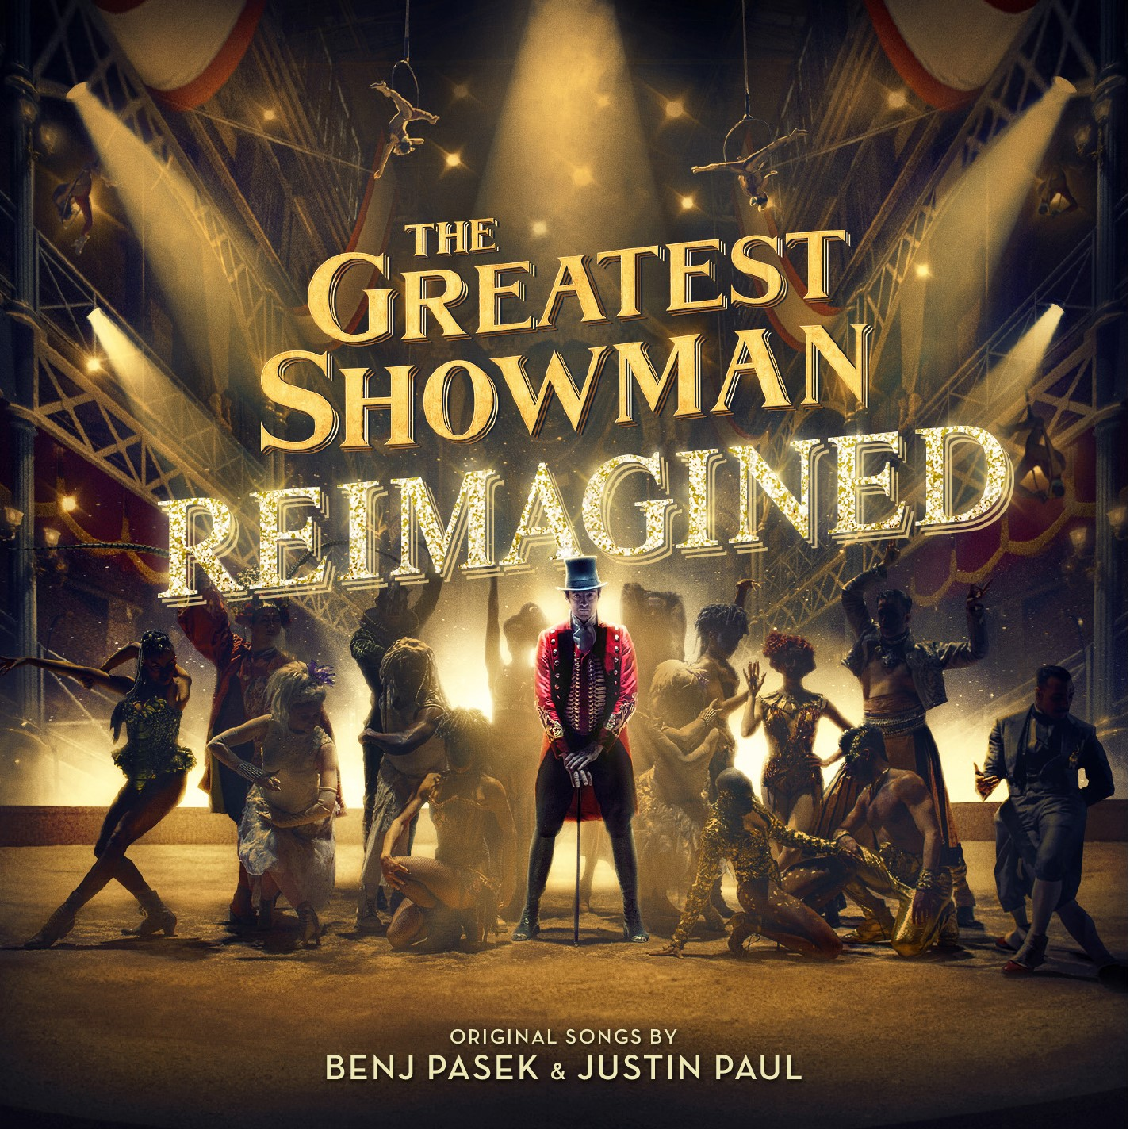

Multi-Grammy award winner Kelly Clarkson has unveiled her stunning rendition of “Never Enough” from Atlantic Records’ highly anticipated “THE GREATEST SHOWMAN – REIMAGINED” album today. Watch the lyric video for her version of “Never Enough” HERE. “I am so honored to be a part of ‘The Greatest Showman – Reimagined,” said Clarkson. “‘Never Enough’ is a beautiful song and I hope y’all dig my version.”

The unprecedented new companion to Atlantic’s RIAA 2x platinum certified soundtrack to 20th Century Fox’s blockbuster musical film, will arrive everywhere on Friday, November 16th and is available for pre-order HERE.

Last week, Panic! At the Disco released their rework of “The Greatest Show,” lauded by Billboard as “a triumphant rendition” and amassing nearly 4 million views on YouTube within just a week.

“THE GREATEST SHOWMAN – REIMAGINED” also came accompanied by P!nk’s chart-topping version of “A Million Dreams” and the “A Million Dreams (Reprise)” performed by her daughter Willow Sage Hart. The two recorded together in the studio, which is featured in an incredibly heartwarming video (watch here) that has already amassed more than 9 million views. P!nk’s version of “A Million Dreams” has also proven to be a smash – reaching #2 on the iTunes overall songs chart in just a few short days.

“THE GREATEST SHOWMAN – REIMAGINED” sees songs from the film, all written by GRAMMY®, Tony®, and Academy Award-winning duo Benj Pasek & Justin Paul (La La Land, Dear Evan Hansen) covered by a remarkable cast of artists. The album is highlighted by a new version of the 3x platinum certified smash, “This Is Me,” performed by Keala Settle, Kesha and the legendary Missy Elliott. Other superstars contributing include Sara Bareilles, Years & Years and Jess Glynne, MAX and Ty Dolla $ign, James Arthur and Anne-Marie, and Zac Brown Band, among others. As if that weren’t enough, the album will include three bonus tracks, performed by Pentatonix, Craig David, and Kesha. See track listing below.

“THE GREATEST SHOWMAN – REIMAGINED” is produced by Benj Pasek & Justin Paul, GRAMMY® Award-winning (and 5x nominee) Atlantic Records President, West Coast Kevin Weaver (Furious 7, Suicide Squad, The Fault in Our Stars, The Fate of the Furious) and GRAMMY® Award-winning Atlantic Records President, A&R Pete Ganbarg (Twenty One Pilots, Hamilton: Original Broadway Cast Recording, Dear Evan Hansen: Original Broadway Cast Recording). The album received Executive Music Production by Justin Paul.

20th Century Fox’s The Greatest Showman is a bold and original musical that celebrates the birth of show business and the sense of wonder we feel when dreams come to life. Inspired by the ambition and imagination of P.T. Barnum, The Greatest Showman tells the story of a visionary who rose from nothing to create a mesmerizing spectacle that became a worldwide sensation. The Greatest Showman was directed by exciting new filmmaker Michael Gracey. The film stars Academy Award-nominee Hugh Jackman alongside Academy Award-nominee Michelle Williams, Zendaya, Zac Efron, and Rebecca Ferguson.

“THE GREATEST SHOWMAN – REIMAGINED”
(Atlantic Records)
Release Date: November 16th

TRACKLISTING

# # #

1. The Greatest Show – Panic! At The Disco
2. A Million Dreams – P!nk
3. A Million Dreams (Reprise) – Willow Sage Hart
4. Come Alive – Years & Years and Jess Glynne
5. The Other Side – MAX and Ty Dolla $ign
6. Never Enough – Kelly Clarkson
7. This Is Me (The Reimagined Remix) –Keala Settle, Kesha and Missy Elliott
8. Rewrite The Stars – James Arthur and Anne-Marie
9. Tightrope – Sara Bareilles
10. From Now On – Zac Brown Band

BONUS:
11. The Greatest Show – Pentatonix
12. Come Alive - Craig David
13. This Is Me - Kesha

