FOR IMMEDIATE RELEASE
November 16, 2018

“THE GREATEST SHOWMAN – REIMAGINED” OUT NOW

ACCOMPANIED BY “REWRITE THE STARS” OFFICIAL VIDEO FEATURING ANNE-MARIE & JAMES ARTHUR

SONGS FROM HIGHLY ANTICIPATED ALL-STAR COMPANION ALBUM HAVE ALREADY AMASSED OVER 100 MILLION STREAMS GLOBALLY IN THREE WEEKS PRIOR TO ALBUM RELEASE

ALBUM IMMEDIATELY ASCENDED INTO THE #1 CHART POSITION ON ITUNES UPON RELEASE

FEATURES NEW VERSIONS OF SONGS ORIGINALLY FOUND ON CHART-TOPPING SOUNDTRACK – AVAILABLE HERE VIA ATLANTIC RECORDS

OTHER CONTRIBUTING GLOBAL SUPERSTARS INCLUDE P!NK, PANIC! AT THE DISCO, KELLY CLARKSON, MISSY ELLIOTT, KESHA, JAMES ARTHUR, ANNE- MARIE, PENTATONIX, ZAC BROWN BAND, TY DOLLA $IGN, SARA BAREILLES AND MORE

“THE GREATEST SHOWMAN – REIMAGINED” FEATURING ALL SONGS WRITTEN BY
GRAMMY®, TONY®, and ACADEMY AWARD-WINNING DUO BENJ PASEK AND JUSTIN PAUL

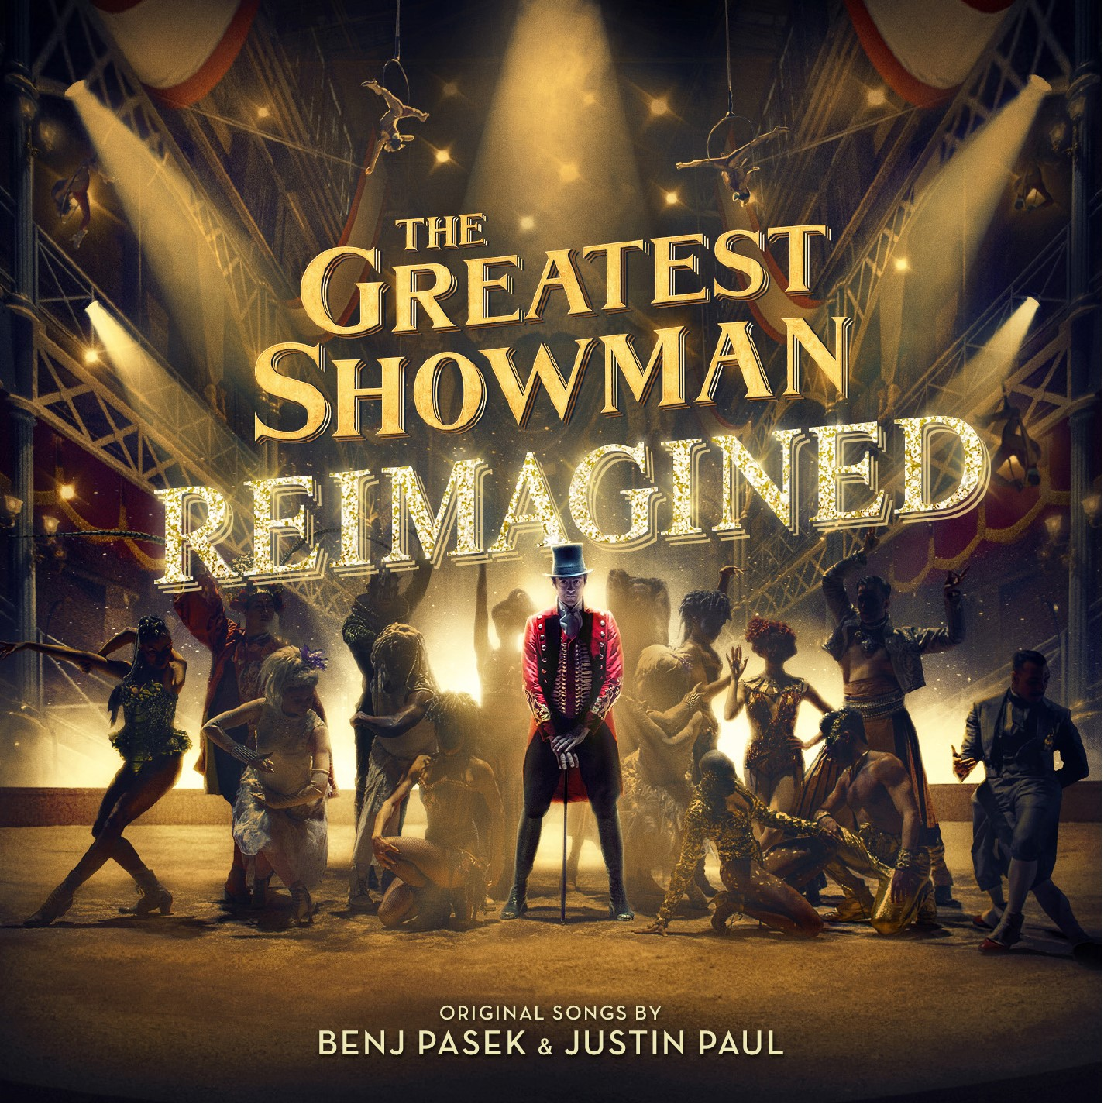

Atlantic Records announces today the release of the highly anticipated “THE GREATEST SHOWMAN – REIMAGINED” (buy/stream HERE). The unprecedented new companion to Atlantic’s RIAA 2x platinum certified soundtrack for 20th Century Fox’s blockbuster musical film has already amassed an incredible 100 million streams globally through individual tracks and videos released in recent weeks and immediately ascended today into the #1 chart position on iTunes upon release. Today’s full album comes accompanied by an awe-inspiring official video for “Rewrite the Stars” featuring multi-platinum artists Anne-Marie and James Arthur – watch HERE.

Last week, multi-Grammy award winner Kelly Clarkson unveiled her stunning rendition of “Never Enough,” with Entertainment Weekly asserting “The Greatest Showman’s power ballad is in good hands” and People Magazine declaring “Kelly Clarkson might just be the Greatest Show-Woman… the original American Idol used her million-dollar pipes to tackle ‘Never Enough’ and the results are, as predicted, enthralling.” Watch the official lyric video for the track HERE.

Prior to Clarkson’s reimagined smash, Panic! At the Disco released their rework of “The Greatest Show,” lauded by Billboard as “a triumphant rendition.”

“THE GREATEST SHOWMAN – REIMAGINED” also came accompanied by P!nk’s chart-topping version of “A Million Dreams” and the “A Million Dreams (Reprise)” performed by her daughter Willow Sage Hart. The two recorded together in the studio, which is featured in an incredibly heartwarming video (watch here). P!nk’s version of “A Million Dreams” also proved to be a smash – reaching #2 on the iTunes overall songs chart in just a few short days.

“THE GREATEST SHOWMAN – REIMAGINED” sees songs from the film, all written by GRAMMY®, Tony®, and Academy Award-winning duo Benj Pasek & Justin Paul (La La Land, Dear Evan Hansen) covered by a remarkable cast of artists. The album is highlighted by a new version of the 3x platinum certified smash, “This Is Me,” performed by Keala Settle, Kesha and the legendary Missy Elliott. Other superstars contributing include Sara Bareilles, Years & Years and Jess Glynne, MAX and Ty Dolla $ign, James Arthur and Anne-Marie, and Zac Brown Band, among others. As if that weren’t enough, the album also includes three bonus tracks, performed by Pentatonix, Craig David, and Kesha. See track listing below.

Fitness technology company Peloton will celebrate the release of "The Greatest Showman Reimagined" in a 30-minute themed-cycling ride with Head Instructor Robin Arzon today (11/16) at 1:30pm ET. The ride will also be available in Peloton's on-demand archive, for Members interested in taking the class in the future. With world-class instructors passionate about how music can be used to motivate Members, Peloton’s partnership with the soundtrack highlights yet again the incredible impact of the music on listeners around the world.

“THE GREATEST SHOWMAN – REIMAGINED” is produced by Benj Pasek & Justin Paul, GRAMMY® Award-winning (and 5x nominee) Atlantic Records President, West Coast Kevin Weaver (Furious 7, Suicide Squad, The Fault in Our Stars, The Fate of the Furious) and GRAMMY® Award-winning Atlantic Records President, A&R Pete Ganbarg (Twenty One Pilots, Hamilton: Original Broadway Cast Recording, Dear Evan Hansen: Original Broadway Cast Recording). The album received Executive Music Production by Justin Paul.

20th Century Fox’s The Greatest Showman is a bold and original musical that celebrates the birth of show business and the sense of wonder we feel when dreams come to life. Inspired by the ambition and imagination of P.T. Barnum, The Greatest Showman tells the story of a visionary who rose from nothing to create a mesmerizing spectacle that became a worldwide sensation. The Greatest Showman was directed by exciting new filmmaker Michael Gracey. The film stars Academy Award-nominee Hugh Jackman alongside Academy Award-nominee Michelle Williams, Zendaya, Zac Efron, and Rebecca Ferguson.

“THE GREATEST SHOWMAN – REIMAGINED”
(Atlantic Records)

TRACKLISTING

# # #

1. The Greatest Show – Panic! At The Disco
2. A Million Dreams – P!nk
3. A Million Dreams (Reprise) – Willow Sage Hart
4. Come Alive – Years & Years and Jess Glynne
5. The Other Side – MAX and Ty Dolla $ign
6. Never Enough – Kelly Clarkson
7. This Is Me (The Reimagined Remix) –Keala Settle, Kesha and Missy Elliott
8. Rewrite The Stars – James Arthur and Anne-Marie
9. Tightrope – Sara Bareilles
10. From Now On – Zac Brown Band

BONUS:
11. The Greatest Show – Pentatonix
12. Come Alive - Craig David
13. This Is Me - Kesha

