***THE GREATEST SHOWMAN* SOUNDTRACK ROARS ON**

**ALBUM SPENDS SECOND WEEK AT #1 ON BILLBOARD 200 CHART**

**20TH CENTURY FOX’S *The Greatest Showman* in theaters now**

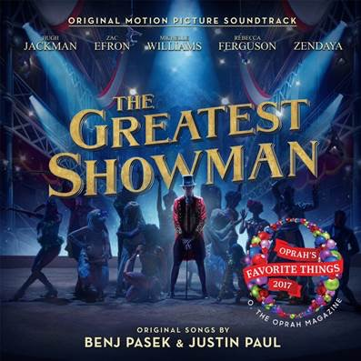

**STREAM *THE GREATEST SHOWMAN*:** [https://Atlantic.lnk.to/TheGreatestShowman](https://protect-us.mimecast.com/s/sEfhCJ67QJhgAMYosOxjSY)

“**The Greatest Showman – Original Motion Picture Soundtrack**” (available now via **Atlantic Records**) is spending a second week at #1 on the **Billboard 200** albums chart, becoming the first soundtrack to spend multiple weeks on top of the chart since Atlantic’s *Suicide Squad : The Album* in 2016*.* The album reached #1 on **iTunes** in 68 countries, with 9 songs charting on the **Spotify Top 200** Global chart and tracks added to both **Today’s Top Hits** on **Spotify** (“**Rewrite The Stars**” and “**This Is Me**”) and **Today’s Hits** on **Apple Music** (“**This Is Me**”). Last week the album did over **37 million streams** in the US alone, while internationally hitting #1 on the official UK, Italian and Australian album charts.

The release recently saw a triumphant win at the 75th annual **Golden Globe Awards**, with “**This Is Me**” (performed by **Keala Settle,** lyric video: <http://Atlanti.cr/thisismelyricvideo>) taking home the award for **Best Original Song - Motion Picture**. The 20th Century Fox musical film, in theaters now, received three total Golden Globe nominations, also including **Best Motion Picture - Musical or Comedy** and **Best Performance by an Actor in a Motion Picture - Musical or Comedy** (**Hugh Jackman**). Raking in early Oscar-buzz, the **Los Angeles Times** declared “**This Is Me**” to be *“a virtual lock for an original song nomination at the Academy Awards.”*

***The Greatest Showman*** is a bold and original musical that celebrates the birth of show business and the sense of wonder we feel when dreams come to life. Inspired by the ambition and imagination of P.T. Barnum, ***The Greatest Showman*** tells the story of a visionary who rose from nothing to create a mesmerizing spectacle that became a worldwide sensation. ***The Greatest Showman*** is directed by exciting new filmmaker **Michael Gracey**, with songs co-produced and written by Tony and Academy Award winning and GRAMMY®-nominated duo **Benj Pasek** & **Justin Paul** (***La La Land***, ***Dear Evan Hansen***), co-produced by GRAMMY®-nominee **Greg Wells** (**Twenty One Pilots,** **Adele**, **Katy Perry**) and executive produced by Tony and GRAMMY® Award winner **Alex Lacamoire** (***Hamilton, Dear Evan Hansen***). The film stars Academy Award nominee **Hugh Jackman** alongside Academy Award nominee **Michelle Williams**, **Zendaya**, **Zac Efron**, and **Rebecca Ferguson**.

“**The Greatest Showman – Original Motion Picture Soundtrack**” has been overseen at Atlantic Records by GRAMMY® Award winning (five time nominee) Atlantic Records West Coast President **Kevin Weaver** (“**Furious 7**,” “**Suicide Squad**,” “**The Fault in Our Stars**,” “**The Fate of the Furious”**) and GRAMMY®-nominated Atlantic Records President, A&R **Pete Ganbarg** (“**Hamilton – Original Broadway Cast Recording**,” “**Dear Evan Hansen – Original Broadway Cast Recording**,” **Twenty One Pilots**).

For more information on *The Greatest Showman*, please visit [www.foxmovies.com/movies/the-greatest-showman](https://protect-us.mimecast.com/s/k5XsCL95JLIlw812SKJOX9)

For press inquiries, please contact [sheila.richman@atlanticrecords.com](mailto:sheila.richman@atlanticrecords.com)