FOR IMMEDIATE RELEASE
OCTOBER 2, 2020

TREY SONGZ UNLOCKS PRE-ORDER FOR HIGHLY ANTICIPATED 8th STUDIO ALBUM BACK HOME TODAY

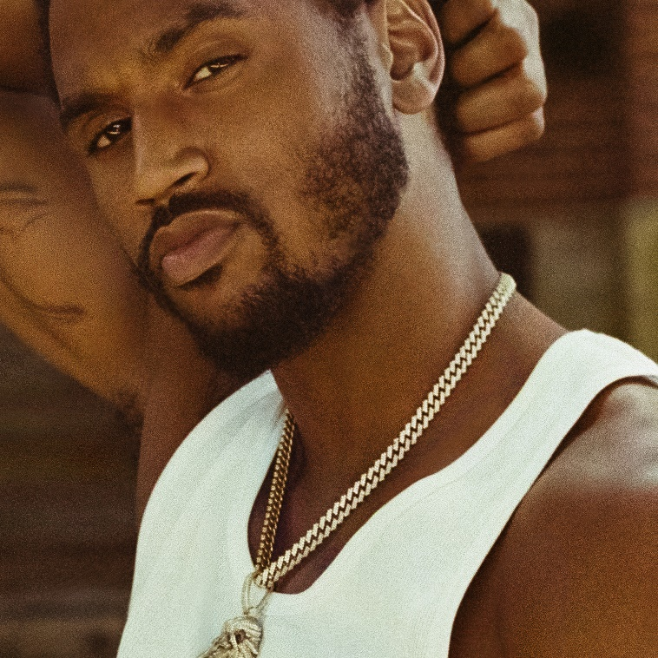

MULTI-PLATINUM R&B ICON TO RELEASE NEW ALBUM ON OCTOBER 9TH

NEW TRACK “TWO WAYS” AVAILABLE FOR STREAMING AND DOWNLOAD NOW

After influencing and impacting R&B for 15 years, Trey Songz finally returns home…

The 3x GRAMMY® Award-nominated R&B superstar launches the pre-order for his anxiously awaited eighth full-length album, BACK HOME, today; see HERE. The full length album will arrive at all DSPs and streaming services on October 9th via Atlantic Records. Igniting this chapter, he also just shared a new track entitled “Two Ways.” The pre-order unlocks an instant grat download of “Two Ways” as well as the previously released fan favorites “Circles,” “Back Home (Feat. Summer Walker),” and “2020 Riots: How Many Times.”

In celebration of the release, he chose to unveil “Two Ways” first as one of his personal “favorites.” With its slinky guitar, throwback beat, and vocal acrobatics, the track immediately captivates. Detailing the breaking point of a relationship, this heartfelt heartbreak anthem indicates what audiences should expect from BACK HOME i.e. classic Trey Songz through and through. The track, which was teased on Instagram Live back in August, easily became a fan-favorite.

He teased out the album’s arrival last month with “Circles.” Already, it has accumulated over 8 million streams worldwide and 3.2 million YouTube views on the music video. Attracting critical acclaim, Revolt praised it as “a celebration of Black relationships,” and Billboard included it among “First Beat” and added, “The Virginia crooner acknowledges the revolving door in his relationship between him and his lover, and seeks to end the cyclical process.” Meanwhile, the title track “Back Home” has emerged as his biggest R&B radio hit in six years. It captured No. 7 on the Billboard Adult R&B Airplay Chart, marking his third Top 10 on the respective chart. Not to mention, it has already eclipsed 36 million global streams and a total of 4.2 million YouTube views.

On the other end of the spectrum, Trey has made important political statements with his recent endeavors. As he reflects on going Back Home, the importance of driving voter awareness leading into the historic upcoming presidential election has been crucial. The artist recently took part in the Be Woke Vote campaign, an initiative designed to drive visibility around the importance in voting.

Earlier this summer, he made headlines with “2020 Riots: How Many Times.” Over production from longtime collaborator Troy Taylor, the simultaneously tearful and powerful official video consists of footage shot over Trey’s BLACK LIVES MATTER weekend event. It fittingly took over the area he calls home—Petersburg and Richmond, VA—in honor of JuneTeenth 2020. Uproxx praised the single’s “gospel-inflected chorus,” noting, “(Trey) takes to task the concept of colorblindness, pointing out the hypocrisy of claiming not to see color when it’s clear that Black Americans have faced incarceration, wrongful death at the hands of the police, and income inequality at a disproportionate rate.” A portion of all proceeds from “2020 Riots: How Many Times” benefit both Black Lives Matter and the Community Justice Exchange’s National Bail Fund Network.

Trey has also been on the frontlines of multiple community protests and charity events in recent months, including the aforementioned Black Lives Matter weekend event earlier this summer held in commemoration of both Juneteenth and Father’s Day. The three-day event – prompted by former NBA All-Star Ricky Davis & The Ricky Davis Legacy Foundation, music industry legend Tony Draper, and GRAMMY® Award-nominated rapper Pusha T's #FEEDYOURCITYCHALLENGE – raised awareness and provided fresh groceries and essential PPE supplies for thousands of community members to use during the ongoing BLM protests. In addition, he recently participated in the #FEEDYOURCITYCHALLENGE in Los Angeles, alongside fellow musicians Roddy Ricch, Jhene Aiko, Mustard and more.

Since the release of his 2005 Atlantic Records debut I Gotta Make It, singer, actor, entrepreneur, performer, and Virginia native Trey Songz has achieved over 7.9 Billion Global streams and sales combined and received three GRAMMY® Award nominations. He has also earned 16-plus RIAA Certified platinum and gold singles and albums. Plus, he landed back-to-back #1 debuts on the Billboard Top 200 with the RIAA gold-certified Chapter V in 2012 and RIAA platinum-certified TRIGGA in 2014 and staunchly carried a tradition of classic R&B into the 21st century.

Now, he takes his fans on a journey to find out what matters most in life on BACK HOME.

“I wanna make the kind of R&B that inspired me to sing,” he says. “The songs that make you love, the ones that make cry and the ones that make you smile, laugh and dance. Music is the soundtrack that plays while we live our lives, and I wanna be there for my fans while they are living through this truly special time that we’ll never forget. I say I’m “Back Home” because the music feels that way. I hope you feel the same.”

For the first time, Trey Songz invites us BACK HOME with him.

Welcome to his boldest and brightest chapter yet.

# # #

CONNECT WITH TREY SONGZ
TREYSONGZ.COM
TWITTER | FACEBOOK | YOUTUBE | INSTAGRAM
ATLANTICRECORDS.COM

