FOR IMMEDIATE RELEASE
MARCH 27, 2019

ATLANTIC RECORDS & STXFILMS ANNOUNCE
“UGLYDOLLS ORIGINAL MOTION PICTURE SOUNDTRACK”
WITH LEAD SINGLE BY GRAMMY® AWARD WINNING GLOBAL SUPERSTAR KELLY CLARKSON

KELLY CLARKSON’S “BROKEN & BEAUTIFUL,” PRODUCED BY MARSHMELLO & STEVE MAC,
AND WRITTEN FOR THE FILM BY P!NK, IS AVAILABLE NOW, WITH ANIMATED LYRIC VIDEO,
AND FEATURED AS THE FILM’S END CREDITS SONG

ANIMATED MUSICAL STARRING THE VOICES OF INTERNATIONAL MEGASTARS KELLY CLARKSON, JANELLE MONÁE, NICK JONAS, BLAKE SHELTON, BEBE REXHA, CHARLI XCX, LIZZO, PITBULL & MORE, ALL PERFORMING NEW ORIGINAL SONGS IN THE MOVIE

ALL-STAR COMPANION ALBUM TO ALSO INCLUDE BRAND NEW SONGS BY GENRE-BENDING ARTISTS WHY DON’T WE, PENTATONIX & ANITTA

“UGLYDOLLS ORIGINAL MOTION PICTURE SOUNDTRACK” IS AVAILABLE FOR PRE-ORDER NOW AND ARRIVES AT ALL DSPS APRIL 26; STXFILMS’ UGLYDOLLS OPENS NATIONWIDE ON MAY 3, 2019

LISTEN TO “BROKEN & BEAUTIFUL” HERE
WATCH “BROKEN & BEAUTIFUL” LYRIC VIDEO HERE
PRE-ORDER “UGLYDOLLS ORIGINAL MOTION PICTURE SOUNDTRACK” HERE

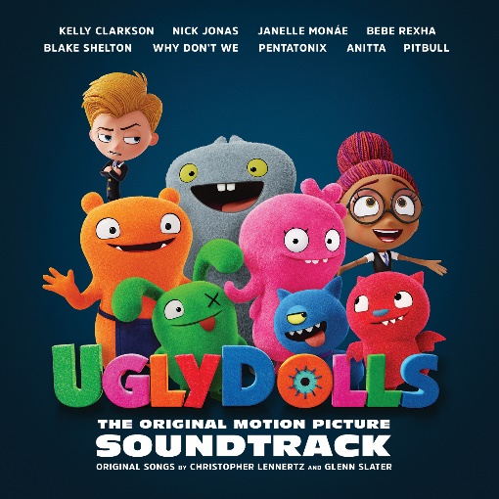

Today, Atlantic Records in partnership with STXfilms officially announces “UGLYDOLLS ORIGINAL MOTION PICTURE SOUNDTRACK,” a brand-new album with original music by an all-star cast of massive global superstars to accompany the highly-anticipated animated musical comedy UglyDolls. The record label who brought you “The Greatest Showman – Original Motion Picture Soundtrack,” “Hamilton – Original Broadway Cast Recording,” and more, is delivering another collection of incredible new and original songs heralded by the first single “Broken & Beautiful,” performed by GRAMMY Award-winning global superstar Kelly Clarkson, who stars in UglyDolls as the film’s lead character Moxy.

Moxy (Clarkson) and her gang of lovably imperfect characters will go on a hilarious journey through UglyVille, where they embrace what it means to be unique and discover that you don’t have to be perfect to be amazing!

“Broken & Beautiful,” an original song written for UglyDolls is out now at all DSPs (listen HERE), while “UGLYDOLLS ORIGINAL MOTION PICTURE SOUNDTRACK” is now available for pre-order at select DSPs (pre-order HERE). “UGLYDOLLS ORIGINAL MOTION PICTURE SOUNDTRACK” arrives at all DSPs April 26th. UglyDolls will hit theatres everywhere May 3rd.

“Broken & Beautiful” is accompanied by a custom animated lyric video, which is streaming now on Kelly Clarkson’s official YouTube channel (watch HERE). The powerful and inspiring new single was co-written by P!NK alongside Johnny McDaid and Steve Mac (Ed Sheeran’s “Shape Of You” and P!NK’s “What About Us”) and Marshmello. The song was produced by Steve Mac & Marshmello. Kelly has several upcoming nationally televised performances of “Broken & Beautiful,” including NBC’s The Tonight Show Starring Jimmy Fallon on April 3rd and TODAY on April 4th. Kelly will also be a talk guest on ABC’s Live with Kelly & Ryan on April 5th followed by an interview with Kathie Lee & Hoda on TODAY set to air April 8th. Additionally, Apple Music is already showing early support for “Broken & Beautiful,” naming the single ‘Bop of the Week’ on the Beats 1 show A-List Pop Live.

“UGLYDOLLS ORIGINAL MOTION PICTURE SOUNDTRACK” will include brand new songs from the film by cast members Nick Jonas, Blake Shelton, Janelle Monáe, Bebe Rexha, as well as songs inspired by the film from Why Don’t We, Pentatonix and Anitta. See full track listing below. The next few weeks will be filled with new music and visual releases in the lead-up to the soundtrack’s highly-anticipated April 26th release day.

An STXfilms and Alibaba Pictures presentation, UglyDolls is directed by Kelly Asbury and will be released in theaters on May 3rd, 2019. Also starring in the film’s voice cast are Wanda Sykes, Gabriel Iglesias, Wang Leehom, Emma Roberts, Bebe Rexha, Charli XCX and Lizzo.

“UGLYDOLLS ORIGINAL MOTION PICTURE SOUNDTRACK” is being overseen by GRAMMY® Award winning (five-time nominee) Atlantic Records West Coast President Kevin Weaver (“Greatest Showman,” “Furious 7,” “Suicide Squad,” “The Fault in Our Stars,” “The Fate of the Furious”) and President of Music for STXfilms and STXtelevision, Jason Markey. Acclaimed songwriters Christopher Lennertz and Glenn Slater worked in collaboration with a team of world-class producers on the record including, Philip Lawrence, Davy Nathan, Jesse Shatkin, Mayer Hawthorne, Stint, Jonas Jeberg, Jussifer, Scott Hendricks, The Monsters & Strangerz, MAG and Louis Schoorl.

PRESS CONTACT:
Chelsey Northern / chelsey.northern@atlanticrecords.com / 818.238.6832

UGLYDOLLS ORIGINAL MOTION PICTURE SOUNDTRACK
(APRIL 26TH – ATLANTIC RECORDS)

1) Kelly Clarkson - Broken & Beautiful (from the movie UGLYDOLLS)
2) Kelly Clarkson - Couldn’t Be Better (Pop Version)
3) Kelly Clarkson - Today’s the Day
4) Kelly Clarkson and the UglyDolls Cast - Couldn’t Be Better (Movie Version)
5) UglyDolls Cast - Today’s the (Perfect) Day
6) Nick Jonas - The Ugly Truth
7) Pentatonix - You Make My Dreams
8) Nick Jonas - The Uglier Truth
9) Janelle Monáe (feat. Kelly Clarkson) - All Dolled Up
10) Janelle Monáe & Kelly Clarkson - Unbreakable
11) UglyDolls Cast - The Big Finale
12) Bebe Rexha - Girl in the Mirror
13) Anitta - Ugly
14) Why Don’t We - Don’t Change
15) Blake Shelton - Wallflowers & Weeds
16) Anitta - Ugly (“Fea”)

