FOR IMMEDIATE RELEASE
APRIL 25, 2019

KELLY CLARKSON STARS ALONGSIDE DAUGHTER RIVER ROSE
IN OFFICIAL VIDEO FOR “BROKEN & BEAUTIFUL”

AN EXCLUSIVE FIRST LOOK AIRED EARLIER ON NBC’S TODAY –
WATCH THE EMPOWERING VIDEO THAT BLENDS LIVE ACTION AND CUSTOM ANIMATION HERE

AN ANIMATED “UGLYDOLL” VERSION OF GLOBAL SUPERSTAR ARTIST/PRODUCER/DJ MARSHMELLO MAKES CAMEO IN THE VIDEO FOR “BROKEN & BEAUTIFUL,” WHICH WAS PRODUCED BY MARSHMELLO HIMSELF AND STEVE MAC

GRAMMY® WINNING SUPERSTAR TO PERFORM “BROKEN & BEAUTIFUL”
AS SHE HOSTS THE BILLBOARD MUSIC AWARDS ON MAY 1ST

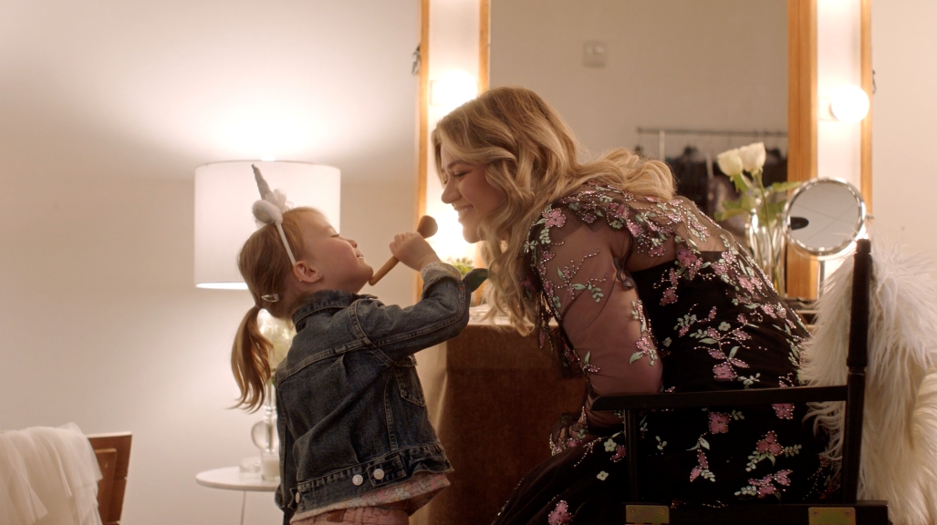

ALL-STAR COMPANION TO ANIMATED MUSICAL COMEDY ARRIVES TOMORROW – PRE ORDER HERE
STXFILMS’ UGLYDOLLS OPENS IN THEATRES NATIONWIDE ON MAY 3RD

Atlantic Records in partnership with STXfilms have announced today’s premiere of the official companion video to Kelly Clarkson’s “Broken & Beautiful,” the stunning hit single from the eagerly awaited “UGLYDOLLS ORIGINAL MOTION PICTURE SOUNDTRACK.” Earlier this morning, an exclusive first look at the official video aired during NBC’s TODAY. The empowering colorful clip, which stars both Clarkson and her adorable daughter River Rose alongside exclusive animation of the film’s lead character Moxy (played by Clarkson herself), can be viewed HERE. Blending live action and custom animation, the video also features a cameo of a personalized “UglyDoll” version of global superstar artist/producer/DJ Marshmello, who produced the song alongside Steve Mac. The “UGLYDOLLS ORIGINAL MOTION PICTURE SOUNDTRACK” arrives at all DSPs tomorrow, April 26th; STXfilms’ highly anticipated animated musical comedy, UglyDolls, arrives in theatres everywhere on May 3rd.

Composed for UglyDolls, “Broken & Beautiful” is co-written by P!NK alongside Johnny McDaid, Steve Mac (Ed Sheeran’s “Shape Of You” and P!NK’s “What About Us”), and Marshmello and produced by Steve Mac & Marshmello. “Broken & Beautiful” is available now at all DSPs HERE; the uplifting track is also accompanied by a custom animated lyric video and is fast proving a massive success, coming in as this week’s “Most Added” new single at Hot AC radio stations nationwide. Along with its popular success, the single earned immediate critical applause upon its release, with Rolling Stone praising it as a “sleek new electro-pop song… (‘Broken & Beautiful’) utilizes a quiet-loud dynamic, with Clarkson belting in a high register on the chorus.” The New York Times declared “Broken & Beautiful” to be “a classic empowerment anthem…from the forthcoming animated movie UglyDolls, in which Clarkson plays a plush toy seeking self-acceptance,” while GQ named the single to its “The 4.5 Songs You Need to Hear This Week,” proclaiming simply, “Mark my words: Kelly Clarkson will EGOT.”

Clarkson – who stars in UglyDolls as the film’s lead character, Moxy – will host and perform “Broken & Beautiful” at the upcoming Billboard Music Awards, set for broadcast on NBC next Wednesday, May 1st (check local listings). The GRAMMY® Award-winning superstar previously celebrated the single’s arrival with stunning live performances on NBC’s The Tonight Show Starring Jimmy Fallon (streaming HERE) and TODAY (streaming HERE). In addition, the multi-platinum singer-songwriter sat down for interviews on ABC’s Live with Kelly & Ryan and with Kathie Lee & Hoda on NBC’s TODAY (streaming HERE).

A brand-new album featuring original music by an incredible line-up of global superstars, “UGLYDOLLS ORIGINAL MOTION PICTURE SOUNDTRACK” is available for pre-order now at select DSPs HERE. The collection also includes the international hit single, “Ugly” (“Fea”), by Latin GRAMMY® Award-nominated Brazilian pop superstar Anitta, available now for streaming and download in three languages HERE; companion visuals are available to view in English, Spanish, and Portuguese. Last week saw the arrival of “Don’t Change,” performed by rising pop stars Why Don’t We, available at all DSPs HERE; the official video can be viewed at the group’s wildly popular YouTube channel HERE. As if all that weren’t enough, “UGLYDOLLS ORIGINAL MOTION PICTURE SOUNDTRACK” also includes brand new songs from the film by cast members Nick Jonas, Blake Shelton, Janelle Monáe, and Bebe Rexha. Also starring in the film’s voice cast are Wanda Sykes, Gabriel Iglesias, Wang Leehom, Emma Roberts, Charli XCX, and Lizzo.

PRESS CONTACT:
Chelsey Northern / chelsey.northern@atlanticrecords.com / 818.238.6832

