FOR IMMEDIATE RELEASE
DECEMBER 3, 2021

VANCE JOY RECRUITS RAC FOR “MISSING PIECE” REMIX

MULTI-PLATINUM SINGER-SONGWRITER TAPS GRAMMY-NOMINATED PRODUCER FOR REWORK OF HIS MOST RECENT SINGLE

ORIGINAL TRACK CURRENTLY #2 AT ALTERNATIVE RADIO, HOLDS OVER 80 MILLION STREAMS
+ CONTINUES TO STREAM OVER 2 MILLION TIMES A WEEK IN THE US

LISTEN TO “MISSING PIECE (RAC REMIX)” HERE
WATCH THE VISUALIZER HERE
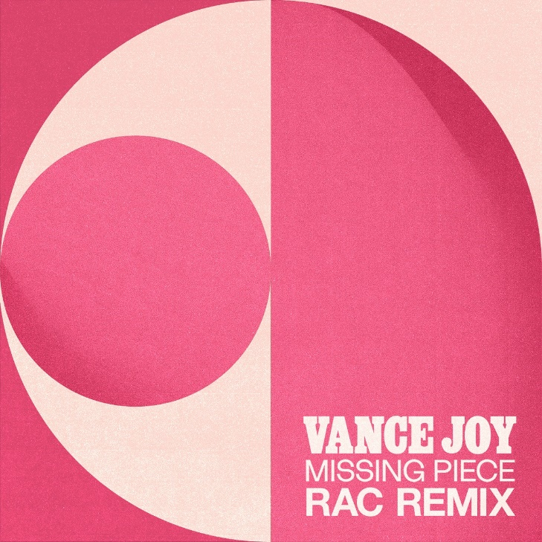
DOWNLOAD ARTWORK HERE

Multi-platinum singer/songwriter Vance Joy and legendary GRAMMY-nominated producer RAC have teamed up for a new rework of Joy’s current single - “Missing Piece (RAC Remix)” is available now HERE. RAC has remixed the world’s biggest superstars including Lady Gaga and Lana Del Rey.

The impressive rework follows a recent remix from GRAMMY-nominated duo Sofi Tukker (Lady Gaga, Billie Eilish), streaming now HERE. The original track, written with Joel Little (Taylor Swift, Khalid, Lorde), currently boasts over 80 million streams and continues to stream over 2 million times a week in the US alone. The infectious track currently stands at #2 at Alternative Radio and was featured on ABC’s Grey’s Anatomy. Vance Joy also gave a beautiful performance of the song on The Late Late Show with James Corden – streaming now HERE.

A true icon, Joy’s catalogue boasts over 5 billion streams, as well as over 3 billion views on TikTok (with 2.6 million user-created videos). Joy has lit up stages around the world on a string of sold out headline tours and festivals, playing iconic stages such as Red Rocks Amphitheatre, Coachella, Firefly, Austin City Limits and more, as well as special guest turns on stadium runs by Taylor Swift and P!nk. Joy recently announced a pair of US headlining shows for June 2022. The acclaimed artist will play Nashville, TN’s famed Ryman Auditorium on June 2, 2022 and New York’s Pier 17 on June 4, 2022. The shows will go on sale this Friday, November 19 at 10AM local time. For tickets and details please visit: https://www.vancejoy.com/tour.

Joy recently kicked off the holiday season with the release of a beautiful cover of The Pogues’ “Fairytale of New York.” Part of Atlantic Records’ annual holiday compilation, the rendition of the English punk band’s 1987 Christmas classic was originally released to his YouTube channel last year, instantly becoming a fan favorite (watch here).

DOWNLOAD PRESS PHOTOS HERE

ABOUT VANCE JOY
You don't sell over two million copies of your debut album without some serious hard work, and Australian singer/songwriter Vance Joy has never been shy of major elbow grease. After performing at open mic nights in Melbourne, Joy introduced the world to his ukulele-led charm ‘Riptide’, which became an instant global classic.

Vance Joy (born James Keogh) consolidated on that first impression with further anthems ‘Mess is Mine’, ‘Georgia’ and ‘Fire and the Flood’ off his 2014's debut ’dream your life away’. Vance Joy then toured the globe on Taylor Swift’s 1989 World Tour, and played world famous festivals such as Lollapalooza, Coachella, and more. After his successful Sold Out 2016 ‘Fire and The Flood’ North American theatre run, and Australian performances at the Sydney Opera House, Vance Joy kicked off the campaign for his Sophomore album ‘Nation of Two’ with the lead single ‘Lay It On Me’ showing it was destined to be another successful album. The success of ‘Nation of Two’ saw Vance Joy tour the world throughout 2018 headlining legendary venues such as Red Rocks Amphitheatre, and theatres acorss Latin American, Europe and Australia including two sold-out hometown shows at Melbourne’s Rod Laver Arena.

It’s no surprise that listeners all over the world connect to Vance Joys intimate yet anthemic songwriting. His lyrics take you on a journey that will reach out and hold you for a delicate moment. Bringing together a unique, charming mix of folk music with pop influences, these songs capture the familiar pulse of everyday experiences in a unique and celebratory manner.

CONNECT WITH VANCE JOY:
WEBSITE | FACEBOOK | TWITTER | INSTAGRAM | YOUTUBE

For press inquiries, please contact:
Kelly McWilliam // Kelly.McWilliam@atlanticrecords.com
Libby Kober // Libby.Kober@atlanticrecords.com

