FOR IMMEDIATE RELEASE
OCTOBER 15, 2021

VANCE JOY TAPS SOFI TUKKER FOR NEW SPIN ON “MISSING PIECE”

MULTI-PLATINUM SINGER-SONGWRITER TEAMS UP WITH GRAMMY-NOMINATED DJ DUO FOR AN UPBEAT REWORK OF THE RISING SINGLE

ORIGINAL TRACK CURRENTLY #7 AT ALTERNATIVE RADIO
+ CONTINUES TO STREAM OVER 2 MILLION TIMES A WEEK IN THE US

LISTEN TO “MISSING PIECE (SOFI TUKKER REMIX)” HERE
WATCH THE VISUALIZER HERE
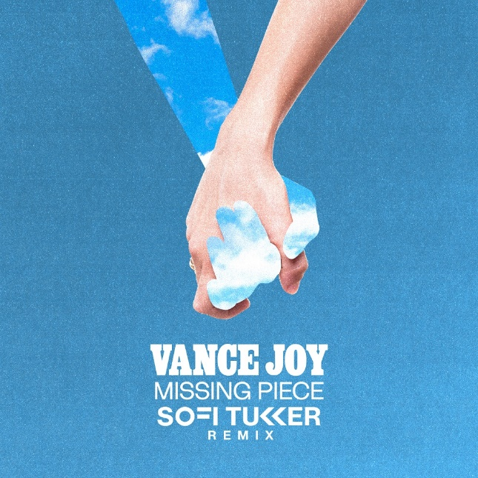
DOWNLOAD ARTWORK HERE

Multi-platinum singer/songwriter Vance Joy and GRAMMY-nominated duo Sofi Tukker (Lady Gaga, Billie Eilish) have teamed up for an impressive rework of Joy’s current single - “Missing Piece (Sofi Tukker Remix)” is available now HERE. Watch the visualizer HERE.

The original track, written with Joel Little (Taylor Swift, Khalid, Lorde), dropped earlier this summer and continues to stream over 2 million times a week in the US alone. Boasting 60 million streams, the track currently stands at #7 at Alternative Radio and was featured on ABC’s Grey’s Anatomy. Vance Joy also gave a beautiful performance of the song on The Late Late Show with James Corden – streaming now HERE.
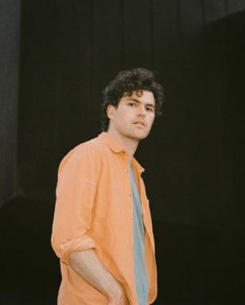
DOWNLOAD PRESS PHOTOS HERE

ABOUT VANCE JOY
You don't sell over two million copies of your debut album without some serious hard work, and Australian singer/songwriter Vance Joy has never been shy of major elbow grease. After performing at open mic nights in Melbourne, Joy introduced the world to his ukulele-led charm ‘Riptide’, which became an instant global classic.

Vance Joy (born James Keogh) consolidated on that first impression with further anthems ‘Mess is Mine’, ‘Georgia’ and ‘Fire and the Flood’ off his 2014's debut ’dream your life away’. Vance Joy then toured the globe on Taylor Swift’s 1989 World Tour, and played world famous festivals such as Lollapalooza, Coachella, and more. After his successful Sold Out 2016 ‘Fire and The Flood’ North American theatre run, and Australian performances at the Sydney Opera House, Vance Joy kicked off the campaign for his Sophomore album ‘Nation of Two’ with the lead single ‘Lay It On Me’ showing it was destined to be another successful album. The success of ‘Nation of Two’ saw Vance Joy tour the world throughout 2018 headlining legendary venues such as Red Rocks Amphitheatre, and theatres acorss Latin American, Europe and Australia including two sold-out hometown shows at Melbourne’s Rod Laver Arena.

It’s no surprise that listeners all over the world connect to Vance Joys intimate yet anthemic songwriting. His lyrics take you on a journey that will reach out and hold you for a delicate moment. Bringing together a unique, charming mix of folk music with pop influences, these songs capture the familiar pulse of everyday experiences in a unique and celebratory manner.

CONNECT WITH VANCE JOY:
WEBSITE | FACEBOOK | TWITTER | INSTAGRAM | YOUTUBE

For press inquiries, please contact:
Kelly McWilliam // Kelly.McWilliam@atlanticrecords.com
Libby Kober // Libby.Kober@atlanticrecords.com

