FOR IMMEDIATE RELEASE

FEBRUARY 1, 2018

VANCE JOY RELEASES “SATURDAY SUN”

FOURTH TRACK TO BE RELEASED OFF SOPHOMORE ALBUM NATION OF TWO, OUT FEBRUARY 23RD

“SATURDAY SUN” PREMIERED THIS MORNING AS A ZANE LOWE WORLD RECORD

NATION OF TWO ALBUM PRE-ORDERS AVAILABLE NOW

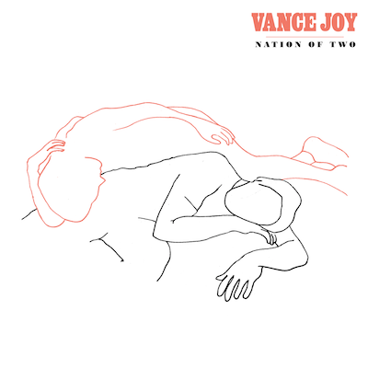

LISTEN/POST “SATURDAY SUN”: https://youtu.be/3175ZqIvvEE
BUY/STREAM “SATURDAY SUN” + PRE-ORDER NATION OF TWO: https://lnk.to/NationOfTwo
HI RES IMAGES (PHOTO AND ALBUM ART): http://press.atlanticrecords.com/vance-joy/

Multi-platinum Australian singer/songwriter Vance Joy has today released “Saturday Sun,” the fourth track to be unveiled off his highly-anticipated sophomore album Nation of Two. The song was premiered this morning as a Zane Lowe World Record via Lowe’s Beats 1 broadcast – reaching over 100 countries worldwide. Listen to Vance Joy’s accompanying interview with Zane Lowe here: https://apple.co/_VanceJoy
“Saturday Sun” follows the success of the recently released “We’re Going Home,” which came accompanied by an official music video (here) directed by frequent Vance Joy collaborator Mimi Cave (Sylvan Esso, tUnE-yArDs, Jim James).

“We’re Going Home” followed fan favorite “Like Gold” and the alternative hit single “Lay It On Me” as the third song available to fans from the forthcoming album Nation of Two. To date, the three released tracks from the album have already been streamed over 70 million times worldwide.

Along with the official video for “We’re Going Home,” Vance Joy revealed the release date, album cover art (above) and tracklisting (below) for the album, as well as a stunning Rolling Stone Australia cover story.

Nation of Two marks the follow-up to Vance Joy’s RIAA platinum certified worldwide breakthrough album, 2014’s dream your life away. Featuring 13 new songs, Nation of Two features tales of love and longing anchored by Vance Joy’s delicate storytelling, masterful instrumentation, and compelling vocals.

“Nation of Two describes a perfectly self-contained couple,” said Vance Joy, who also illustrated the album’s cover artwork. “Their world beginning and ending at the bed they share, the car they ride in, or any other place where they're together…the idea that their love for each other gives them their bearings; a point of reference that makes sense of life.”

2018 will bring another batch of high-profile festival performances for the artist, including the Coachella Valley Music & Arts Festival and Shaky Knees. Last year Vance Joy became a fixture on the international festival circuit, performing at New York City’s Panorama, Chicago’s Lollapalooza, San Francisco’s Outside Lands, the Austin City Limits Music Festival, and Montreal’s Osheaga Festival.

“Lay It On Me,” the first single from Nation of Two, was the Most Added song at both Alternative and Triple A radio outlets for the first two weeks after its release and rose to #3 at Alternative radio in the US, having previously spent four weeks at #1 at the Triple A format. The track is now crossing to the Hot AC format. Vance Joy performed the song last fall on “Jimmy Kimmel Live!”

Vance Joy’s debut album dream your life away recently surpassed one million in consumption in the U.S. alone, with hit singles “fire and the flood” and “Georgia” both now certified Gold. The album also featured the Platinum certified “Mess Is Mine” and the 4x Platinum blockbuster hit, “Riptide.” Based on the success of those songs, Vance Joy was the #1 Most Played artist at Alternative radio in 2015. The singer/songwriter has built a massive global following and has surpassed one billion cumulative streams across platforms.

For more, please see:
http://vancejoy.com
www.facebook.com/Vancejoy
http://twitter.com/vancejoy
https://www.instagram.com/vancejoy/
https://www.youtube.com/user/vancejoymusic
www.atlanticrecords.com

Contact:

Chelsey Northern
Chelsey.Northern@atlanticrecords.com
818-238-6832

Elizabeth Kober
Elizabeth.Kober@atlanticrecords.com
212-707-2562

VANCE JOY
Nation Of Two
Release Date: February 23rd

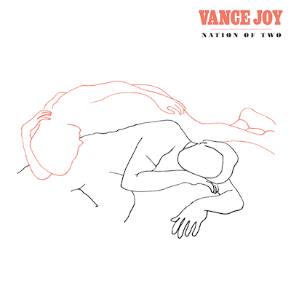

Track Listing

- Call if You Need Me
- Lay It On Me
- We’re Going Home
- Saturday Sun
- Take Your Time
- I’m With You
- Like Gold
- Alone With Me
- Crashing Into You
- One Of These Days
- Little Boy
- Bonnie & Clyde
- Where We Start
# # #

