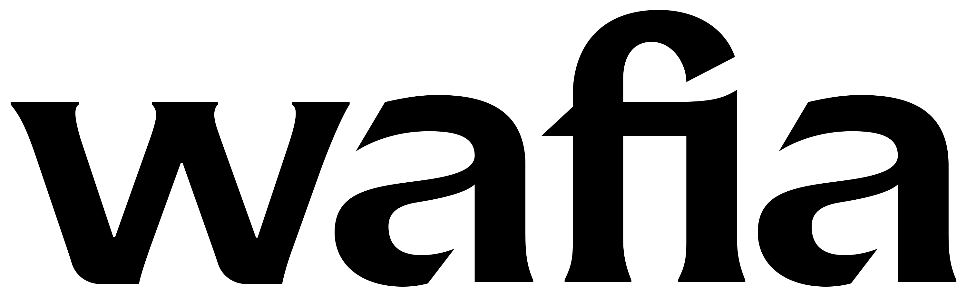
For L.A.-based singer/songwriter Wafia, the possibilities in pop music go way beyond escapism. Since breaking through as a featured vocalist on Louis the Child’s gold-certified smash “Better Not,” the Iraqi-Syrian, queer-identifying artist has brought a deep sense of purpose to her kaleidoscopic dance-pop, turning each track into a powerful conduit for self-discovery. On her new EP Good Things, Wafia shares her most impactful body of work yet, boldly detailing the end of a bad relationship and the life-changing transformation that followed.

“For a long time I thought that when you love someone, you love them unconditionally and put up with however they treat you,” says Wafia. “At some point I realized I was preaching positivity and self-empowerment in my music, but I wasn’t always making those decisions in my own life. I felt like I owed it to myself and to my audience to become a better version of myself.”

Made with producers like John Hill (Portugal. The Man, Demi Lovato) and Sammy Witte (Harry Styles, Jessie Ware), Good Things unfolds with a raw vulnerability that comes from processing her breakup in real time. The effervescent single “Pick Me,” for instance, took shape from a particularly illuminating heart-to-heart with co-writer Caroline Ailin (Dua Lipa, Selena Gomez). “There’s a phrase I started saying to myself around the time of the breakup: ‘I would pick me every time,’” Wafia explains. “I was talking to Caroline about how that had become like a mantra to me, and so we decided to turn it into a song.” With its kinetic piano melody and brightly dizzying beats, “Pick Me” ultimately makes for an anthem of self-celebration, every line lit up in Wafia’s airy but potent vocal work. “I love how you hear the title and assume it’s going to be a love song for someone else, but really it’s a song for yourself,” she notes.

Not only a major breakthrough in her emotional growth, Good Things marks a profound evolution in Wafia’s sound, a journey that began with the making of the EP’s shapeshifting lead single “Flowers & Superpowers.” Produced by Rogét Chahayed (Travis Scott, DRAM) and Grammy Award-winner Hit-Boy (Beyoncé, Jay-Z & Kanye West), “Flowers & Superpowers” finds Wafia elegantly merging elements of R&B and alt-pop and even country, dreaming up a gorgeously textured backdrop to her tale of a bad edible trip. “Ever since we wrote that song, I’ve felt like I have a much stronger understanding of the direction I want to go in,” she says. “It’s like a perfect marriage of all my influences and everything I want to bring to my music.”

Along with spotlighting Wafia’s prismatic sensibilities—informed by artists as eclectic as Marvin Gaye and Shania Twain and Arab pop stars like Nancy Ajram—Good Things reveals her gift for inhabiting so many moods within a single song, a factor that makes brilliant use of her stunning vocal range. On “Hurricane,” for instance, Wafia drifts from frustration to longing to self-assured resolve as she muses on the havoc wrought by toxic masculinity. “My ex was a producer and wanted to be in the session the day we wrote ‘Hurricane,’ but I told him there were too many people in the room,” she recalls. “He took that as a personal attack, and told me later that I would’ve written a better song if he’d been there. It made it very clear that he could only love me if there was something in it for him, which was a huge turning point for me.”

Elsewhere on Good Things, Wafia explores everything from the self-doubt that comes with being broke and aimless (on “Butterflies,” a sweetly weary slow-burner) to the irresistible thrill in rising above those who try to keep you down (on the EP’s disco-ready title track). And on “Lose a Friend,” Wafia offers up a beautifully melancholy ballad about the demise of a close friendship. “It’s so strange how there really isn’t a word for a friend breakup, because to me it’s almost more painful than a romantic breakup,” says Wafia. “Out of all these songs that one’s the hardest to talk about, because I’m still trying to figure out what went wrong.”

As Wafia points out, the emotional realism of Good Things traces back to her longtime habit of carefully tracking her moods and mindset. “I have a Notes folder on my phone where I keep a very stream-of-consciousness record of how I’m feeling—so now I’ve got this giant document of every feeling I’ve ever felt for the last five years,” she says. “When I’m going in to write a song, I’ll look through that and try to dissect things a little further, and figure out what the takeaway might be. Reflection is a very big part of my songwriting process.”

Born in the Netherlands, Wafia first began setting her emotional outpouring to melody at age 12. After moving around for most of her childhood—living all over Europe and in New Zealand—her family eventually settled in Australia, where she took up guitar and started booking solo gigs in high school. Although she later studied biomedicine at college, with plans of becoming a doctor, Wafia soon felt an undeniable urge to return to music. “Halfway through my first year I realized, ‘I’ve got to start writing again,’” she says. Mining inspiration from indie-folk acts like Bon Iver, she began playing acoustic sets in local cafés and posting her performances on Tumblr, quickly building a loyal following online. When her 2014 single “Let Me Love You” amassed over five million streams on SoundCloud, Wafia left school and put out a series of independent releases. On the heels of her 2018 EP VIII—a six-song effort featuring her heartrending single “Bodies,” written the day her Syrian family members were denied refugee status for entrance into Australia—Wafia joined forces with Louis the Child for “Better Not” and next teamed up with Wrabel for “I’m Good” (a viral hit that landed at #14 on Triple J’s Hottest 100 of 2018). As she continued collaborating with in-demand producers, Wafia signed to Atlantic Records/Rodeo Records, making her label debut with “Flowers & Superpowers” in fall 2019.

With her first full-length due out soon, Wafia hopes that Good Things might instill her audience with the same sense of strength she found in creating the EP. “Even though these songs are about falling in love with someone who wasn’t good for me, they’re also about the beauty of coming out of that, and learning how to love yourself,” she says. “It would mean so much to me if they could help people to know that they have value, and to feel more comfortable in their skin. I always want my music to leave people feeling better about themselves than they did before.”

