FOR IMMEDIATE RELEASE
AUGUST 21, 2020

WAFIA RELEASES GOOD THINGS EP

BOUNDARY-BREAKING INDIE-POP RISING STAR RELEASES GOOD THINGS EP

UPLIFTING AND TRANSFORMATIVE BODY OF WORK FEATURES NEW SINGLE “GOOD THINGS”

TITLE TRACK’S BUBBLY AND COLORFUL VIDEO STREAMING NOW HERE

LISTEN TO GOOD THINGS HERE
WATCH THE “GOOD THINGS” VIDEO HERE
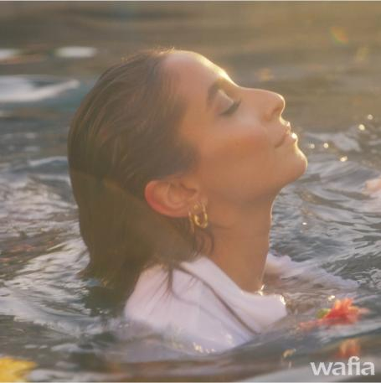
DOWNLOAD ART HERE

“Her music reflects her intersectionality as a globe-trotting queer Arab Muslim woman, delving into identity, sexuality, politics and, of course, love.”
-VOGUE

“Armed with a euphonious voice and a penchant for brooding synths, you know she's the real deal.”
-NYLON

“Vulnerability and transparency is what makes Wafia's music so powerful…”
-i-D

Your feel-good, self-love dance party playlist has arrived! The trailblazing, RIAA-Certified Gold singer-songwriter, Wafia, has released her most impactful body of work yet; Good Things is available now HERE. Recently named one of VOGUE’s “New LGBTQ+ Musicians to Listen to Now,” the new project sees Wafia boldly detail the end of a bad relationship and the life-changing transformation that followed.

“I shed a lot of heaviness in the last year, friendships and relationships that didn’t serve me any longer,” Wafia shares. “I grieved a lot and some days I still do but anything difficult comes with an opportunity for something better. This EP is about that.”

The EP features the rising star’s newest single, “Good Things.” The upbeat and glistening bop offers us the much-needed reminder that despite hard times, we all have got good things goin on! The track arrives today with a bubbly, 90s inspired video. The video, led by an all-female crew and directed by Ashley Tsai, features Wafia and some of her best girl friends. Check out the colorful and mood-boosting video on Wafia’s official YouTube channel HERE.

“This song to me is a celebration of all the good that comes your way when you make the space for it,” Wafia says about “Good Things.” “I think everyone at one point has had someone tell them they can’t do something and that makes for great fuel, it always feels good to prove someone wrong.

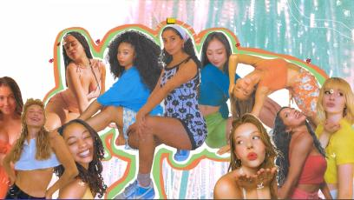

About the video, Wafia said, “Putting this video together with so many incredible women was so much fun. I was very much inspired by all the scrapbooking my little sister Ruaa had done for the ‘Pick Me’ lyric video so I knew we had to take it further into this the ‘Good Things’ world.”

Good Things is highlighted by lead single “Pick Me,” which Elton John featured on his Rocket Hour radio show earlier this month. Elton John hailed the track as “great” and was not alone in praising the song. NYLON echoed John calling the single a “playful bop about keeping your priorities straight” and Teen Vogue stated “It's bright, it's groovy, and it's definitely going to put you in a good mood.”

The project also includes previously release singles “Hurricane,” which premiered on Triple J in Australia last month, the euphoric track “Flowers & Superpowers,” which Refinery 29 praised as having the power to “put you in your own good place,” as well as the new track “Butterflies” which Wafia performed at Lollapalooza’s virtual festival earlier this month.

Despite current physical distance, Wafia has been collaborating and creating with her friends more than ever. For the feel-good “Pick Me” video, the indie-pop star tapped a group of her friends and influencers for a virtual dance party visual, and the whimsical single artwork for both “Pick Me” and “Hurricane” were created by fellow recording artist Lil Halima. Wafia also tapped her sister for the colorful and vibrant “Pick Me” lyric video. Additionally, earlier this week Wafia hosted a “Good Things Virtual Party” to celebrate the EP release and give her fans a sneak peek at the “Good Things” music video as well as talk about the project and lead fans through a yoga session alongside some of her best friends.

The new EP follows the release of an impressive string of singles including Hurts (Feat. Louis the Child & Whethan),” “I’m Good,” and her smash hit collaboration with Louis the Child “Better Not (Feat. Wafia).”

Good Things Tracklist:
1. Hurricane
2. Pick Me
3. Butterflies
4. Flowers & Superpowers
5. Good Things
6. How To Lose A Friend

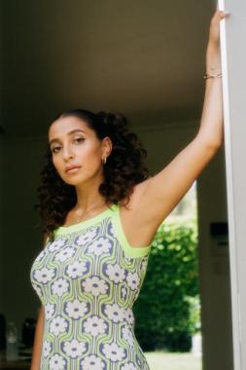
*Download high-res artwork and press images*

ABOUT WAFIA:
For Australia-raised, L.A.-based singer/songwriter Wafia, the possibilities in pop music go way beyond escapism. Since breaking through as a featured vocalist on Louis the Child’s gold-certified smash “Better Not,” the Iraqi-Syrian, queer-identifying artist has brought a deep sense of purpose to her kaleidoscopic dance-pop, turning each track into a powerful conduit for self-discovery. With over 300 million worldwide streams, and widespread acclaim from the likes of VOGUE, Billboard, W, LADYGUNN, NPR, PAPER, and more, Wafia is keenly aware of her position in life and is committed to empowering marginalized communities, at home and abroad, while also helping women of all shapes, sizes, and nationalities find themselves in her music. Through her unique art is distinctly personal, Wafia firmly believes creative gifts are meant to be shared and is passionately determined to create a positive environment that says all are welcome here.

WHAT CRITICS ARE SAYING ABOUT WAFIA

“Wafia’s sound is tinged with a specific kind of magic that’s been missing from the world as of late, the kind you find dancing the night away in a room full of strangers…The queer Iraqi-Syrian musician’s music was meant for a dance floor.”
-LADYGUNN

“It's bright, it's groovy, and it's definitely going to put you in a good mood.”
-TEEN VOGUE

“Wafia turns in a sparkling, happy take that sounds like the way you feel when your ex doesn't have any power over you anymore.”
-REFINERY 29

CONNECT WITH WAFIA
OFFICIAL
FACEBOOK
YOUTUBE
TWITTER
INSTAGRAM

For press inquiries, please contact:
Kelly McWilliam // Kelly.McWilliam@atlanticrecords.com
Jessica Nall // Jessica.Nall@atlanticrecords.com

