FOR IMMEDIATE RELEASE
SEPTEMBER 2, 2020

WAFIA TAPS R3HAB FOR “GOOD THINGS” REMIX

BOUNDARY-BREAKING INDIE-POP RISING STAR TEAMS UP WITH
FELLOW NETHERLANDS-BORN, ARAB ARTIST, CHART-TOPPING DJ R3HAB

TITLE TRACK OFF NEW GOOD THINGS EP GETS HIGH ENERGY REMIX

LISTEN TO “GOOD THINGS (R3HAB REMIX) HERE
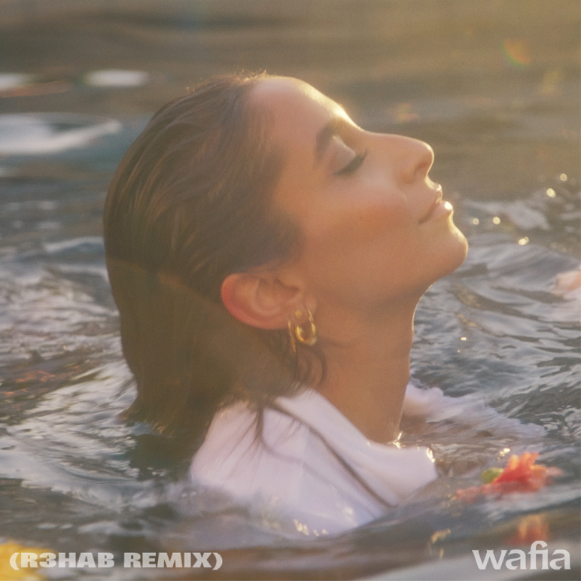
DOWNLOAD ART HERE

Trailblazing, RIAA-Certified Gold singer-songwriter, Wafia, has teamed up with fellow Netherlands-born, Arab artist R3HAB for an incredible rework of her latest single “Good Things” – listen to the remix HERE. The original track, an upbeat and glistening bop, arrived last month and reminded us that despite hard times, we all have got good things goin on! Chart-topping DJ R3HAB took the incredible track and made it into an irresistible, dance-floor ready banger.

Wafia shared about the remix, "I’ve been a big fan of R3HAB for a while now and I’m so excited to have him hop on this remix."

Recently named one of VOGUE’s “New LGBTQ+ Musicians to Listen to Now” and Billboard Pride’s artist of the month, Wafia is showing no signs of slowing down! Last month she released her transformative Good Things EP, highlighted by the title track as well as the lead single “Pick Me,” which Elton John hailed as “great” and featured the track on his Rocket Hour radio show, “Hurricane,” which premiered on Triple J in Australia and “Butterflies” which Wafia performed at Lollapalooza’s virtual festival last month.

Good Things was met with immediate critical acclaim with Billboard saying “[on] 'Good Things,' Wafia is showcasing her classic songwriting along with a willingness to get weird," LADYGUNN hailing “Wafia is a badass…Good Things is all around feel good and each song features its own unique instrumentation…The EP is the diary of a breakup and self-discovery” and Refinery 29 stating “Rather than seeing the glass half empty, Wafia prefers to look at the bright side, happily counting blessing after blessing in ‘Good Things.’ We could all take a page out of her book and engage in some gratitude in these tumultuous times.”

The original track, arrived with the EP and was accompanied by a bubbly, 90s inspired video. The video, led by an all-female crew and directed by Ashley Tsai, features Wafia and some of her best girl friends. Check out the colorful and mood-boosting video on Wafia’s official YouTube channel HERE.

“This song to me is a celebration of all the good that comes your way when you make the space for it,” Wafia says about “Good Things.” “I think everyone at one point has had someone tell them they can’t do something and that makes for great fuel, it always feels good to prove someone wrong.

The new EP follows the release of an impressive string of singles including Hurts (Feat. Louis the Child & Whethan),” “I’m Good,” and her smash hit collaboration with Louis the Child “Better Not (Feat. Wafia).”

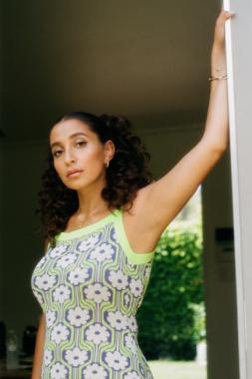
*Download high-res artwork and press images*

ABOUT WAFIA:
For Australia-raised, L.A.-based singer/songwriter Wafia, the possibilities in pop music go way beyond escapism. Since breaking through as a featured vocalist on Louis the Child’s gold-certified smash “Better Not,” the Iraqi-Syrian, queer-identifying artist has brought a deep sense of purpose to her kaleidoscopic dance-pop, turning each track into a powerful conduit for self-discovery. With over 300 million worldwide streams, and widespread acclaim from the likes of VOGUE, Billboard, W, LADYGUNN, NPR, PAPER, and more, Wafia is keenly aware of her position in life and is committed to empowering marginalized communities, at home and abroad, while also helping women of all shapes, sizes, and nationalities find themselves in her music. Through her unique art is distinctly personal, Wafia firmly believes creative gifts are meant to be shared and is passionately determined to create a positive environment that says all are welcome here.

WHAT CRITICS ARE SAYING ABOUT WAFIA

“Her music reflects her intersectionality as a globe-trotting queer Arab Muslim woman, delving into identity, sexuality, politics and, of course, love.”
-VOGUE

“The 27-year-old pop singer found fame thanks to her intentional pop stylings — now on her major label debut project 'Good Things,' Wafia is showcasing her classic songwriting along with a willingness to get weird."
-BILLBOARD

“Armed with a euphonious voice and a penchant for brooding synths, you know she's the real deal.”
-NYLON

“Vulnerability and transparency is what makes Wafia's music so powerful…”
-i-D

“Wafia’s sound is tinged with a specific kind of magic that’s been missing from the world as of late, the kind you find dancing the night away in a room full of strangers…The queer Iraqi-Syrian musician’s music was meant for a dance floor.”
-LADYGUNN

“It's bright, it's groovy, and it's definitely going to put you in a good mood.”
-TEEN VOGUE

“Wafia turns in a sparkling, happy take that sounds like the way you feel when your ex doesn't have any power over you anymore.”
-REFINERY 29

“Wafia’s kindness radiates throughout her voice and her music”
-AMERICAN SONGWRITER

CONNECT WITH WAFIA
OFFICIAL
FACEBOOK
YOUTUBE
TWITTER
INSTAGRAM

For press inquiries, please contact:
Kelly McWilliam // Kelly.McWilliam@atlanticrecords.com
Jessica Nall // Jessica.Nall@atlanticrecords.com

