FOR IMMEDIATE RELEASE
JULY 8, 2020

WAFIA ANNOUNCES GOOD THINGS EP + UNLEASHES NEW TRACK “HURRICANE”

BOUNDARY-BREAKING MUSLIM, QUEER, INDIE-POP RISING STAR ANNOUNCES
GOOD THINGS EP; OUT FRIDAY, AUGUST 21

UPBEAT NEW TRACK “HURRICANE” OUT NOW;
WATCH THE TOUCING NEW HOMEMADE LYRIC VIDEO HERE

LISTEN TO “HURRICANE” HERE
WATCH THE LYRIC VIDEO HERE
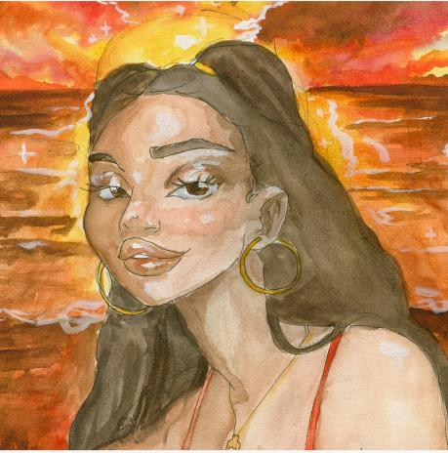
*Download single art here*

Trailblazing, RIAA-Certified Gold singer-songwriter, Wafia, has announced her upcoming Good Things EP, out Friday, August 21. The EP will include the irresistibly catchy track “Hurricane,” which premiered today on Triple J in Australia and is available everywhere HERE, as well as lead single “Pick Me” which was hailed as a “playful bop about keeping your priorities straight” by NYLON. Recently named one of VOGUE’s “New LGBTQ+ Musicians to Listen to Now”, Wafia has also released a touching homemade lyric video for “Hurricane,” created from Wafia’s personal videos documenting her time in quarantine. In the new visual, Wafia surprises her friends and spreads much needed positivity to her loved ones – watch the uplifting video on Wafia’s official YouTube channel HERE.

“When you go through a tough break up, there are a lot of secondary losses that can come with it too - you & your ex’s mutual friends, their family, the community you built together and last year I lost all of that,” Wafia shares. “I took a lot of time to reflect and I realised I had so many incredible people around me of my own that were there and they were constants. This song to me is about my friendship with them and celebrates them. I spent a day recently driving around LA delivering some of those people flowers and cakes I baked which I filmed and then turned into a little lyric video.”

Earlier this year, the rising indie-pop star released the sunny and lovable track, “Pick Me.” Shortly after its release, Wafia tapped a group of her friends and influencers for a virtual dance party visual, which premiered via Refinery 29. The outlet praised the video as “shift[ing] the narrative towards what happens when Wafia chooses herself in the end. Freed from the restraints of a failed love story, she celebrates the new chapter of her life with the people who helped her get there — her friends…”

Despite current physical distance, Wafia has been collaborating and creating with her friends more than ever. The whimsical single artwork for both “Pick Me” and “Hurricane” were created by fellow recording artist Lil Halima. Wafia also tapped her sister for the colorful and vibrant “Pick Me” lyric video -- watch the handmade visual HERE. Wafia has been joining her friends, including singer/songwriter Wrabel and director/photographer Alexandra Gavillet on her Instagram livestreams, for hilarious and entertaining segments called “Wafia learns something.”

The latest singles follow the release of her euphoric track “Flowers & Superpowers,” Hurts (Feat. Louis the Child & Whethan),” “I’m Good,” and her smash hit collaboration with Louis the Child “Better Not (Feat. Wafia).”

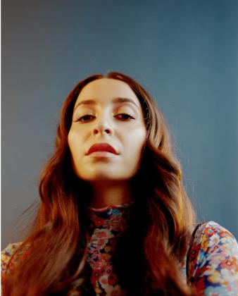
*Download high-res artwork and press images*

ABOUT WAFIA:
Hailed by VOGUE as “the 24-year-old, Muslim, Iraqi-Syrian, queer artist that is single-handedly shaking up the music industry with her ‘purposeful pop,’” Wafia has made waves for magnifying identifiable and idiosyncratic experiences in the form of alternative electro anthems rich with keen observation and lyrical power. With over 300 million worldwide streams, and widespread acclaim from the likes of W, LADYGUNN, NPR, PAPER, Teen Vogue, and more, Wafia is keenly aware of her position in life and is committed to empowering marginalized communities, at home and abroad, while also helping women of all shapes, sizes, and nationalities find themselves in her music. Through her unique art is distinctly personal, Wafia firmly believes creative gifts are meant to be shared and is passionately determined to create a positive environment that says all are welcome here.

WHAT CRITICS ARE SAYING ABOUT WAFIA

“Her music reflects her intersectionality as a globe-trotting queer Arab Muslim woman, delving into identity, sexuality, politics and, of course, love.”
-VOGUE

“Armed with a euphonious voice and a penchant for brooding synths, you know she's the real deal.”
-NYLON

“Vulnerability and transparency is what makes Wafia's music so powerful…”
-i-D

“Wafia’s sound is tinged with a specific kind of magic that’s been missing from the world as of late, the kind you find dancing the night away in a room full of strangers…The queer Iraqi-Syrian musician’s music was meant for a dance floor.”
-LADYGUNN

“It's bright, it's groovy, and it's definitely going to put you in a good mood.”
-TEEN VOGUE

“Wafia turns in a sparkling, happy take that sounds like the way you feel when your ex doesn't have any power over you anymore.”
-REFINERY 29

CONNECT WITH WAFIA
OFFICIAL
FACEBOOK
YOUTUBE
TWITTER
INSTAGRAM

For press inquiries, please contact:
Kelly McWilliam // Kelly.McWilliam@atlanticrecords.com
Jessica Nall // Jessica.Nall@atlanticrecords.com

