FOR IMMEDIATE RELEASE
MAY 5, 2020

WAFIA CHOOSES HERSELF ON NEW TRACK “PICK ME”

BOUNDARY-BREAKING MUSLIM, QUEER, INDIE-POP DARLING
RELEASES NEW SELF-LOVE ANTHEM

RISING SINGER-SONGWRITER TEAMS UP WITH HER SISTER TO CREATE AN AT-HOME LYRIC VIDEO

LISTEN TO “PICK ME” HERE
WATCH THE LYRIC VIDEO HERE
“I Pick Me…Every Day, Every Night, Every single week…I Pick Me”
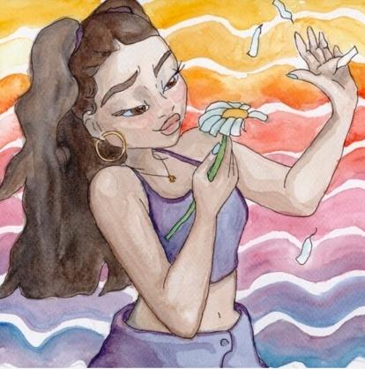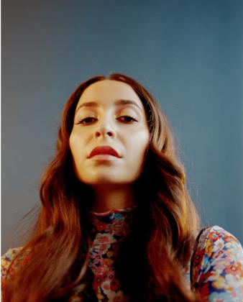
*Download high-res artwork*

Trailblazing, RIAA-Certified Gold singer-songwriter Wafia has released her eagerly-awaited, feel-good new single “Pick Me,” available now on all DSPs and streaming services HERE via Atlantic Records/Rodeo Records. The sunny and lovable track is the perfect addition to your go-to, feel-good playlist that has kept you going throughout quarantine! In spite of current physical distance, Wafia is collaborating and creating with her friends more than ever. The single arrives alongside whimsical artwork made by fellow recording artist Lil Halima as well as a colorful and vibrant lyric video created by her sister -- Watch the handmade lyric video HERE.

Wafia has also been joining her friends, including singer/songwriter Wrabel and director/photographer Alexandra Gavillet on her Instagram livestreams, for hilarious and entertaining segments called “Wafia learns something.” The rising singer has also tapped a group of her friends and influencers for the official “Pick Me” video, out soon.

The self-empowerment anthem was produced by John Hill (Portugal. The Man, Demi Lovato, Foster The People) and Chong The Nomad and written by Caroline Ailin (Dua Lipa, Katy Perry, Selena Gomez.), Chong The Nomad and Wafia.

“I wrote this song with Caroline Ailin after coming out of a bad relationship last year,” shares Wafia. “The break up period dragged out way more than it needed to but in all of our angry calls and texts I came to see how much he resented me and my career. The version of me he wanted was meek, obedient, not muslim and a lot less ambitious. We worked on my music together but the better my music would do, the tighter he’d hold on. This song really isn’t about him though. There was a version of me that existed last year that was really almost prepared to be what he wanted just to stop the fights and the yelling. I’m not proud of that. Then I caught a glimpse of what that would look like 20 or even 5 years down the track and I knew how miserable and resentful I’d be. I didn’t want that for him but most of all for myself. Love shouldn’t make you pick like that and if it does, it’s not the right one.”

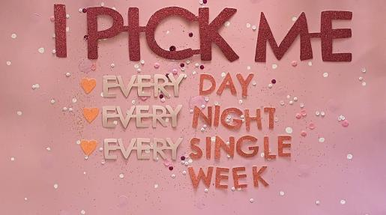

“Pick Me” follows the release of her Atlantic Records/Rodeo Records debut “Flowers & Superpowers.” The track was produced by GRAMMY® Award-nominee Rogét Chahayed (Travis Scott, DRAM, Louis the Child) & GRAMMY® Award-winner Hit-Boy (Travis Scott, Beyoncé, Jay-Z & Kanye West) and was co-written by Wafia and Wrabel, with whom she previously collaborated on the 2018 hit, “I’m Good.”

“Flowers” received an intoxicating remix by Australian DJ/Producer Kito. Kito has delivered official remixes for superstars such as Beyoncé, Trinidad James, Jorja Smith, and more. Wafia unveiled the original track last month as well as a dreamy, kaleidoscopic companion visual – directed by filmmaker/photographer Alexandra Gavillet – Watch it HERE.

ABOUT WAFIA:
Hailed by VOGUE as “the 24-year-old, Muslim, Iraqi-Syrian, queer artist that is single-handedly shaking up the music industry with her ‘purposeful pop,’” Wafia has made waves for magnifying identifiable and idiosyncratic experiences in the form of alternative electro anthems rich with keen observation and lyrical power. She first arrived with an initial series of independent releases and collaborations but truly captured the world’s attention with her featured role on Louis the Child’s 2018 smash, “Better Not (Feat. Wafia).” The RIAA gold-certified track earned worldwide streams in excess of 200 million along with widespread acclaim from the likes of W, Idolator, Ladygunn, NPR, Wonderland, i-D, and more.

Now based in Los Angeles, after growing up in Australia, Wafia quickly followed up with her own “I’m Good,” drawing millions of worldwide streams as well as further applause from The FADER, which wrote, “Produced by John Hill and co-written with Wrabel, (‘I’m Good’ is) built around a pulsing beat and shimmery instrumentation that, together, sound like a moment of self-confident clarity.” “I’m Good” is “a perfect song,” declared Refinery 29. “The groove…is truly second to none, and paired with (Wafia’s) airy vocals, it makes for a next-level conception on a classic genre of song.”
“Flowers & Superpowers” followed Wafia’s recently released Atlantic Records debut single, “Hurts (Feat. Louis the Child & Whethan),” available now at all DSPs and streaming services. The bouncy, euphoric track is joined by a stunning companion video, directed by Chicago-based filmmaker collective, Weird Life Films (Laura Gordon, Mike Monachos, Ryan Ohm and Jackson James). The track drew applause from such high-profile media outlets as Billboard, which declared it “a fresh pop tune,” adding, “’Hurts’ puts Wafia's sweetheart vocals over a thumping bass beat, shimmering R&B textures and a woobly hook.”
With over 300 million worldwide streams to her name thus far, Wafia is keenly aware of her position in life and is committed to empowering marginalized communities, at home and abroad, while also helping women of all shapes, sizes, and nationalities find themselves in her music. Through her unique art is distinctly personal, Wafia firmly believes creative gifts are meant to be shared and is passionately determined to create a positive environment that says all are welcome here.

WHAT CRITICS ARE SAYING ABOUT WAFIA

"Wafia is the Muslim, Iraqi-Syrian, queer artist that is single-handedly shaking up the music industry with her ‘purposeful pop’ – her multi-national identity being at the epicenter of her music.”
-VOGUE

“Armed with a euphonious voice and a penchant for brooding synths, you know she's the real deal…”
-NYLON

“Vulnerability and transparency is what makes Wafia's music so powerful…”
i-D

“She will put you in your own good place…”
-Refinery29

“When she sings, it's as if she's curling her notes around the space she needs to take for herself..”
-PAPER

CONNECT WITH WAFIA
OFFICIAL
FACEBOOK
YOUTUBE
TWITTER
INSTAGRAM

For press inquiries, please contact:
Kelly McWilliam // Kelly.McWilliam@atlanticrecords.com
Jessica Nall // Jessica.Nall@atlanticrecords.com

