FOR IMMEDIATE RELEASE
MAY 15, 2020

WAFIA CONNECTS WITH FRIENDS IN NEW FEEL-GOOD “PICK ME” VIDEO

BOUNDARY-BREAKING MUSLIM, QUEER, INDIE-POP RISING STAR RELEASES
THE OFFICIAL VIDEO FOR HER NEW SELF-LOVE ANTHEM HERE

RISING SINGER-SONGWRITER TEAMS UP WITH HER FRIENDS FOR A
VIRTUAL, MOOD BOOSTING DANCING PARTY

WATCH THE NEW VIDEO HERE
LISTEN TO “PICK ME” HERE
“I Pick Me…Every Day, Every Night, Every single week…I Pick Me”
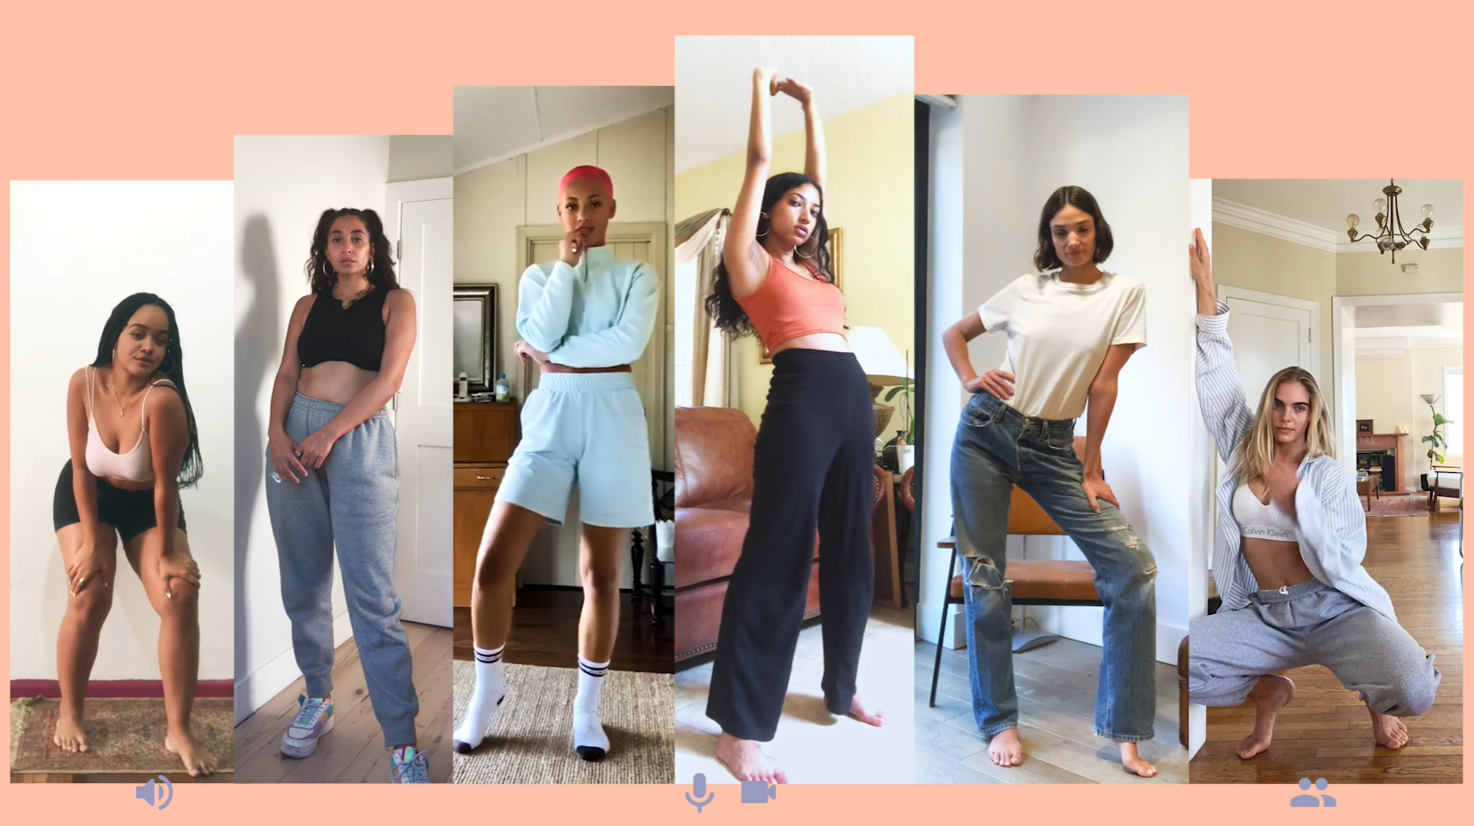

“A playful bop about keeping your priorities straight.” – NYLON

“Wafia turns in a sparkling, happy take that sounds like the way you feel when your ex doesn't have any power over you anymore.” – REFINERY 29

“It's bright, it's groovy, and it's definitely going to put you in a good mood.” – TEEN VOGUE

Last week, trailblazing, RIAA-Certified Gold singer-songwriter Wafia released her sunny and lovable new track, “Pick Me.” Today, the rising singer has released the official video to the living-room-dance-party ready track via Refinery 29 which praised the visual as “shift[ing] the narrative towards what happens when Wafia chooses herself in the end. Freed from the restraints of a failed love story, she celebrates the new chapter of her life with the people who helped her get there — her friends…” Wafia tapped a group of her friends and influencers for a virtual dance party in the adorable new video, streaming now on Wafia’s official YouTube channel HERE.

Despite current physical distance, Wafia has been collaborating and creating with her friends more than ever. The single arrived last week with whimsical artwork made by fellow recording artist Lil Halima as well as a colorful and vibrant lyric video created by her sister -- Watch the handmade lyric video HERE.

Wafia has also been joining her friends, including singer/songwriter Wrabel and director/photographer Alexandra Gavillet on her Instagram livestreams, for hilarious and entertaining segments called “Wafia learns something.”

The self-empowerment anthem was produced by John Hill (Portugal. The Man, Demi Lovato, Foster The People) and Chong The Nomad and written by Caroline Ailin (Dua Lipa, Katy Perry, Selena Gomez.), Chong The Nomad and Wafia.

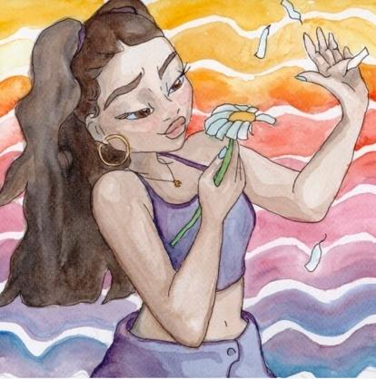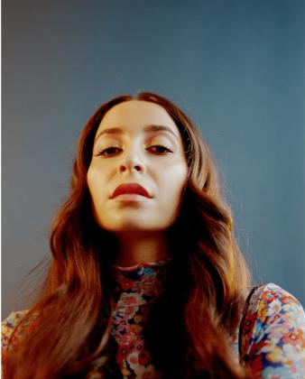
*Download high-res artwork and press images*

CONNECT WITH WAFIA
OFFICIAL
FACEBOOK
YOUTUBE
TWITTER
INSTAGRAM

For press inquiries, please contact:
Kelly McWilliam // Kelly.McWilliam@atlanticrecords.com
Jessica Nall // Jessica.Nall@atlanticrecords.com

