FOR IMMEDIATE RELEASE
JUNE 25, 2021

WAFIA, TA-KU AND MASEGO LIGHT UP THE SUMMER WITH “WIDE OPEN”

BOUNDARY-BREAKING SINGER-SONGWRITER RETURNS WITH STUNNING NEW SINGLE
FEATURING AUSTRALIAN PRODUCER TA-KU AND SOULFUL R&B VOCALIST MASEGO

LISTEN TO “WIDE OPEN” HERE
WATCH THE VIDEO HERE
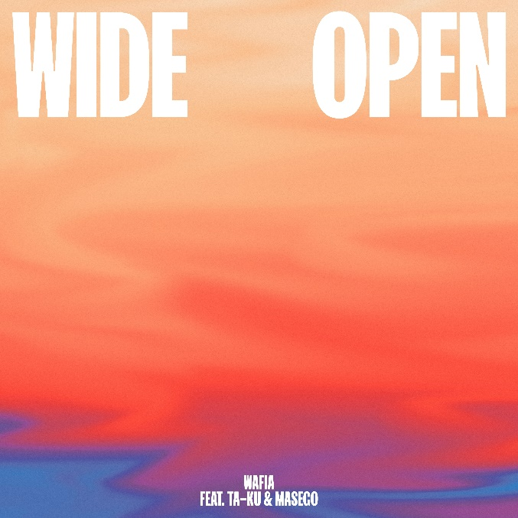
DOWNLOAD ARTWORK HERE

Trailblazing singer-songwriter Wafia has teamed up with Australian beatmaster, and her longtime collaborator, Ta-ku and soulful R&B vocalist Masego for their dazzling summer track, “Wide Open” – available now HERE. The trio also stars in the official companion video, streaming now HERE.

“Ta-Ku and I met Masego in 2016 when we all went on tour around the US together,” Wafia shared. “It was so great to bring them back together for this track, in some ways I think it’s an homage to peak Soundcloud era when we were all doing our things on there.”

“It goes without saying that Wafia has always been an amazing songwriter,” said Ta-Ku. “She's the #1 person who pushed me to use my voice more. So I was honored when she sent me this demo. I'm just honored to be able to connect the dots and bring my biggest inspirations together on a track"
“I met Taku and Wafia at a special time in my life,” Masego recalls. “I got to see what it was like tour and put on an elegant show. We had legendary, spontaneous photo shoots and I’m honored to be on a record with these two.”
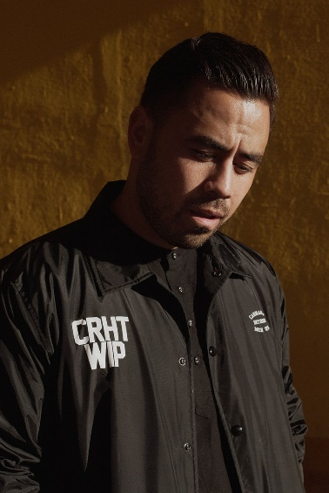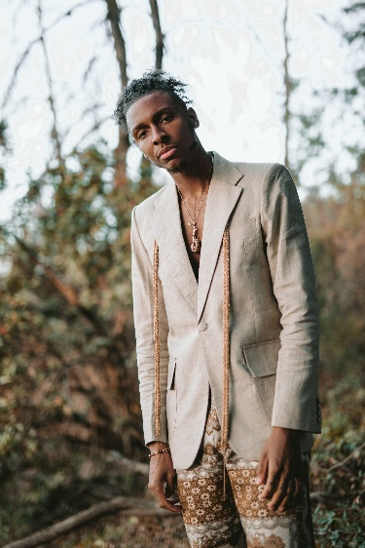
DOWNLOAD PRESS PHOTOS HERE

Named by VOGUE among its “New LGBTQ+ Musicians to Listen to Now” and “Artist of the Month” by Billboard Pride, Wafia is fast proving a groundbreaking, RIAA gold-certified icon. “Wide Open” follows last year’s acclaimed Good Things EP, highlighted by the transformative title track as well as the extraordinary lead single “Pick Me,” the latter hailed as “great” by none other than Sir Elton John and featured on his popular Apple Music radio show, Elton John’s Rocket Hour.

“Wide Open” marks Wafia’s latest collaboration with hit-making producer Ta-Ku. In 2016, the iconic duo released their acclaimed EP (m)edian, which chronicles a story about compromise in relationships. The longtime friends and collaborators celebrated the EP with a stunning performance on NPR’s Tiny Desk – check it out HERE.

Good Things was greeted by with immediate critical acclaim, with Billboard praising Wafia for her “classic songwriting along with a willingness to get weird." “Wafia is a badass,” declared LADYGUNN. “Good Things is all around feel good and each song features its own unique instrumentation.” “Rather than seeing the glass half empty, Wafia prefers to look at the bright side,” wrote Refinery 29, “happily counting blessing after blessing in ‘Good Things.’ We could all take a page out of her book and engage in some gratitude in these tumultuous times.”

ABOUT WAFIA:
Hailed by VOGUE as “the 24-year-old, Muslim, Iraqi-Syrian, queer artist that is single handedly shaking up the music industry with her ‘purposeful pop,’” Wafia first arrived with an initial series of independent releases and collaborations but truly captured the world’s attention with her featured role on Louis the Child’s RIAA gold certified 2018 smash, “Better Not (Feat. Wafia),” now boasting worldwide streams in excess of 200 million and counting.

With over 300 million worldwide streams to her name thus far, Wafia is keenly aware of her position in life and is committed to empowering marginalized communities, at home and abroad, while also helping women of all shapes, sizes, and nationalities find themselves in her music. Though her unique art is distinctly personal, Wafia firmly believes creative gifts are meant to be shared and is passionately determined to create a positive environment that says all are welcome here.

ABOUT TA-KU:
Ta-ku might be the modern day renaissance man. Haven risen to prominence as one of Australia’s most in-demand beatmakers, the Perth-based artist (real name Regan Matthews) has found himself curator of a rapidly expanding, multi-disciplinary creative empire.

From the early ‘Soundcloud Era’ days uploading daily cuts to a clutch of co-writes & production efforts for the likes of Anderson Paak, Flume, Chet Faker, BANKS, Childish Gambino, Wafia, Alina Baraz, Masego, Ty Dolla Sign, Justin Timberlake and more as well as countless self-releases.

This insatiable drive to create is a personal one. Ta-ku now applies it to a diverse range of passion projects that encompass photography, design, creative direction, business & fashion. From being founder & CD of his own creative agency Pretty-Soon, owner of Westons Barbershop in his hometown in Perth to his creative label 823 - a community built on a love for an appreciation to those who inspire you.The common thread for his work is one of collaboration and self-expression, the key to managing these disparate passions is respect.

ABOUT MASEGO
Hailed as a “musical polyglot" by the Los Angeles Times, Masego is a singular talent and surprising presence – a saxophone player, a singer, a rapper, a comedian, a DJ. NPR Musicpraised him as “musical shapeshifter, the creator of a blueprint for a new kind of sound." Lady Lady, Masego’s 2018 debut album, put him on the map. "Tadow," the lead single, has surpassed half a billion global streams and been certified Platinum by the RIAA. Since the album’s release, Masego has toured the world, headlining sold-out tours and starring on festival stages across every continent but Antarctica. Masego and his hit single, “Mystery Lady” feat. Don Toliver, are featured in Apple Music’s new campaign for Spatial Audio.

PRAISE FOR WAFIA:

“Her music reflects her intersectionality as a globe-trotting queer Arab Muslim woman, delving into identity, sexuality, politics and, of course, love.”
-VOGUE

“The 27-year-old pop singer found fame thanks to her intentional pop stylings — now on her major label debut project 'Good Things,' Wafia is showcasing her classic songwriting along with a willingness to get weird."
-BILLBOARD

“Armed with a euphonious voice and a penchant for brooding synths, you know she's the real deal.”
-NYLON

“Vulnerability and transparency is what makes Wafia's music so powerful…”
-i-D

“Wafia’s sound is tinged with a specific kind of magic that’s been missing from the world as of late, the kind you find dancing the night away in a room full of strangers…The queer Iraqi-Syrian musician’s music was meant for a dance floor.”
-LADYGUNN

“It's bright, it's groovy, and it's definitely going to put you in a good mood.”
-TEEN VOGUE

“Wafia turns in a sparkling, happy take that sounds like the way you feel when your ex doesn't have any power over you anymore.”
-REFINERY 29

“Wafia’s kindness radiates throughout her voice and her music”
-AMERICAN SONGWRITER

CONNECT WITH WAFIA
OFFICIAL | FACEBOOK | YOUTUBE | TWITTER| INSTAGRAM

For press inquiries, please contact:
Kelly McWilliam // Kelly.McWilliam@atlanticrecords.com
Jessica Nall // Jessica.Nall@atlanticrecords.com

