WALLOWS ANNOUNCE SOPHOMORE ALBUM
TELL ME THAT IT’S OVER
& RELEASE NEW SINGLE “ESPECIALLY YOU”

THE ARIEL RECHTSHAID-PRODUCED ALBUM TO BE RELEASED MARCH 25TH
PRE-ORDER HERE

WATCH THE “ESPECIALLY YOU” MUSIC VIDEO HERE

ALSO ANNOUNCE UK, EUROPE, AUSTRALIA & NEW ZEALAND TOUR DATES
& NORTH AMERICAN TOUR SUPPORT ARTISTS

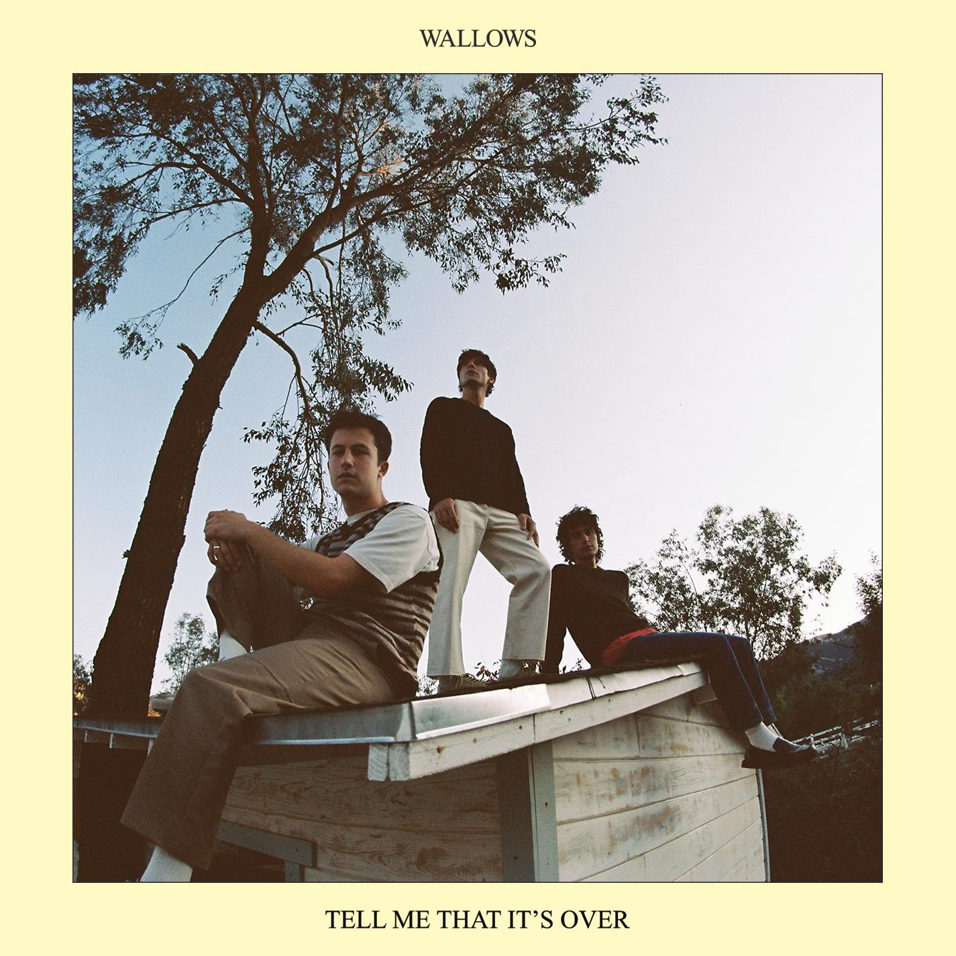
(Album art, DL here)

Ever-evolving band Wallows announce their highly anticipated sophomore album, Tell Me That It’s Over, today and release new single “Especially You” with an accompanying music video directed by Jason Lester. Watch HERE. Tell Me That It’s Over, out March 25th, was produced by the multi-GRAMMY Award winning Ariel Rechtshaid (Vampire Weekend, Haim, Adele) and contains 10 tracks informed by everything from lo-fi post-punk to indie-folk to early-’90s dance-pop psychedelia. See track list below and pre-order the album HERE.

On the meaning behind album single “Especially You” Dylan Minnette says, “It’s about when you’re in the early stages of a relationship and you get so worried that the other person’s mind will change at the flip of a switch. It’s about stressing over the smallest things for no reason, but it’s definitely self-aware about the fact that I’m doing this all to myself.”

TMTIO is a thrilling continuation of the sonic exploration first begun on Wallows’ 2019 album Nothing Happens— one of the highest streamed debuts from any band that year, featuring their platinum-selling single “Are You Bored Yet?” (feat. Clairo). Following their critically acclaimed 2020 EP “Remote,” the band released the first taste of music from their upcoming album with single “I Don’t Want to Talk” in September of 2021.

TELL ME THAT IT’S OVER TRACK LIST
- Hard to Believe
- I Don’t Want to Talk
- Especially You
- At the End of the Day
- Marvelous
- Permanent Price
- Missing Out
- Hurts Me
- That’s What I Get
- Guitar Romantic Search Adventure

TMTIO will be available in several physical formats, as well as digital: white vinyl available exclusively at wallowsmusic.store, a yellow cassette, CD, CD box set with exclusive t-shirt, Urban Outfitters exclusive light blue vinyl, Amazon exclusive orange vinyl, and yellow vinyl available for online pre-order and at your local independent record store. A limited amount of signed yellow vinyl is also available at wallowsmusic.store (while supplies last).

In September, Wallows announced the first part of their 2022 Tell Me That It’s Over tour which begins in Seattle, WA on April 1, 2022 (see full list of dates below). Today the band is pleased to announce UK, Europe, Australia & New Zealand tour dates as well, along with special guests Spill Tab, Jordana, May-A, and Hatchie joining them on the road (full list of support with tour dates below).

Pre-sales for the newly announced dates begin on Tuesday, February 8th at 10am local time with fans who pre-order the new album in the UK, Europe, Australia and New Zealand through wallowsmusic.store by Monday, February 7th at 12pm local time getting first access. All Wallows newsletter subscribers will be able to access pre-sale tickets on Wednesday, February 9th at 10am local time and general on sale is Friday, February 11th at 10am local time. North American tour tickets are already on sale HERE.

A limited number of VIP packages for North American dates and ‘Especially You’ packages for international dates are available as well. For tickets and more information, visit wallowsmusic.com/tour.

TELL ME THAT IT’S OVER TOUR
2022
April 01 – Seattle, WA – The Paramount Theatre * (SOLD OUT)
April 02 – Vancouver, BC – The Orpheum * (SOLD OUT)
April 03 – Portland, OR – McMenamins Crystal Ballroom * (SOLD OUT)
April 04 – Portland, OR – McMenamins Crystal Ballroom * (SOLD OUT)
April 06 – San Francisco, CA – The Warfield * (SOLD OUT)
April 07 – San Francisco, CA – The Warfield * (SOLD OUT)
April 08 – Sacramento, CA – Ace of Spades * (SOLD OUT)
April 10 – Phoenix, AZ – The Van Buren * (SOLD OUT)
April 11 – Albuquerque, NM – Sunshine Theater * (SOLD OUT)
April 12 – Tucson, AZ – Rialto Theatre * (SOLD OUT)
April 16 – Indio, CA – Coachella
April 23 – Indio, CA – Coachella
May 15 – Austin, TX – Stubb’s Waller Creek Amphitheater +
May 16 – Austin, TX – Stubb’s Waller Creek Amphitheater + (SOLD OUT)
May 17 – Dallas, TX – The Factory in Deep Ellum + (MORE TICKETS ADDED)
May 18 – Houston, TX – Lawn at White Oak Music Hall +
May 20 – Atlanta, GA – Coca-Cola Roxy +
May 21 – Atlanta, GA – Tabernacle +
May 23 – Orlando, FL – The Orlando Amphitheater at the Central Florida Fairgrounds +
May 24 – Miami, FL – The Fillmore +
May 26 – St. Petersburg, FL – Jannus Live +
May 27 – St. Augustine, FL – The Saint Augustine Amphitheatre +
May 28 – Columbia, SC – The Senate + (SOLD OUT)
May 29 – Charlotte, NC – The Fillmore + (SOLD OUT)
May 31 – Norfolk, VA – The NorVa * (SOLD OUT)
June 01 – Richmond, VA – The National * (SOLD OUT)
June 03 - Columbus, OH – KEMBA Live! * (MORE TICKETS ADDED)
June 04 – Cleveland, OH – Agora Theatre * (SOLD OUT)
June 06 – Indianapolis, IN – Egyptian Room at Old National Centre * (SOLD OUT)
June 07 – Milwaukee, WI – The Riverside Theater *
June 09 – Kansas City, MO – Arvest Bank Theatre at The Midland *
June 10 – Chesterfield, MO – The Factory at The District * (MORE TICKETS ADDED)
June 11 – Newport, KY – PromoWest Pavilion at OVATION *
June 12 – Pittsburgh, PA – Stage AE *
June 14 – New York, NY – Terminal 5 * (SOLD OUT)
June 15 – New York, NY – Terminal 5 * (SOLD OUT)
June 16 – New York, NY – Terminal 5 *
June 17 – New York, NY – Terminal 5 * (SOLD OUT)
June 19 – Manchester, TN – Bonnaroo Music Festival
June 21 – Washington, DC – The Anthem *
June 22 – Boston, MA – Roadrunner * (SOLD OUT)
June 23 – Philadelphia, PA – The Met *
June 25 – Toronto, ON – HISTORY * (SOLD OUT)
June 26 – Toronto, ON – HISTORY * (SOLD OUT)
June 27 – Detroit, MI – Masonic Temple Theatre *
June 29 – Saint Paul, MN – Palace Theatre *
July 01 – Lincoln, NE – Bourbon Theatre * (SOLD OUT)
July 02 – Denver, CO – Mission Ballroom *
August 26 – Reading, UK – Reading Festival
August 27 – Leeds, UK – Leeds Festival
August 28 – Liverpool, UK – O2 Academy
November 5 – Auckland, NZ – Auckland Town Hall
November 8 – Melbourne, AU – The Forum #
November 10 – Sydney, AU – Enmore Theatre #
November 11 – Brisbane, AU – The Fortitude Music Hall #

2023
January 9 – Dublin, IE – 3Olympia Theatre ^
January 10 – Glasgow, UK – O2 Academy ^
January 11 – Manchester, UK – Academy ^
January 13 – Leeds, UK – Leeds Academy ^
January 14 – Birmingham, UK – O2 Academy ^
January 15 – Bristol, UK – O2 Academy ^
January 17 – Bournemouth, UK – O2 Academy ^
January 18 – London, UK – O2 Academy Brixton ^
January 21 – Utrecht, NL – Tivolivredenburg ^
January 22 – Brussels, BE – Ancienne Belgique ^
January 23 – Paris, FR – La Cigale ^
January 25 – Milan, IT – Magazzini Generali ^
January 26 – Zurich, CH – X-Tra ^
January 27 – Munich, DE – Muffathalle ^
January 29 – Berlin, DE – Astra ^
January 30 – Cologne, DE – Live Music Hall ^
January 31 – Hamburg, DE – Fabrik ^
February 2 – Copenhagen, DK – Vega ^
February 3 – Stockholm, SE – Klubben Fryshuset ^
February 5 – Oslo, NO – Vulkan Arena ^

New dates in BOLD
* w/ Spill Tab
+ w/ Jordana
# w/ Hatchie
^ w/ May-A

Wallows, the Los Angeles-based trio of Dylan Minnette, Braeden Lemasters and Cole Preston, released their acclaimed Atlantic Records debut album, Nothing Happens, in 2019. Produced by GRAMMY® Award-winner John Congleton (St. Vincent, Alvvays, Future Islands) who also produced the band’s 2018 EP Spring, the album quickly became one of the most-streamed debut albums by any band in 2019 and features the breakthrough double platinum single “Are You Bored Yet? (Feat. Clairo),” which has surpassed 674M global streams. 2020 saw Wallows release “OK,” a song that took on a new meaning during the pandemic, and their quarantine-made EP, Remote, as well as being named MTV’s PUSH Artist of the Month for September. Wallows returned in 2021 with brand new single “I Don’t Want to Talk” – a first taste of their sophomore album, Tell Me That It’s Over, and collaboration with producer Ariel Rechtshaid (Vampire Weekend, Haim, Adele) that’s been in the works over the past year. 2022 kicked off with another new single, “Especially You,” and the official announcement that Tell Me That It’s Over will be released on March 25, 2022.

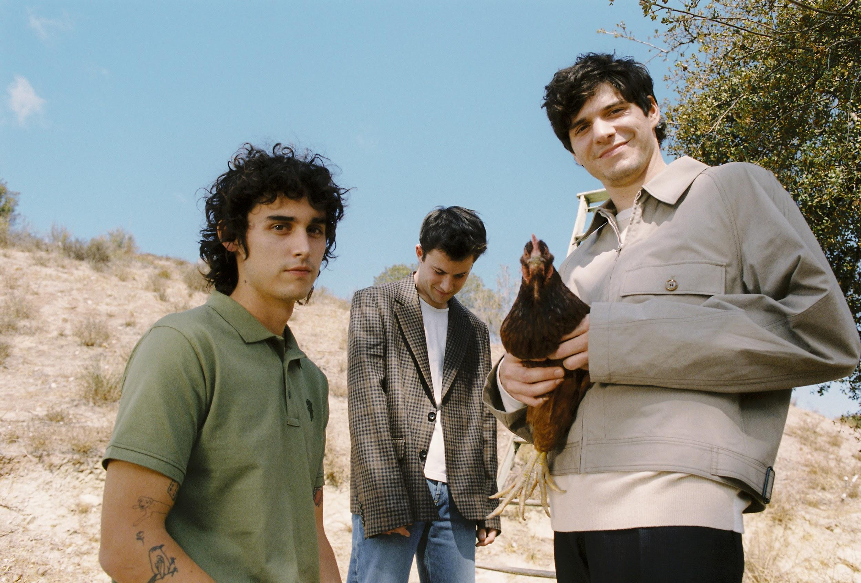
Download photos (Photo Credit: Anthony Pham)

FOR MORE ON WALLOWS, PLEASE VISIT:
WALLOWSMUSIC.COM I FACEBOOK I TWITTER I YOUTUBE I INSTAGRAM | TIK TOK | PRESS SITE

Press contacts: luke@bbgunpress.com | sloan@bbgunpr.com & corey.brewer@atlanticrecords.com | gabrielle.reese@atlanticrecords.com

