WALLOWS RETURN WITH NEW SINGLE “I DON’T WANT TO TALK”

WATCH THE MUSIC VIDEO HERE

2022 NORTH AMERICAN TOUR ANNOUNCED – TICKETS ON SALE FRIDAY OCT 8TH

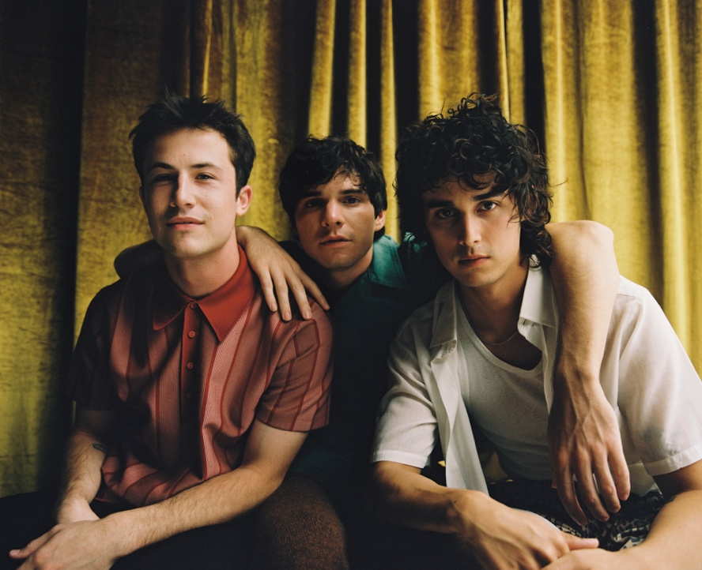
Download photos (Photo Credit: Anthony Pham)

Wallows make a triumphant return today with “I Don’t Want to Talk,” produced by Ariel Rechtshaid (Vampire Weekend, Haim, Adele). The single, their first release since February’s Remote (Deluxe) EP, is accompanied by the Jason Lester-directed official music video – WATCH HERE. “I Don’t Want to Talk” was also featured on Apple’s New Music Daily today- check it out here.

“’I Don’t Want to Talk’ is ultimately a song about insecurities. Not only in yourself, but in this case, particularly in a relationship. It centers around the fear of being away from someone for too long and that ultimately allowing the other person’s head to be turned by someone else, and instead of expressing those fears, completely shutting down and not wanting to talk about it at all.”
–Dylan Minnette

Wallows have also announced the first part of their 2022 Tell Me That It’s Over tour which begins in North America on April 1, 2022 in Seattle, WA (see full list of dates below). Tickets and limited VIP packages go on sale Friday, October 8th at 10am local time. Fans who sign up for Wallows newsletter will have first access to tickets and VIP packages via a special pre-sale starting Tuesday, October 5th at 10am local time and running through Thursday, October 7th at 10pm local time (while supplies last).

VIP packages include early entry to the venue, an exclusive signed poster, tote bag, hat, commemorative VIP laminate, and first access to merchandise. For tickets, more information and to sign up for the newsletter to receive pre-sale access, visit wallowsmusic.com/tour. Additional dates, including international shows, will be announced soon.

TELL ME THAT IT’S OVER TOUR
NORTH AMERICA PART 1

April 01 – Seattle, WA – The Paramount Theatre
April 02 – Vancouver, BC – The Orpheum
April 03 – Portland, OR – McMenamins Crystal Ballroom
April 04 – Portland, OR – McMenamins Crystal Ballroom
April 06 – San Francisco, CA – The Warfield
April 07 – San Francisco, CA – The Warfield
April 08 – Sacramento, CA – Ace of Spades
April 10 – Phoenix, AZ – The Van Buren
April 11 – Albuquerque, NM – Sunshine Theater
April 12 – Tucson, AZ – Rialto Theatre
May 16 – Austin, TX – Stubb’s Waller Creek Amphitheater
May 17 – Dallas, TX – The Factory in Deep Ellum
May 18 – Houston, TX – Lawn at White Oak Music Hall
May 20 – Atlanta, GA – Coca-Cola Roxy
May 23 – Orlando, FL – The Orlando Amphitheater at the Central Florida Fairgrounds
May 24 – Miami, FL – The Fillmore
May 26 – St. Petersburg, FL – Jannus Live
May 27 – St. Augustine, FL – The Saint Augustine Amphitheatre
May 28 – Columbia, SC – The Senate
May 29 – Charlotte, NC – The Fillmore
May 31 – Norfolk, VA – The NorVa
June 01 – Richmond, VA – The National
June 03 - Columbus, OH – Express Live!
June 04 – Cleveland, OH – Agora Theatre
June 06 – Indianapolis, IN – Egyptian Room at Old National Centre
June 07 – Milwaukee, WI – The Riverside Theater
June 09 – Kansas City, MO – Arvest Bank Theatre at The Midland
June 10 – Chesterfield, MO – The Factory at The District
June 11 – Newport, KY – PromoWest Pavilion at OVATION
June 12 – Pittsburgh, PA – Stage AE
June 14 – New York, NY – Terminal 5
June 15 – New York, NY – Terminal 5
June 21 – Washington, DC – The Anthem
June 22 – Boston, MA – To Be Announced
June 23 – Philadelphia, MA – The Met
June 25 – Toronto, ON – HISTORY
June 27 – Detroit, MI – Masonic Temple Theatre
June 29 – Saint Paul, MN – Palace Theatre
July 01 – Lincoln, NE – Bourbon Theatre
July 02 – Denver, CO – Mission Ballroom

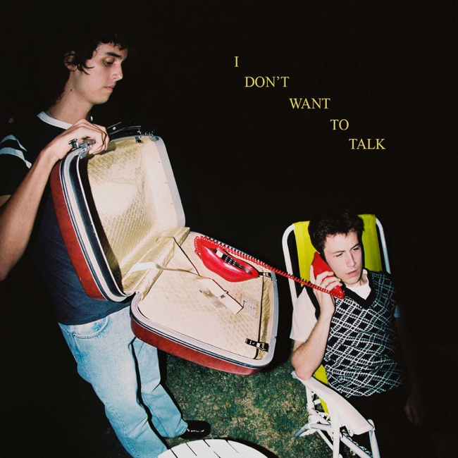
“I Don’t Want to Talk” Single Art (DL here) (Photo Credit: Dillon Matthew)

Wallows, the Los Angeles-based trio of Dylan Minnette, Braeden Lemasters and Cole Preston, released their acclaimed Atlantic Records debut album, Nothing Happens, in 2019. Produced by GRAMMY® Award-winner John Congleton (St. Vincent, Alvvays, Future Islands) who also produced the band’s 2018 EP Spring, the album quickly became one of the most-streamed debut albums by any band in 2019 and features the breakthrough platinum single “Are You Bored Yet? (Feat. Clairo),” which has surpassed 607M global streams. 2020 saw Wallows release “OK,” a song that took on a new meaning during the pandemic, and their quarantine-made EP, Remote, as well as being named MTV’s PUSH Artist of the Month for September. Wallows return in 2021 with brand new single “I Don’t Want to Talk” – a first taste of their collaboration with producer Ariel Rechtshaid (Vampire Weekend, Haim, Adele) that’s been in the works over the past year.

FOR MORE ON WALLOWS, PLEASE VISIT:
WALLOWSMUSIC.COM I FACEBOOK I TWITTER I YOUTUBE I INSTAGRAM | TIK TOK | PRESS SITE

Press contacts: corey.brewer@atlanticrecords.com
gabrielle.reese@atlanticrecords.com

