MURA MASA REMIXES WALLOWS RIAA-CERTIFIED GOLD
SONG OF THE SUMMER “ARE YOU BORED YET? (FEAT CLAIRO)”

LISTEN HERE: https://Wallows.lnk.to/AYBYMM

“ARE YOU BORED YET (FEAT. CLAIRO)” CURRENTLY IN THE TOP 15 ON THE ALTERNATIVE RADIO CHART & SURPASSED 266 MILLION GLOBAL STREAMS

2 SHOWS REMAINING ON VIRTUAL WORLD TOUR- PURCHASE TICKETS & WATCH VIA NO CAP
AT WALLOWS.NOCAPSHOWS.COM

BAND ASKS FANS TO RECREATE DREW KIRSCH-DIRECTED “ARE YOU BORED YET?” MUSIC VIDEO –
SUBMIT YOUR VIDEO HERE

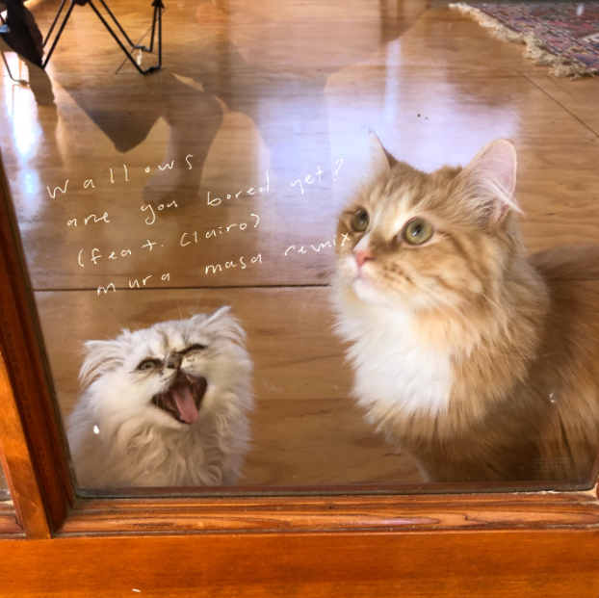
DL artwork here
Wallows smash single “Are You Bored Yet? (feat. Clairo)” has received a fresh take from electronic artist/producer Mura Masa today- listen to the remix HERE. The single, taken from Wallows debut album Nothing Happens, received an RIAA Gold certification in April and has now surpassed 266M global streams. AYBY was also named one of Spotify’s predictions for Songs of the Summer 2020 along with features on Rolling Stone’s “Trending 25” and “Artist 500” charts.
Wallows have 2 shows remaining on their virtual world tour Wallows Live at The Roxy. The tour features unique performances that have been pre-recorded (while following COVID-19 health and safety guidelines) at LA’s famed The Roxy Theatre – also the location of Wallows’ first ever headline show in 2017. Streaming via NoCap, tickets for the remaining shows are on sale now HERE. Every show is available to watch worldwide and will be archived and available to re-watch until October 4th at 11:59pm PT with the purchase of a ticket. Ticket purchasers are encouraged to create an account to access the show archives after the initial premiere, as well as to join the chat in the livestream and more. See below for the remaining dates, times and show details. Wallows also shared a behind the scenes tour doc showing the making of the virtual tour available HERE.
Air Dates & Show Info:
SUNDAY, SEPTEMBER 13 @ 7pm BST/8pm CEST (11am PT) – ‘UK & Europe Show’ – Wallows have picked their own set list for this show
SUNDAY, SEPTEMBER 27 @ 6pm JST/7pm AEST (2am PT) – ‘AUS, NZ & Asia Show’ – ?????? Tune in to find out what Wallows play for their final set live at The Roxy
Wallows also released single “OK” in April, which was produced by John Hill (2x GRAMMY-nominee for Producer of the Year) with co-production from Sachi DiSerafino of Joy Again and GRAMMY-winner John DeBold. It’s available digitally everywhere HERE. The single also received a charismatic official music video that has already amassed nearly 6 million views. Watch HERE.
FOR MORE ON WALLOWS, PLEASE VISIT:
WALLOWSMUSIC.COM I FACEBOOK I TWITTER I YOUTUBE I INSTAGRAM | TIK TOK | PRESS SITE

Press contacts: corey.brewer@atlanticrecords.com
gabrielle.reese@atlanticrecords.com

