WALLOWS
DEBUT ALBUM NOTHING HAPPENS
AVAILABLE NOW VIA ATLANTIC RECORDS

RELEASE “SCRAWNY” MUSIC VIDEO

NOTHING HAPPENS WORLD TOUR KICKS OFF
APRIL 13 WITH COACHELLA DEBUT

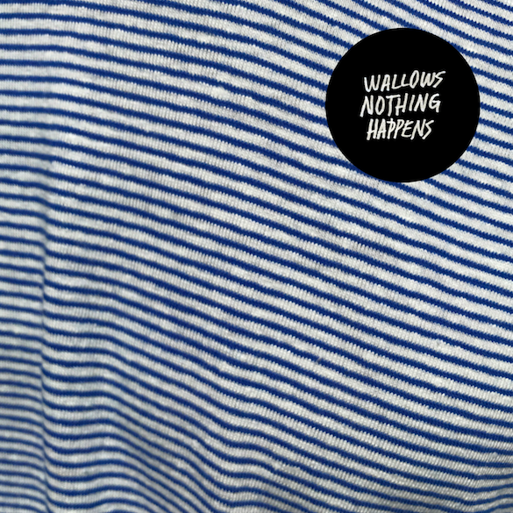

FOR IMMEDIATE RELEASE- March 22, 2019 – Following the release of lead single “Are You Bored Yet? (feat. Clairo)” as well as brand-new tracks “Scrawny” and “Sidelines,” breakout alt-rock trio Wallows’ eagerly-awaited debut album Nothing Happens is available today via Atlantic Records (see full track listing below). Recorded at LA’s Sargent Studios with GRAMMY award-winning producer John Congleton (St. Vincent, Alvvays, Future Islands), the experimental album captures the chaotic emotions that accompany growing up – the vulnerability, fear, and loss, but also the excitement and underlying hope. Listen to Nothing Happens now via https://Wallows.lnk.to/NothingHappens.

“It feels great to finally be releasing our debut record,” Wallows state. “We’ve been playing together for the past 10 years, so it’s been a long time coming. Nothing Happens reflects on our experiences growing up together, our loss of innocence and the thoughts and fears that come with transitioning into adulthood.”

In celebration of Nothing Happens’ release, Wallows have shared the music video for their swaggering hit “Scrawny.” The video, directed by Dillon Dowdell, portrays the track’s simultaneous self-deprecation and overconfidence as Dylan Minnette takes on a much larger opponent in the boxing ring, cheered on by bandmates and cornermen Braeden Lemasters and Cole Preston. Dowdell reveals, “I wanted to make a muscular music video that would play against the scrawny world of the song in a hilarious way.” The song quickly became a fan favorite upon release, with Zane Lowe featuring it as his World Record on Beats1 and Earmilk predicting the track “is destined to be a hit,” continuing “this song oozes with confidence as Wallows starts to develop their truly unique indie sound.” Watch “Scrawny” here: https://Wallows.lnk.to/ScrawnyVideo.

Substream has observed, “Southern California alt-rock trio Wallows has been taking music by storm as of lately,” and the band shows no signs of stopping with the release of Nothing Happens. Single “Are You Bored Yet? (feat. Clairo)” impacted Alternative Radio on Monday and has amassed nearly 10 million combined global streams to date. Wallows debuted the track on The Tonight Show Starring Jimmy Fallon, and will return to The Late Late Show with James Corden on Wednesday, March 27. Idolator raves “Wallows hasn’t put a foot wrong in their still-nascent career. Every song from Nothing Happens has been excellent,” and Pigeons & Planes has named Wallows one of “11 Rising Bands to Listen to in 2019,” forecasting “2019 is undeniably going to be Wallows’ breakout year.”

Next month, Wallows will embark on their biggest tour to date, kicking off with their debut performance at Coachella on Saturday, April 13 and Saturday, April 20. The tour will take the band through major cities in North America, including sold-out shows in San Francisco, Austin, NYC, Boston, Chicago, and LA, among others, before heading overseas to Europe (see below for full list of tour dates). For more information on tickets, visit wallowsmusic.com.

Nothing Happens track list

1. Only Friend
2. Treacherous Doctor
3. Sidelines
4. Are You Bored Yet? (feat. Clairo)
5. Scrawny
6. Ice Cold Pool
7. Worlds Apart
8. What You Like
9. Remember When
10. I’m Full
11. Do Not Wait

Wallows Nothing Happens World Tour Dates

April 13 | Indio, CA | Coachella
April 20 | Indio, CA | Coachella
April 22 | Portland, OR | Wonder Ballroom* (SOLD OUT)
April 23 | Vancouver, CA | Venue Nightclub* (SOLD OUT)
April 24 | Seattle, WA | The Showbox* (Upgraded)
April 26 | San Francisco, CA | The Fillmore* (SOLD OUT)
April 27 | San Francisco, CA | The Fillmore* (SOLD OUT)
April 30 | Dallas, TX | House of Blues* (SOLD OUT)
May 1 | Austin, TX | Scoot Inn* (SOLD OUT)
May 2 | Houston, TX | Warehouse Live*
May 4 | Atlanta, GA | Shaky Knees Festival
May 4 | Atlanta, GA | The Masquerade % (SOLD OUT)
May 6 | Philadelphia, PA | Union Transfer^
May 7 | Washington, DC | 9:30 Club^
May 8 | New York, NY | Irving Plaza^ (SOLD OUT)
May 10 | Boston, MA | Paradise Rock Club^ (SOLD OUT)
May 11 | Clifton Park, NY | Upstate Concert Hall^
May 12 | Toronto, ON | Danforth Music Hall^ (SOLD OUT)
May 14 | Detroit, MI | El Club^ (SOLD OUT)
May 15 | Chicago, IL | Metro^ (SOLD OUT)
May 16 | Minneapolis, MN | Fine Line Music Café^ (SOLD OUT)
May 18 | Boulder, CO | Fox Theatre^ (SOLD OUT)
May 19 | Santa Fe, NM | Meow Wolf^ (SOLD OUT)
May 20 | Phoenix, AZ | Crescent Ballroom^ (SOLD OUT)
May 23 | Los Angeles, CA | The Fonda Theatre ~ (SOLD OUT)
May 24 | Los Angeles, CA | The Fonda Theatre ~ (SOLD OUT)
May 30 | Nimes, France | This Is Not A Love Song Festival
June 1 | Hilvarenbeek, Netherlands | Best Kept Secret
June 2 | Amsterdam, Netherlands | Paradiso # (Upgraded)
June 3 | Hamburg, Germany | Mojo # (Upgraded)
June 6 | London, U.K. | Electric Brixton # (SOLD OUT)
June 7 | Manchester, U.K. | Manchester Academy 2 # (SOLD OUT)
June 8 | Glasgow, U.K. | The Garage # (SOLD OUT)
June 10 | Birmingham, U.K. | O2 Institute # (Upgraded)
June 11 | Leeds, U.K. | Stylus # (Upgraded)
June 13 | Paris, France | La Maroquinerie # (SOLD OUT)
June 14 | Antwerp, Belgium | Kavka Zappa # (Upgraded)
June 15 | Reims, France | La Magnifique Society
July 27-28 | Detroit, MI | Mo Pop Festival

* Mk.Gee Support
^Joy Again Support
% Julia Jacklin Support
~ Slow Hollows Support
# Briston Maroney Support

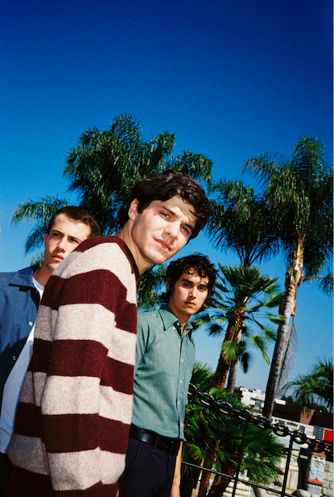
Photo Credit: Alexis Jade Gross
Download press images here
Follow Wallows:

Instagram | Twitter | Facebook
SoundCloud | YouTube | Spotify | Apple Music | Press site

For more information about Wallows, contact
Corey.brewer@atlanticrecords.com

BT PR at 646.405.7010:

Benny Tarantini

Benny@btpr.biz

Stefanie Nester

Stefanie@btpr.biz

For tour inquiries please contact:
Tyler Le
Tyler@btpr.biz

