WALLOWS ANNOUNCE NEW HEADLINE TOUR DATES AND RELEASE VIDEO FOR “ONLY FRIEND” – WATCH HERE

EXTENDING THEIR 2020 NORTH AMERICAN HEADLINE TOUR, INCLUDING SHOW AT BROOKLYN STEEL

2020 TOURING ALSO INCLUDES FESTIVAL APPEARANCES AT LOLLAPALOOZA SOUTH AMERICA AND HANGOUT MUSIC FESTIVAL

DEBUT ALBUM, NOTHING HAPPENS, AVAILABLE NOW

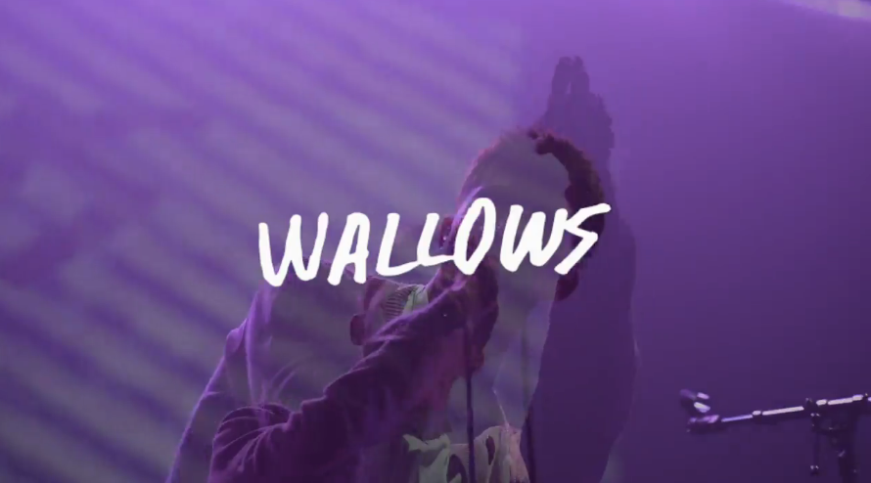

Wallows continue to keep fans on their toes, releasing a video for “Only Friend” (taken from their critically-acclaimed debut album ‘Nothing Happens’), and announcing more headline tour dates for 2020. The “Only Friend” video captures on stage and behind the scenes moments from the band’s final shows of 2019 – Tropicalia festival, Vampire Weekend London and Paris support shows, and their Cologne headline show. Watch HERE.

Also announced today, Wallows have added more dates to their 2020 North American headline tour which kicks off February 13th. New stops include Brooklyn Steel on June 2nd, Philadelphia’s The Fillmore on June 4th, Hartford’s Webster Theater on May 31st, and more. Tickets for the newly announced dates will go on pre-sale for Wallows newsletter subscribers Wednesday, December 11th at 10am local time (sign up at wallowsmusic.com to get access) and general on-sale on Friday, December 13th at 10am local time. For a complete list of dates & ticket information, visit wallowsmusic.com.

Wallows’ acclaimed Atlantic Records debut album, Nothing Happens, is available now for streaming and download HERE. Produced by GRAMMY® Award-winner John Congleton (St. Vincent, Alvvays, Future Islands), the album includes the recent hit singles, “Are You Bored Yet? (Feat. Clairo)” and “Scrawny,” both joined by official companion videos streaming now via YouTube. “Nothing Happens just stands to show that a lot will happen for the band, and they just gotten started,” proclaims FLAUNT MAGAZINE. While THE LOS ANGELES TIMES touted Wallows “a young rock band worth your time in 2019,” and IDOLATOR declared Nothing Happens as “one of the year’s first great albums.”

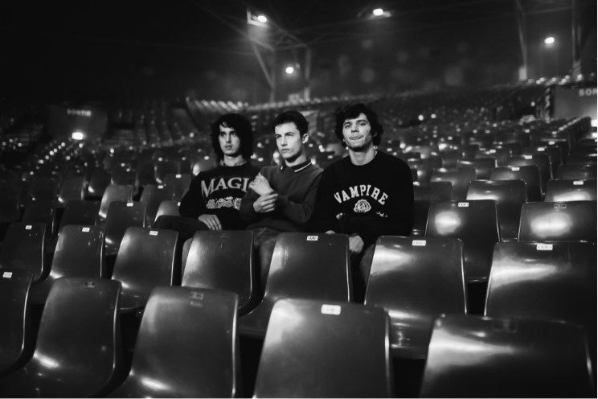
Download press photo HERE; Credit: Joeseth Carter
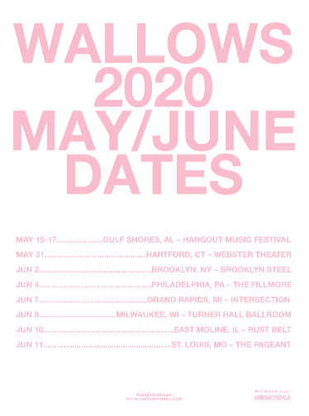
Download Ad mat HERE

WALLOWS ON TOUR 2020
February 13: Iron City – Birmingham, AL ^
February 14: House of Blues – New Orleans, LA (SOLD OUT) ^
February 15: Tabernacle – Atlanta, GA (SOLD OUT) ^
February 17: House of Blues – Lake Buena Vista, FL (SOLD OUT) ^
February 18: Revolution – Ft. Lauderdale, FL (SOLD OUT) ^
February 19: The Ritz YBOR – Tampa, FL (SOLD OUT) ^
February 21: The Underground – Charlotte, NC (SOLD OUT) ^
February 22: Music Farm – Charleston, SC (SOLD OUT) ^
February 23: The Ritz – Raleigh, NC ^
February 25: Rams Head Live – Baltimore, MD (SOLD OUT) ^
February 26: Mr. Smalls Theatre – Pittsburgh, PA (SOLD OUT) ^
February 27: The Westcott Theater – Syracuse, NY (SOLD OUT) ^
February 29 (Matinee): Corona Theatre – Montreal, QC (MATINEE)
February 29 (Late Show): Corona Theatre – Montreal, QC (SOLD OUT) ^
March 1: Higher Ground Ballroom – South Burlington, VT ^
March 2: Fete Ballroom – Providence, RI (SOLD OUT) ^
March 28: Lollapalooza Argentina – Buenos Aires, Argentina *
March 29: Lollapalooza Chile – Santiago, Chile *
April 5: Lollapalooza Brazil – São Paulo, Brazil *
May 15-17: Hangout Music Festival – Gulf Shores, AL *
May 31: Webster Theater – Hartford, CT~
June 2: Brooklyn Steel – Brooklyn, NY~
June 4: The Fillmore – Philadelphia, PA~
June 7: Intersection – Grand Rapids, MI~
June 8: Turner Hall Ballroom – Milwaukee, WI~
June 10: Rust Belt – East Moline, IL~
June 11: The Pageant – St. Louis, MO~

* Festival Performance
^ w/ Penelope Isles
~ w/ mmmonika
FOR MORE ON WALLOWS, PLEASE VISIT:
WALLOWSMUSIC.COM I FACEBOOK I TWITTER I YOUTUBE I INSTAGRAM | PRESS SITE
Press contact: corey.brewer@atlanticrecords.com
Tour press contact: gabrielle.reese@atlanticrecords.com

