WALLOWS EMBARK ON A VIRTUAL WORLD TOUR- 4 NIGHTS OF UNIQUE SHOWS FILMED AT LA’S THE ROXY THEATRE

PURCHASE TICKETS & WATCH VIA NOCAP AT WALLOWS.NOCAPSHOWS.COM

BAND ALSO ASKS FANS TO RECREATE DREW KIRSCH-DIRECTED “ARE YOU BORED YET?” MUSIC VIDEO – SUBMIT YOUR VIDEO HERE

RIAA-CERTIFIED GOLD HIT “ARE YOU BORED YET (FEAT. CLAIRO)” CURRENTLY IN TOP 25 ON THE ALTERNATIVE RADIO CHART & SURPASSED 225 MILLION GLOBAL STREAMS

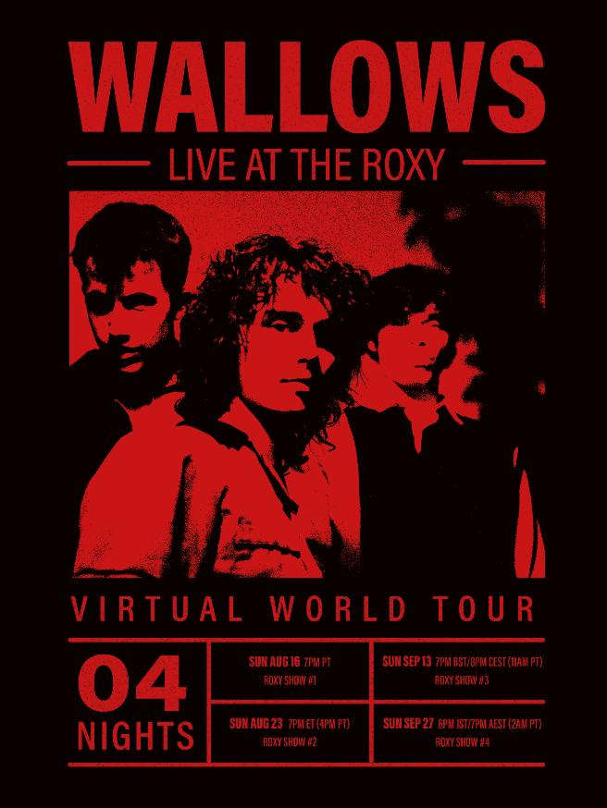
DL poster here
Wallows return to the stage with a Virtual World Tour featuring four unique performances that have been pre-recorded at LA’s famed The Roxy Theatre – also the location of Wallows’ first ever headline show in 2017. Streaming via NoCap, Wallows Live at The Roxy will feature four full production sets, which were filmed while following COVID-19 health and safety guidelines. Tickets are on sale now HERE with the prices as follows: $15/individual show or $55 for a 4-show ticket bundle which includes the limited-edition screen-printed tour poster seen above. See below for a full list of dates, times and show details.
Every show is available to watch worldwide and will be archived and available to re-watch until October 4th at 11:59pm PT with the purchase of a ticket. Ticket purchasers are encouraged to create an account to access the show archives after the initial premiere, as well as to join the chat in the livestream and more.
Air Dates & Show Info:
SUNDAY, AUGUST 16 @ 7pm PT – ‘West Coast Show’ – Performing their debut album, Nothing Happens, in full from start to finish
SUNDAY, AUGUST 23 @ 7pm ET (4pm PT) – ‘East Coast Show’ – Performing a setlist of fan-voted songs
SUNDAY, SEPTEMBER 13 @ 7pm BST/8pm CEST (11am PT) – ‘UK & Europe Show’ – Wallows have picked their own set list for this show
SUNDAY, SEPTEMBER 27 @ 6pm JST/7pm AEST (2am PT) – ‘AUS, NZ & Asia Show’ – ?????? Tune in to find out what Wallows play for their final set live at The Roxy
Wallows single “Are You Bored Yet (feat. Clairo)”, taken from their debut album Nothing Happens, received an RIAA Gold certification in April and now surpassed 225 million global streams. The single was also named one of Spotify’s predictions for Songs of the Summer 2020 along with features on Rolling Stone’s “Trending 25” and “Artist 500” charts.
This past Monday, the band asked fans to recreate their official music video for “Are You Bored Yet?” (directed by Drew Kirsch). Fans can recreate the video shot for shot or any of their favorite moments from the video as close as possible to the original. Wallows will be editing together a new video using the fan submitted footage. Watch the original music video HERE and submit your own footage HERE.
Wallows also released single “OK” in April, which was produced by John Hill (2x GRAMMY-nominee for Producer of the Year) with co-production from Sachi DiSerafino of Joy Again and GRAMMY-winner John DeBold. It’s available digitally everywhere HERE. The single also received a charismatic official music video that has already amassed over 5M views. Watch HERE.
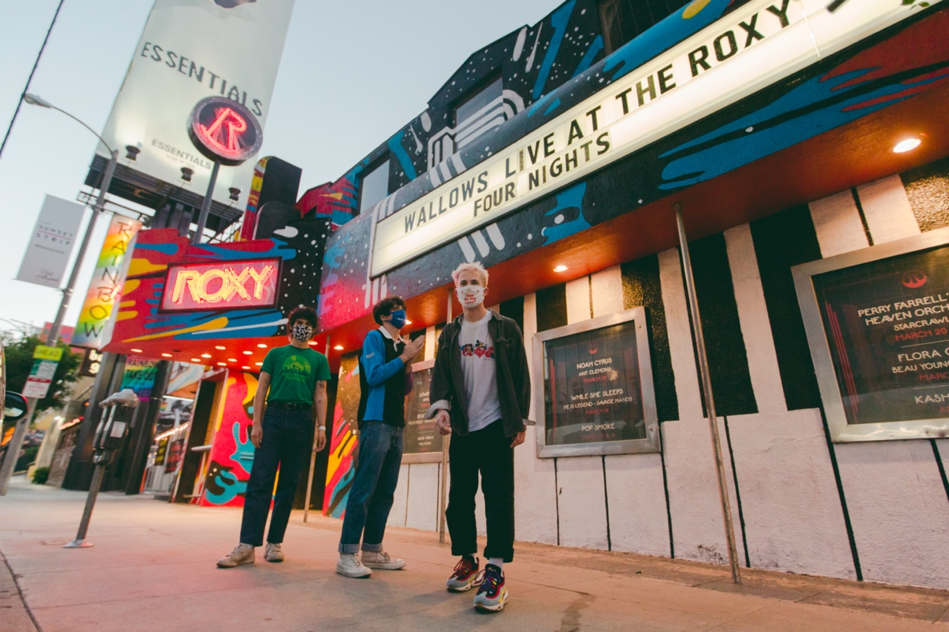
Photo Credit: Nikoli Partiyeli

About NoCap:
NoCap, the brainchild of Roxy Theater co-owner and musician Cisco Adler along with an all-star list of partners in the music and tech industries, is both a platform and promoter of venue-based livestream concerts giving fans around the world access to intimate live performances with unlimited capacity. With its easy-to-use text-based ticketing technology, NoCap is providing a much-needed lifeline for artists, crews and venues suffering during the Covid-19 pandemic that will remain a viable outlet post pandemic while becoming the new general admission creating unlimited profit potential for a new live music model. NoCap gives fans globally a chance to experience live shows by top-tier talent in storied venues, including The Roxy (Los Angeles), Belly Up (Solana Beach, CA/Aspen, CO), SOhO (Santa Barbara), Analog (Nashville), and Wescott Theater (Syracuse), from home or on the go with visually stunning concert-quality sound, creating unforgettable performances. For more info, visit www.nocapshows.com.

FOR MORE ON WALLOWS, PLEASE VISIT:
WALLOWSMUSIC.COM I FACEBOOK I TWITTER I YOUTUBE I INSTAGRAM | TIK TOK | PRESS SITE

Press contacts: corey.brewer@atlanticrecords.com
gabrielle.reese@atlanticrecords.com

