WALLOWS BREAK A SWEAT DOING “VIRTUAL AEROBICS”
NEW SINGLE + VIDEO OUT TODAY

WATCH HERE: https://Wallows.lnk.to/VirtualAerobicsLyrics

RECENTLY RELEASED “NOBODY GETS ME (LIKE YOU)” &
ANNOUNCED ‘REMOTE’ EP OUT OCT 23

“ARE YOU BORED YET” [OFFICIAL FAN VIDEO] OUT NOW

WALLOWS NAMED MTV’S PUSH ARTIST OF THE MONTH FOR SEPTEMBER –
WATCH EXCLUSIVE “ARE YOU BORED YET?” & “NOBODY GETS ME (LIKE YOU)” PERFORMANCES + MORE HERE

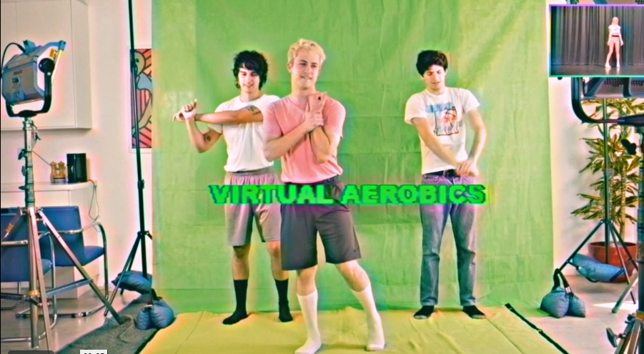

Following their Remote EP announcement and “Nobody Gets Me (Like You)” single release, Wallows are back with “Virtual Aerobics,” the 2nd single from Remote. “Virtual Aerobics,” produced by John DeBold, Sachi Diserafino, and Wallows, is joined by a lyric video directed and edited by Nikoli Partiyeli and choreographed by Emilia Richeson-Valiente of Pony Sweat, a fiercely noncompetitive dance aerobics practice that celebrates anti-perfectionism and the liberation of all bodies. Get your aerobics on with Wallows in the official lyric video HERE.

Remote, Wallows’ new quarantine-made EP is out October 23 and is available to pre-order (including the vinyl version pressed on pink vinyl and featuring the ‘Remote’ logo etched on the b-side) or pre-save now HERE (see track list below). All songs on Remote were produced by Sachi DiSerafino, John DeBold, and Wallows, except for “Nobody Gets Me (Like You)” which was produced by Ariel Rechtshaid (Vampire Weekend, Haim, Adele). In case you missed it, “Nobody Gets Me (Like You)” saw the band team back up with director Dillon Dowdell for another epic music video – picking up where their “OK” collaboration left off.

Last week Wallows asked fans “Are You Registered Yet?” to encourage fans to get ready to vote on National Voter Registration Day in partnership with HeadCount, a non-partisan organization that promotes participation in democracy through music, culture, and digital media. For one day only, the band gave away a download of “Bad Remake” – the last never-before-heard track from the Nothing Happens album sessions – if you checked your voter status, registered or pledged to vote. However, you can still get ready to vote HERE. Wallows also recently asked fans to recreate their “Are You Bored Yet? (feat. Clairo)” music video and they certainly did not disappoint. Watch the “Are You Bored Yet? (feat. Clairo)” official fan video HERE.

REMOTE Track List:
1. Virtual Aerobics
2. Dig What You Dug
3. Nobody Gets Me (Like You)
4. Coastlines
5. Talk Like That
6. Wish Me Luck

“Are You Bored Yet? (feat. Clairo),” taken from Wallows debut album Nothing Happens, has been certified Platinum in the US and Mexico, Gold in Australia and has now surpassed 315M global streams. “Are You Bored Yet?” was also named one of Spotify’s predictions for Songs of the Summer 2020 and has hit the top 5 on the Alternative radio chart. Featured as MTV’s Push Artist of the Month for September, an exclusive performance of “Are You Bored Yet?” is available to watch HERE, along with a performance of Remote EP single “Nobody Gets Me (Like You)” + more.

FOR MORE ON WALLOWS, PLEASE VISIT:
WALLOWSMUSIC.COM I FACEBOOK I TWITTER I YOUTUBE I INSTAGRAM | TIK TOK | PRESS SITE

Press contacts: corey.brewer@atlanticrecords.com
gabrielle.reese@atlanticrecords.com

