Announces New Album
Pacific Daydream
Out on October 27, 2017 Via Crush Music/Atlantic Records

Pre-Order Pacific Daydream HERE
Listen to “Mexican Fender” NOW

“Feels Like Summer” Closing In On Number 1 At Alternative Radio

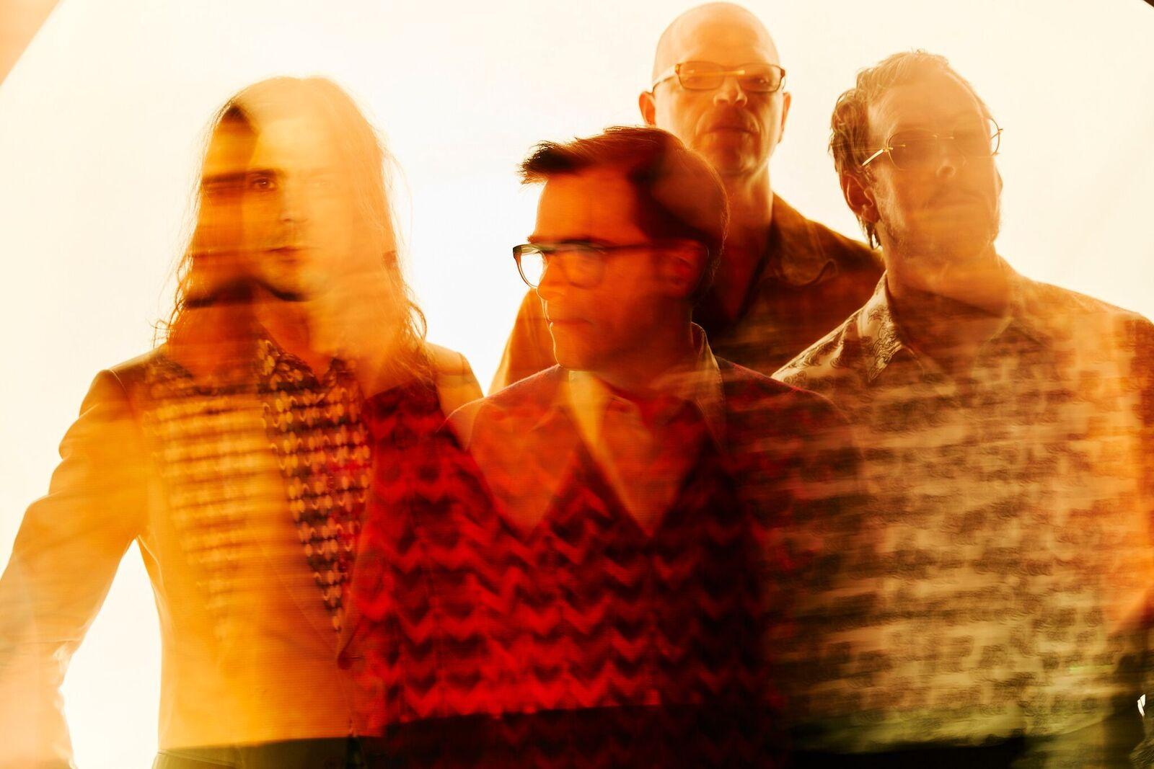
(Photo credit: Jeremy Cowart)

Los Angeles, CA’s Weezer will release their eleventh album, Pacific Daydream on Crush Music/Atlantic Records on October 27th, 2017. Produced by Butch Walker, Pacific Daydream is the follow up to the critically acclaimed album Weezer (The White Album), which was nominated for a Grammy for Best Rock Album at the end of last year. Weezer gave fans another peek of what’s to come from the album with “Mexican Fender,” a new song that debuted earlier today during Zane Lowe’s Beats 1 show on Apple Music. The band spoke with Lowe at length about the new record.

Following the release of Weezer (The White Album), the band began working on what they called “The Black Album,” but as they worked, they found the songs they were writing felt more like reveries from a beach at the end of the world. Instead of forcing a different direction, they began an entirely new album; Pacific Daydream was born. Frontman Rivers Cuomo brings this decision back to a Chinese proverb he says inspired the design behind the entire record:

Once upon a time, I, Chuang Chou, dreamt I was a butterfly, fluttering hither and thither, to all intents and purposes a butterfly. I was conscious only of my happiness as a butterfly, unaware that I was Chou. Soon I awaked, and there I was, veritably myself again. Now I do not know whether I was then a man dreaming I was a butterfly, or whether I am now a butterfly, dreaming I am a man.

Pacific Daydream - an album full of the melodic mastery and craftsmanship for which Weezer are known - is a record that navigates the uncertainty between reality and dreams, blurring the line between the listener knowing if they are daydreaming the world of the album, or if the world of the album is daydreaming them. It’s a record about finding the gray area between the black and the white, about escaping the everyday into the fantasy of what may be just down the line, but also maybe isn’t. It’s an album that sounds like the Beach Boys and The Clash fell in love by the ocean and had one hell of an amazing baby. It’s Weezer doing all the things they do best and then some.

A track listing for Pacific Daydream is still forthcoming, however the album’s current single, “Feels Like Summer,” released in March, has steadily become the dark horse hit of the summer season, currently at #2 and closing in on #1 at Alternative radio, with nearly 20 million plays across streaming services and YouTube. The song is Weezer’s biggest radio hit in a decade, and will be the band’s fourth #1 at Alternative radio.

A pre-order for Pacific Daydream is available HERE. In the meantime, Weezer continue to dominate 2017’s festival season, playing lauded sets across the U.S. and Canada. Tour dates are below.

Pacific Daydream album cover:
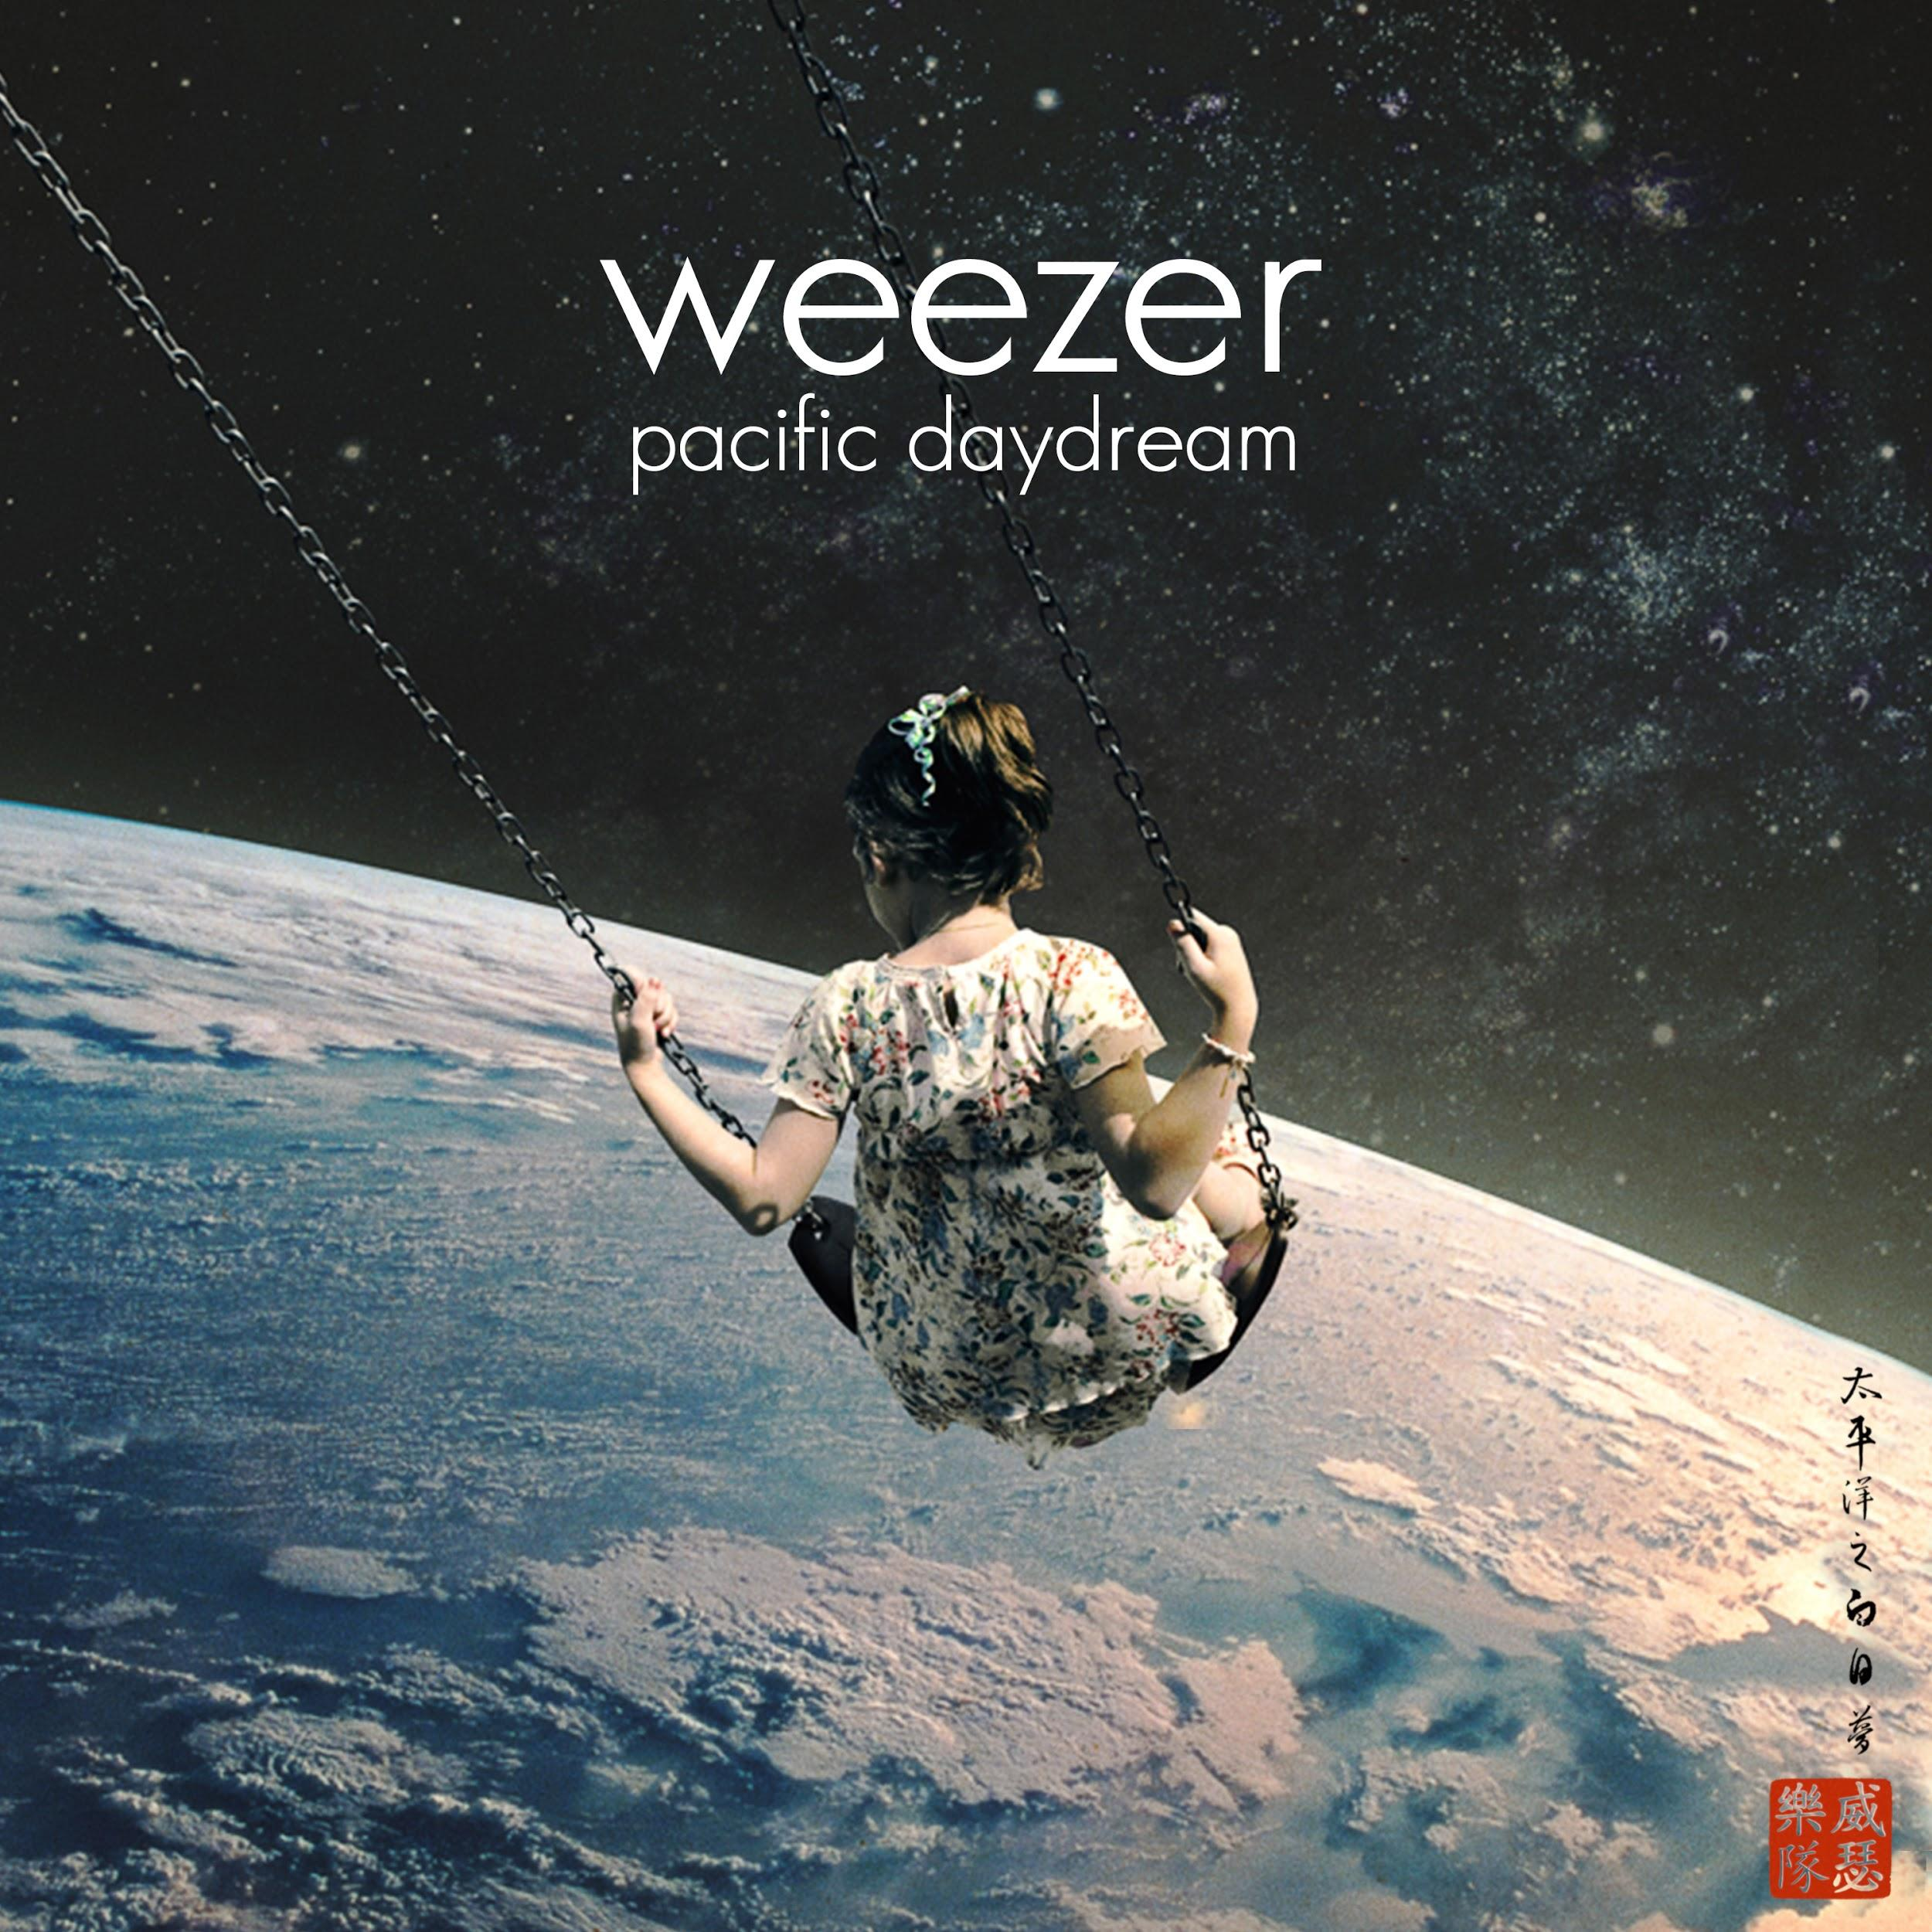

Weezer tour dates:
8/20/17 Oro-Medonte, Canada @ The Big Feastival
8/26/17 Monterrey, Mexico @ Hellow Music Festival
9/2/17 Seattle, WA @ Bumbershoot
9/9/17 Kansas City, KS @ 96.5 The Buzz’s Beach Ball
9/10/17 St. Louis, MO @ LouFest
9/15/17 Del Mar, CA @ KAABOO
9/16/17 Atlanta, GA @ Music Midtown
9/17/17 New York, NY @ The Meadows Music and Arts Festival
10/5/17 Reno, NV @ Grand Sierra Resort and Casino
10/6/17 Napa, CA @ Silverado Resort and Spa
10/7/17 Morrison, CO @ Red Rocks Amphitheatre
10/15/17 Berlin, Germany @ Columbiahalle (with The Orwells)
10/16/17 Cologne, Germany @ Ewerk (with The Orwells)
10/18/17 Brussels, Belgium @ Ancienne Belgique (with The Orwells)
10/19/17 Paris, France @ Olympia (with The Orwells)
10/21/17 Tilburg, Netherlands @ 013 (with The Orwells)
10/23/17 Leeds, United Kingdom @ O2 Academy (with The Orwells)
10/24/17 Glasgow, United Kingdom @ O2 Academy (with The Orwells)
10/25/17 Manchester, United Kingdom @ O2 Apollo (with The Orwells)
10/27/17 Birmingham, United Kingdom @ O2 Academy (with The Orwells)
10/28/17 London, United Kingdom @ Wembley Arena (with Ash, The Orwells)

Weezer are: Brian Bell (guitar/vocals) * Rivers Cuomo (vocals/guitar) * Scott Shriner (bass/vocals) * Pat Wilson (drums)

Weezer:
Website // Facebook // Twitter // Instagram

For more information about Weezer, please contact:
Jen Appel // Katie Nelson - jena@grandstandhq.com // katien@grandstandhq.com

