FOR IMMEDIATE RELEASE

JANUARY 6, 2020

**Why Don’t We enter 2020 with “Chills”**

**Breakout pop group’s 12th release of 2019 OUT now with music video**

**monumental SINGLE “WHAT AM I” PEAKS top 20 AT POP radio**

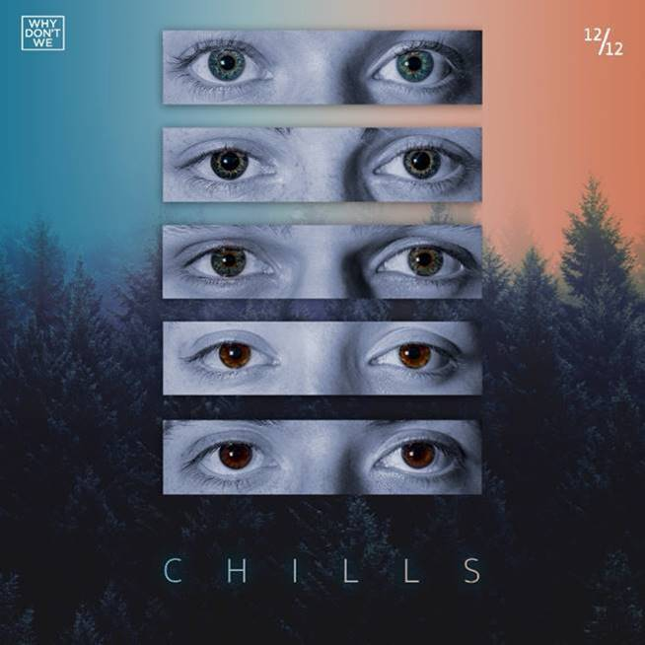

[DOWNLOAD HIGH-RES IMAGES](http://press.atlanticrecords.com/why-dont-we/)

**WATCH “Chills”:** <https://youtu.be/wTdZbbx53uk>

**STREAM “Chills”:** <https://wdw.lnk.to/ChillsPR>

Breakout pop group **Why Don’t We** have dropped their twelfth and final new song of 2019, “**Chills**” available now via **Atlantic Records** with an Evan Hara-directed video companion. The track – self-penned by the group alongside **Michael Pollack** (**Maroon** **5**), **Michael** **Matosic** (**Lauv**) and **Jake Torrey** (**Alesso**) with production by **Earwulf** (**Zara** **Larsson**) – arrived last week, instantly shooting to #1 on the US iTunes’ Overall Songs chart and completing the group’s steady flow of monthly new releases over the past year.

2019 proved to be an exciting year for **Why Don’t We**, ending on a high with their monumental **Ed Sheeran**-penned and **Steve Mac**-produced single “[**What Am I**](https://youtu.be/ZxgbQz4n8-s)” peaking at #19 on Pop radio while boasting over 104 million streams and 14.8 million video views. “**What Am I**” marked the triumphant follow up to “[**8 Letters**](https://youtu.be/C3DlM19x4RQ),” the RIAA-Gold certified Top 20 single which alone accounts for 259 million of the band’s over 1.4 billion global streams and namesake to their just-completed biggest headline run to date, the widely popular and sold out global ***8 Letters Tour****.*

Following performances on the **2019 iHeartRadio Jingle Ball Tour**, **Why Don’t We** is currently hard at work in the studio recording for what is poised to be their most remarkable year yet.

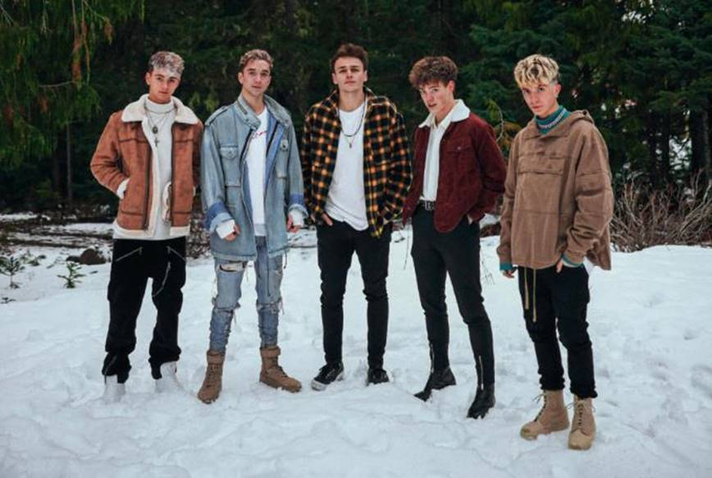

[DOWNLOAD HIGH-RES IMAGES](http://press.atlanticrecords.com/why-dont-we/)

***

*“One of pop music’s biggest breakout stories”* – **NBC’s TODAY**

*“Artist To Watch”* – **ROLLING STONE**

Amassing more than 1.4 billion global audio streams, 4.4 million Instagram followers, and total YouTube views exceeding 560 million with over 3.2 million subscribers in just 3 years, Why Don’t We has become one of pop music’s biggest breakout stories. Taking an innovative and unconventional approach towards releasing new music and actively engaging their rapidly growing fanbase, the prolific young group – the quintet ranges in age from 18-21 years old – put out their first five EPs in under 12 months. After only a year together, the group earned a highly coveted spot on the entire iHeartRadio Jingle Ball Tour, including the New York City stop at Madison Square Garden where they shared the stage with Taylor Swift, Ed Sheeran and more. Their 2018 inaugural full length album, *8 Letters*, debuted in the top 10 on the Billboard 200 at #9 and immediately shot to #1 on US iTunes’ Overall Albums chart (along with topping charts in over 20 more territories around the globe) – while the title track is RIAA-certified Gold, hit Top 20 at Pop radio and boasts over 259 million global streams to date. The band has sold out back-to-back North American headlining tours, and most recently wrapped their most extensive global *8 Letters Tour* (which included a stop at New York City’s Radio City Music Hall which sold out in under two hours). The group took home the award for Choice Music Group at the 2019 Teen Choice Awards and received a nomination for Best Group at the 2019 MTV Video Music Awards. High profile national television appearances include performances on NBC’s TODAY Show (including back-to-back summer concerts in Rockefeller Plaza), ABC’s Good Morning America, nationally syndicated Live with Kelly and Ryan, CBS’s The Late Late Show with James Corden, ABC's Jimmy Kimmel Live! and more.  Press highlights include features in Rolling Stone, Entertainment Weekly, Billboard, PAPER and TIME among others.  WHY DON’T WE is:  Daniel Seavey, Zach Herron, Corbyn Besson, Jonah Marais, and Jack Avery

**CONNECT**:

[WHYDONTWEMUSIC.COM](http://whydontwemusic.com/) | [TWITTER](http://twitter.com/whydontwemusic) | [INSTAGRAM](https://www.instagram.com/whydontwemusic/) | [FACEBOOK](https://facebook.com/whydontwemusic) | [YOUTUBE](https://www.youtube.com/channel/UCgJMQU7JOIoP-YnrhH_P-bA) | [ASSETS](http://press.atlanticrecords.com/why-dont-we/)

**CONTACT:**

Glenn Fukushima | [glenn.fukushima@atlanticrecords.com](mailto:glenn.fukushima@atlanticrecords.com)

Ted Sullivan | [ted.sullivan@atlanticrecords.com](mailto:ted.sullivan@atlanticrecords.com)