FOR IMMEDIATE RELEASE
SEPTEMBER 29, 2020

Why Don’t We return with “Fallin’”

Multi-talented band emerges from hiatus with self-penned/CO-produced
new single “Fallin’” – out now alongside high octane music video

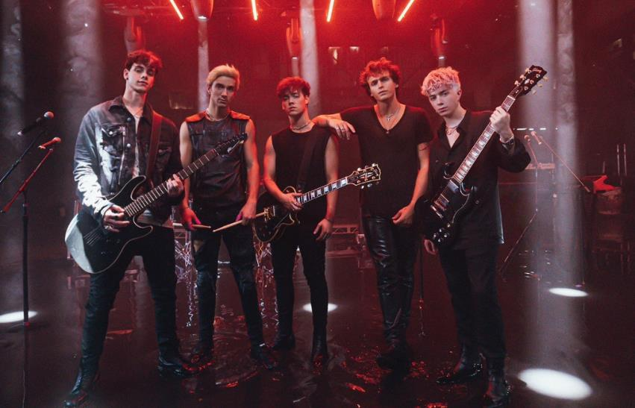
DOWNLOAD HIGH-RES IMAGES

WATCH: https://WhyDontWe.lnk.to/FallinVideoPR
STREAM: https://WhyDontWe.lnk.to/FallinPR

Multi-talented band Why Don’t We have officially returned with their new self-penned/co-produced single “Fallin’” – available now via Atlantic Records alongside a high octane Isaac Rentz-directed music video which saw a broadcast premiere today via MTV. Opening with an iconic drumline, the track steamrolls out of the gate towards a magnetic and massive refrain punctuated by fiery falsetto and a chant, “Maybe, we’ll just keep fallin’.”

Following three years spent primarily on the road, the Los Angeles quintet – Daniel Seavey, Corbyn Besson, Jonah Marais, Jack Avery, and Zach Herron – flatlined all social media in January to delve into the studio and write, record and produce their next chapter themselves. Powering up pop with D.I.Y. energy, the band kickstarted their evolution through a combination of deft musicality and bold experimentation.

“Writing and co-producing our own music has been one of the most rewarding experiences for us,” explains Corbyn. “In the past four years we’ve become confident enough to reinvent ourselves, becoming the band we always hoped to be.”

“It was time to do this ourselves,” says Daniel. “These are our ideas, melodies, and thoughts.”

Breaking their hiatus earlier this month, the group started a social media frenzy with a mysterious #WhereIsWDW campaign that amassed over 5.5 million impressions in under six days. Their return also marked the beginning of the band’s partnership with HeadCount and Atlantic Records’ task force ATL Votes to encourage voter registration. Kicking off with the unveiling of a “Why Don’t We Vote” mural in Los Angeles, the band is urging their wide network of fans and beyond to make their voices heard this November. For more information, please visit headcount.org/wdw.

Since their debut in 2016, Why Don’t We has amassed over 3 billion global career streams, 670 million YouTube views, 4.8 million Instagram followers, two RIAA Platinum-certified singles, four RIAA Gold-certified singles, two Top 20 singles at Pop radio, and a Top 10 Billboard 200 debut album. Taking an innovative and unconventional approach towards releasing new music and actively engaging their rapidly growing fanbase, the band put out their first five EPs within their first year together and followed shortly after with their inaugural full-length 8 Letters album in 2018. Last year saw the release of new singles monthly, including standouts “Big Plans,” “I Don’t Belong In This Club” featuring Macklemore, & the Ed Sheeran-penned/Steve Mac-produced hit “What Am I.”

The band has sold out back-to-back North American and global headline tours, in addition to performing on historic stages such as Radio City Music Hall (selling out the venue in under two hours) and Madison Square Garden (as part of the iHeartRadio Jingle Ball Tour). Furthermore, Why Don’t We took home the award for “Choice Music Group” at the 2019 Teen Choice Awards, received a nomination for “Best Group” at the 2019 MTV Video Music Awards, and has made high profile national television appearances on NBC’s TODAY Show (including back-to-back summer concerts in Rockefeller Plaza), ABC’s Good Morning America, nationally syndicated Live with Kelly and Ryan, CBS’s The Late Late Show with James Corden, ABC's Jimmy Kimmel Live! and more.

WHY DON’T WE is: Daniel Seavey, Corbyn Besson, Jonah Marais, Jack Avery, and Zach Herron

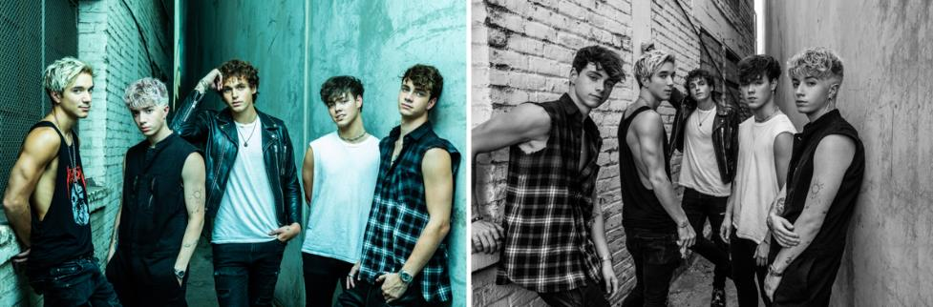
DOWNLOAD HIGH-RES IMAGES

CONNECT:
WHYDONTWEMUSIC.COM | TWITTER | INSTAGRAM | FACEBOOK | YOUTUBE | ASSETS

CONTACT:
Sheila Richman (Atlantic Records) | Sheila.Richman@atlanticrecords.com
Ted Sullivan (Atlantic Records) | ted.sullivan@atlanticrecords.com
Dvora Englefield (Lede Company) | Dvora.Englefield@ledecompany.com
Courtni Asbury (Lede Company) | courtni.asbury@ledecompany.com

