FOR IMMEDIATE RELEASE

OCTOBER 29, 2021

**Why Don’t We shares “Love Back (Stripped Back)”**

**Multi-talented band go acoustic with triumphant new single,**

**available now via Atlantic Records**

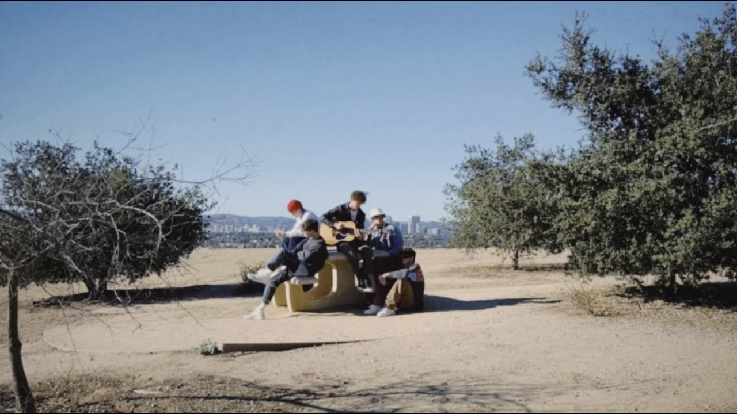

[DOWNLOAD HIGH-RES IMAGES](http://press.atlanticrecords.com/why-dont-we/)

**WATCH/STREAM “LOVE BACK” (STRIPPED BACK):** [https://WhyDontWe.lnk.to/LoveBackStrippedBack](https://nam04.safelinks.protection.outlook.com/?url=https%3A%2F%2Fwhydontwe.lnk.to%2FLoveBackStrippedBack&data=04%7C01%7CBrian.Sommer%40atlanticrecords.com%7Ca3451a9d967a4f1c3bf508d99a940cb7%7C8367939002ec4ba1ad3d69da3fdd637e%7C0%7C0%7C637710782925545130%7CUnknown%7CTWFpbGZsb3d8eyJWIjoiMC4wLjAwMDAiLCJQIjoiV2luMzIiLCJBTiI6Ik1haWwiLCJXVCI6Mn0%3D%7C1000&sdata=j8ND1HfBy3uhmNiCc7iFUqRCxjxFuqh16%2FRVy7weBys%3D&reserved=0)

**STREAM “LOVE BACK”:** <https://WhyDontWe.lnk.to/LoveBack>

Multi-talented band **Why Don’t We** go acoustic for a stripped back take of their triumphant new single “**Love Back**” – available now via **Atlantic** **Records**. The breezy new version premieres today alongside a serene video shot at Tanaka Farms in Irvine, CA.

Teaming up with GRAMMY-nominated producer **JHart**, “**Love** **Back**” finds **Why Don’t We** sounding refreshed as ever after a turbulent year, finding creative solace and marking the beginning an exciting new era. Already boasting over 12 million global steams, the track was featured by **PEOPLE Magazine** who touted the group’s “control over their own destinies.”

*“We are so thankful to be able to release new music for our fans after they have been such an incredible support system for us throughout the past five years as a band. ‘****Love******Back’*** *is the start of our most authentic chapter yet, and we can’t wait for what’s next.”* – **WHY DON’T WE**

Since their debut in 2016, **Why Don’t We** has amassed over 3 billion global career streams, over 880 million YouTube views, 6 million Instagram followers, two RIAA Platinum-certified singles, four RIAA Gold-certified singles, two Top 20 singles at Pop radio, and two Top 10 albums on the Billboard 200 chart. Taking an innovative and unconventional approach towards releasing new music and actively engaging their rapidly growing fanbase, the band put out their first five EPs within their first year together and followed shortly after with their inaugural full-length ***8 Letters***album in 2018.Soon after, 2019 saw the release of new singles monthly, including standouts “**Big Plans**,” “**I Don’t Belong In This Club**” featuring **Macklemore**, & the **Ed Sheeran**-penned/**Steve Mac**-produced hit “**What Am I**.”

The Los Angeles quintet—**Daniel Seavey**, **Corbyn Besson**, **Jonah** **Marais**, **Jack** **Avery**, and **Zach** **Herron**— went back to basics for their sophomore album, flatlining all social media and picking up their instruments to personally write, record, and produce the music themselves. Led by the band’s inaugural Billboard Hot 100 charting single “**Fallin’ (Adrenaline)**,” ***The Good Times and The Bad Ones***earned their highest debut on the Billboard 200 at #3 and their first #1 album on the album sales chart.

The band has sold out back-to-back North American and global headline tours, in addition to performing on historic stages such as **Radio City Music Hall** (selling out the venue in under two hours) and **Madison Square Garden** (as part of the **iHeartRadio Jingle Ball Tour**). Furthermore, **Why Don’t We** took home the award for “Choice Music Group” at the **2019 Teen Choice Awards**, received a nomination for “Best Group” at the **2019 MTV Video Music Awards**, and has made high profile national television appearances on NBC’s **TODAY Show** (including back-to-back summer concerts in Rockefeller Plaza), ABC’s **Good Morning America**, nationally syndicated **Live with Kelly and Ryan**, **The Ellen DeGeneres Show**, NBC’s **The Kelly Clarkson Show**, CBS’s **The Late Late Show with James Corden**, ABC's **Jimmy Kimmel Live!** and more.

[DOWNLOAD HIGH-RES IMAGES](http://press.atlanticrecords.com/why-dont-we/)

**CONNECT**:

[WHYDONTWEMUSIC.COM](http://whydontwemusic.com/) | [TWITTER](http://twitter.com/whydontwemusic) | [INSTAGRAM](https://www.instagram.com/whydontwemusic/) | [FACEBOOK](https://facebook.com/whydontwemusic) | [YOUTUBE](https://www.youtube.com/channel/UCgJMQU7JOIoP-YnrhH_P-bA) | [ASSETS](http://press.atlanticrecords.com/why-dont-we/)

**CONTACT**:

TED SULLIVAN (ATLANTIC RECORDS) | [TED.SULLIVAN@ATLANTICRECORDS.COM](mailto:TED.SULLIVAN@ATLANTICRECORDS.COM)