FOR IMMEDIATE RELEASE
OCTOBER 25, 2019

WHY DON’T WE SHARE 10TH NEW TRACK OF 2019, “MAD AT YOU”

Breakout pop group’s monumental new SINGLE “WHAT AM I”
penned by Ed Sheeran & produced by Steve Mac CHARTING TOP 25 AT POP radio

Blockbuster ‘8 Letters Tour’ continues global domination
in Europe, Asia & Australia through end of year

WHY DON’T WE JOINS 2019 IHEARTRADIO JINGLE BALL TOUR LINE-UP

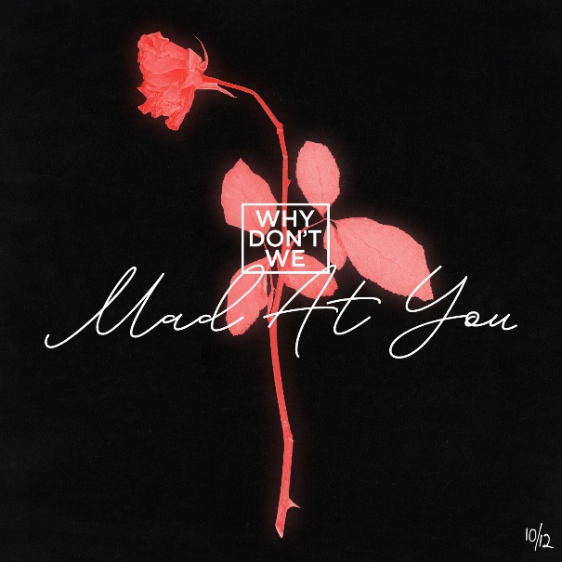
DOWNLOAD HIGH-RES IMAGES

STREAM “MAD AT YOU”: LINK
WATCH “WHAT AM I” music video: LINK

Breakout pop group Why Don’t We have dropped their tenth new song of 2019, “Mad At You” – available now via Atlantic Records. The track, produced by Rogét Chahayed (Travis Scott, Halsey), arrives with news of the group joining the 2019 iHeartRadio Jingle Ball Tour line-up, performing at stops in Dallas, Philadelphia, Atlanta & more (full routing below).

“Mad At You” follows the release of Why Don’t We’s monumental new single “What Am I,” which continues to hold strong in the top 25 at Pop radio while boasting over 43.8 million streams and 10 million video views. Since release, the band has performed “What Am I” on NBC’s TODAY Show Citi Concert Series, MTV’s TRL and ABC’s Live with Kelly & Ryan, in addition to hosting six widely successful merch pop-up shops across the US.

Penned by Ed Sheeran and produced by Steve Mac, “What Am I” marks the triumphant follow up to “8 Letters” – the RIAA-Gold certified Top 20 single which alone accounts for 232 million of the band’s over 1.4 billion global streams. The single marks a continuation of an exciting year for Why Don’t We, highlighted by their biggest headline run to date, the widely popular and sold out 8 Letters Tour, which continues its global domination through end of year in Europe, Southeast Asia, Australia, and New Zealand.

Known for their prolific and creative output, Why Don’t We has maintained a steady flow of monthly new releases this year – most recently including a Live and Unplugged Session of “What Am I” that further highlights the band’s musicality and a high energy Cash Cash Remix. 2019 also saw the band take home the award for Choice Music Group at the 2019 Teen Choice Awards, in addition to receiving a nomination for Best Group at the 2019 MTV Video Music Awards.

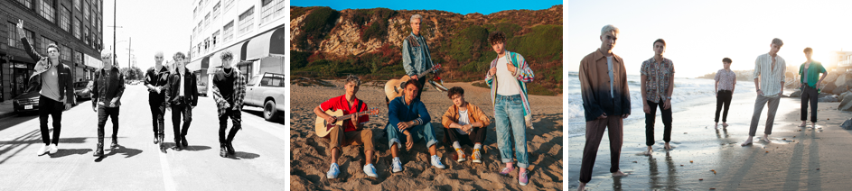
DOWNLOAD HIGH-RES IMAGES

***

“One of pop music’s biggest breakout stories” – NBC’s TODAY
“Artist To Watch” – ROLLING STONE

Amassing more than 1.4 billion global audio streams, 4.2 million Instagram followers, and total You Tube views exceeding 524 million with over 3 million subscribers in just 3 years, Why Don’t We has become one of pop music’s biggest breakout stories. Taking an innovative and unconventional approach towards releasing new music and actively engaging their rapidly growing fanbase, the prolific young group – the quintet ranges in age from 18-21 years old – put out their first five EPs in under 12 months. After only a year together, the group earned a highly coveted spot on the entire iHeartRadio Jingle Ball Tour, including the New York City stop at Madison Square Garden where they shared the stage with Taylor Swift, Ed Sheeran and more. Their 2018 inaugural full length album, 8 Letters, debuted in the top 10 on the Billboard 200 at #9 and immediately shot to #1 on US iTunes’ Overall Albums chart (along with topping charts in over 20 more territories around the globe) – while the title track is RIAA-certified Gold, hit Top 20 at Pop radio and boasts over 232 million global streams to date. The band has sold out back-to-back North American headlining tours, and is currently on the road for their most extensive 8 Letters Tour (which included a stop at New York City’s Radio City Music Hall which sold out in under two hours). High profile national television appearances include performances on NBC’s TODAY Show (including back-to-back summer concerts in Rockefeller Plaza), ABC’s Good Morning America, nationally syndicated Live with Kelly and Ryan, CBS’s The Late Late Show with James Corden, ABC's Jimmy Kimmel Live! and more. Press highlights include features in Rolling Stone, Entertainment Weekly, Billboard, PAPER and TIME among others. WHY DON’T WE is: Daniel Seavey, Zach Herron, Corbyn Besson, Jonah Marais, and Jack Avery

TOUR:
Dec 1 – Tampa, FL @ Amalie Arena (93.3 FLZ Jingle Ball)
Dec 3 – Dallas, TX @ Dickies Arena (106.1 KISS FM Jingle Ball)
Dec 9 – Minneapolis, MN @ Xcel Energy Center (101.3 KDWB Jingle Ball)
Dec 10 – Indianapolis, IN @ Bankers Life Fieldhouse (99.5 ZPL Jingle Jam)
Dec 11 – Philadelphia, PA @ Wells Fargo Arena (Q102’s Jingle Ball)
Dec 13 – Wilkes-Barre, PA @ Kirby Center (98.5 KRZ Let It Show)
Dec 15 – Boston, MA @ TD Garden (KISS 108’s Jingle Ball)
Dec 16 – Washington, DC @ Capital One Arena (Hot 99.5)
Dec 17 – Cincinnati, OH @ Madison Theater (KISS 107.1 KISSmas Concert)
Dec 18 – Chicago, IL @ All State Arena (103.5 KISS FM’s Jingle Ball)
Dec 19 – Memphis, TN @ Landers Center (Q107.5 Jingle Jam)
Dec 20 – Atlanta, GA @ State Farm Arena (Power 96.1 Jingle Ball)
Dec 22 – Ft. Lauderdale, FL @ BB&T Center (Y100’s Jingle Ball)

CONNECT:
WHYDONTWEMUSIC.COM | TWITTER | INSTAGRAM | FACEBOOK | YOUTUBE | ASSETS

CONTACT:
Glenn Fukushima | glenn.fukushima@atlanticrecords.com
Ted Sullivan | ted.sullivan@atlanticrecords.com

