FOR IMMEDIATE RELEASE
MAY 20, 2019

WHY DON’T WE DROP NEW TRACK “UNBELIEVABLE”

FIFTH NEW SONG OF 2019 AVAILABLE NOW

BREAKOUT POP GROUP SET TO RETURN FOR TODAY SHOW
CITI CONCERT SERIES IN ROCKEFELLER PLAZA ON LABOR DAY

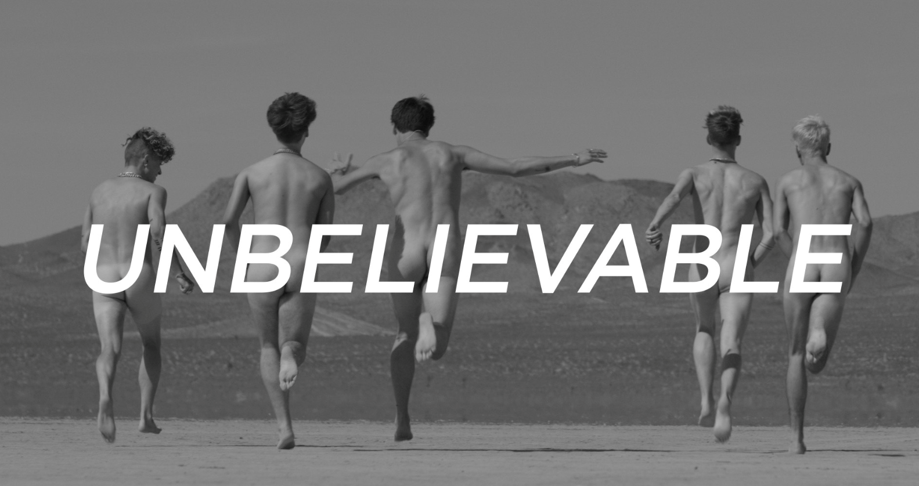

WATCH “Unbelievable” LYRIC VIDEO: https://youtu.be/LPdiR0tvvm8

“One of pop music’s biggest breakout stories” – NBC’s TODAY
“Artist To Watch” – ROLLING STONE
“the next generation’s all-American boy band” – PAPER
“The Next Boy Band Taking Over The World” – NYLON

Atlantic recording artists Why Don’t We have released their fifth new track of 2019, “Unbelievable” – available now via all DSPs. The summer-ready song arrives on the heels of the band’s explosive collaborative single “I Don’t Belong In This Club” with Macklemore and the group’s announce as part of the 2019 TODAY Show Citi Concert Series line-up, returning once again to Rockefeller Plaza on Labor Day (Sept. 2nd) following last year’s performance which garnered one of the largest crowds of the summer.

Known for their prolific and creative output, both “Unbelievable” and “I Don’t Belong In This Club” continue a steady flow of new releases from Why Don’t We – also including “Big Plans” (which shot to #1 on the iTunes all-genres chart), “Cold In LA” and last month’s soundtrack contribution to STXFilm’s UglyDolls, “Don’t Change.”

Why Don’t We is gearing up for the second leg of their biggest headline run to date, the 8 Letters Tour, resuming July 18th in Costa Mesa, CA. The tour’s wildly successful and completely sold out first leg included stops in Los Angeles, Boston, Chicago, and New York City – where the band sold out the legendary Radio City Music Hall in just two hours. For ticketing details, tour updates, and more, please visit www.whydontwemusic.com.

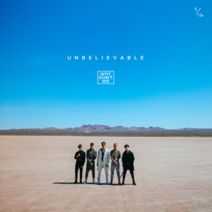
DOWNLOAD HIGH-RES IMAGE

***

Amassing more than 750 million global audio streams, 3.8 million Instagram followers, and total You Tube views exceeding 426 million with over 2.7 million subscribers in under 2 years, Why Don’t We has become one of pop music’s biggest breakout stories. Taking an innovative and unconventional approach towards releasing new music and actively engaging their rapidly growing fanbase, the prolific young group – the quintet ranges in age from 17-20 years old – put out four EPs in under 12 months. The group closed 2017 on a high note, performing on the entire iHeartRadio Jingle Ball Tour, including the New York City stop at Madison Square Garden where they shared the stage with Taylor Swift, Ed Sheeran, Camilla Cabello and more. Their debut full length album, 8 Letters, debuted in the top 10 on the Billboard 200 at #9 and immediately shot to #1 on US iTunes’ Overall Albums chart (along with topping charts in over 20 more territories around the globe) – while the title track hit Top 20 at Pop radio and boasts over 130 million global audio and video streams to date. The band has sold out back-to-back North American headlining tours, and is currently on the road for their most extensive 8 Letters Tour (which included a stop at New York City’s Radio City Music Hall which sold out in under two hours). High profile national television appearances include performances on NBC’s TODAY Show (including their summer concert series in Rockefeller Plaza), ABC’s Good Morning America, nationally syndicated Live with Kelly and Ryan, CBS’s The Late Late Show with James Corden, ABC's Jimmy Kimmel Live! and more. Press highlights include features in Rolling Stone, Entertainment Weekly, Billboard, and TIME among others. WHY DON’T WE is: Daniel Seavey, Zach Herron, Corbyn Besson, Jonah Marais, and Jack Avery

***

WHY DON’T WE
8 LETTERS NORTH AMERICAN TOUR

July 18 – Costa Mesa, CA – OC Fair
July 19 – San Diego, CA – Cal Coast Credit Union Open Air Theatre
July 20 – Las Vegas, NV – PARK Theater
July 22 – Paso Robles, CA – California Mid-State Fair
July 25 – Kansas City, MO – Starlight Amphitheatre
July 26 – Rogers, AR – Walmart AMP
July 27 – St. Louis, MO – Fabulous Fox Theatre
July 28 – Nashville, TN – Ascend Amphitheater
July 30 – Louisville, KY – The Louisville Palace
August 1 – Boca Raton, FL – Mizner Park Amphitheatre
August 2 – Jacksonville, FL – Daily’s Place Amphitheater
August 3 – Raleigh, NC – The Red Hat Amphitheater
August 5 – Baltimore, MD – Pavilion
August 6 – Albany, NY – Palace Theatre
August 8 – Gilford, NH – Bank of New Hampshire Pavilion
August 9 – Uncasville, CT – Mohegan Sun Arena
August 10 – Philadelphia, PA – The Met
August 11 – Moon Township, PA – UPMC Events Center
August 13 – Springfield, IL – Illinois State Fair
August 14 – Lincoln, NE – Pinnacle Bank Arena
August 18 – Park City, KS – Hartman Arena
August 20 – Charleston, SC – Volvo Car Stadium
August 21 – Pelham, AL – Oak Mountain Amphitheatre
August 25 – Cincinnati, OH – PNC Pavilion at Riverbend
August 26 – Grand Rapids, MI – Devos Performance Hall
August 28 – Cleveland, OH – Jacobs Pavilion
August 29 – Syracuse, NY – New York State Fair
August 31 – Allentown, PA – The Great Allentown Fair

CONNECT:
WHYDONTWEMUSIC.COM | TWITTER | INSTAGRAM | FACEBOOK | YOUTUBE | ASSETS

CONTACT:
Glenn Fukushima | glenn.fukushima@atlanticrecords.com
Ted Sullivan | ted.sullivan@atlanticrecords.com

