FOR IMMEDIATE RELEASE
NOVEMBER 12, 2020

Why Don’t We announce new album
The Good Times and The Bad Ones

Multi-talented band’s sophomore full-length arrives
January 15th via Atlantic Records
+ available for pre-order/pre-save now

New single “Fallin’ (Adrenaline)” explodes on Charts, with high-octane performances on Jimmy Kimmel Live! & The Ellen DeGeneres Show

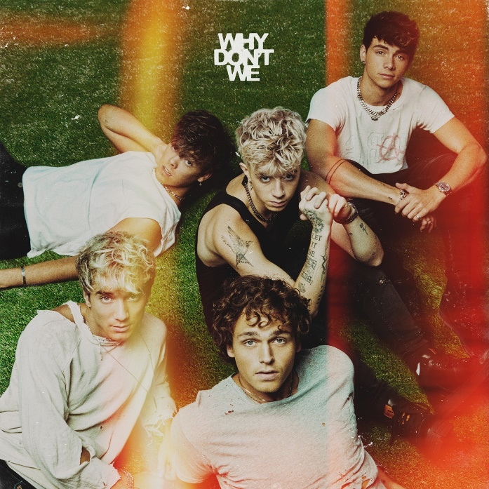
DOWNLOAD HIGH-RES IMAGES

WATCH/STREAM “FALLIN’”: https://WhyDontWe.lnk.to/FallinPR
PRE-SAVE/PRE-ORDER ALBUM: https://whydontwe.lnk.to/TGTATBO

Multi-talented band Why Don’t We have announced their highly anticipated sophomore full-length album, The Good Times and The Bad Ones, arriving January 15th via Atlantic Records and available for pre-order/pre-save now via https://whydontwe.lnk.to/TGTATBO (including limited quantity autographed CDs and cassettes). Self-penned and co-produced by the group, the album marks a new chapter kickstarted through a combination of deft musicality and bold experimentation.

“Writing and co-producing our own music has been one of the most rewarding experiences for us,” explains Corbyn. “In the past four years we’ve become confident enough to reinvent ourselves, becoming the band we always hoped to be.”

“It was time to do this ourselves,” says Daniel. “These are our ideas, melodies, and thoughts.”

The 10-track collection features their smash new single “Fallin’ (Adrenaline)” – which has amassed over 46 million global streams and over 15 million video views since release. The single exploded onto the Top 40 radio chart, debuting at #35 and ascending this week to #23, in addition to earning the band their first career Billboard Hot 100 entry at #37. Furthermore, “Fallin’ (Adrenaline)” has proved a social media sensation with a viral TikTok campaign that reached over 109 million profiles, a behind-the-scenes YouTube docuseries, and a new lyric video out today featuring polaroid photos that fans can win by pre-save/pre-ordering The Good Times and The Bad Ones (https://whydontwe.lnk.to/FallinLyricVideoPR). Last week saw Why Don’t We make their return to ABC’s Jimmy Kimmel Live! with a high-octane performance of “Fallin’ (Adrenaline),” followed today by their debut performance on The Ellen DeGeneres Show and additional high profile appearances to be announced soon.

Following three years spent primarily on the road, the Los Angeles quintet – Daniel Seavey, Corbyn Besson, Jonah Marais, Jack Avery, and Zach Herron – went dark on social media in January to delve into the studio and write, record and produce their next chapter themselves. Breaking their hiatus last month, the group started a social media frenzy with a mysterious #WhereIsWDW campaign that amassed over 5.5 million impressions in under six days. Their return also marked the beginning of the band’s partnership with HeadCount and Atlantic Records’ task force ATL Votes to encourage voter registration.

Since their debut in 2016, Why Don’t We has amassed over 3 billion global career streams, 703 million YouTube views, 5 million Instagram followers, two RIAA Platinum-certified singles, four RIAA Gold-certified singles, two Top 20 singles at Pop radio, and a Top 10 Billboard 200 debut album. Taking an innovative and unconventional approach towards releasing new music and actively engaging their rapidly growing fanbase, the band put out their first five EPs within their first year together and followed shortly after with their inaugural full-length 8 Letters album in 2018. Last year saw the release of new singles monthly, including standouts “Big Plans,” “I Don’t Belong In This Club” featuring Macklemore, & the Ed Sheeran-penned/Steve Mac-produced hit “What Am I.”

The band has sold out back-to-back North American and global headline tours, in addition to performing on historic stages such as Radio City Music Hall (selling out the venue in under two hours) and Madison Square Garden (as part of the iHeartRadio Jingle Ball Tour). Furthermore, Why Don’t We took home the award for “Choice Music Group” at the 2019 Teen Choice Awards, received a nomination for “Best Group” at the 2019 MTV Video Music Awards, and has made high profile national television appearances on NBC’s TODAY Show (including back-to-back summer concerts in Rockefeller Plaza), ABC’s Good Morning America, nationally syndicated Live with Kelly and Ryan, CBS’s The Late Late Show with James Corden, ABC's Jimmy Kimmel Live! and more.

WHY DON’T WE is: Daniel Seavey, Corbyn Besson, Jonah Marais, Jack Avery, and Zach Herron

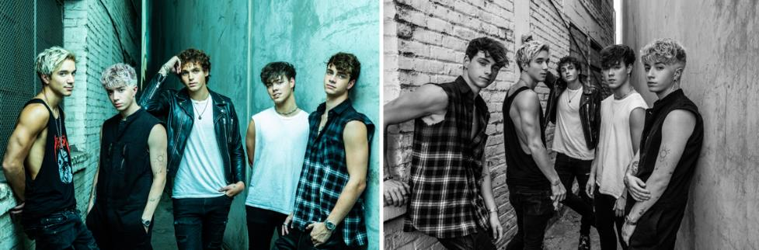
DOWNLOAD HIGH-RES IMAGES

CONNECT:
WHYDONTWEMUSIC.COM | TWITTER | INSTAGRAM | FACEBOOK | YOUTUBE | ASSETS

CONTACT:
Sheila Richman (Atlantic Records) | Sheila.Richman@atlanticrecords.com
Ted Sullivan (Atlantic Records) | ted.sullivan@atlanticrecords.com
Dvora Englefield (Lede Company) | Dvora.Englefield@ledecompany.com
Courtni Asbury (Lede Company) | courtni.asbury@ledecompany.com

