For Immediate Release

September 17, 2020 (7a PST/10a EST)

**The Return of Why Don’t We**

**Multi-talented band emerges from hiatus to announce self-penned/produced**

**new single “Fallin’” arriving September 29th via Atlantic Records**

**WDW teams up with HeadCount & ATL Votes for “Why Don’t We Vote” campaign**

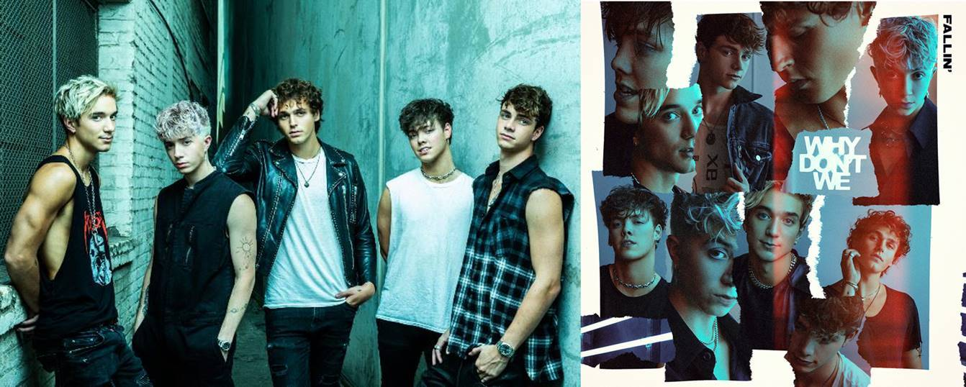

[DOWNLOAD HIGH-RES IMAGES](http://press.atlanticrecords.com/why-dont-we/) (credit: Pamela Littky)

***Autographed single CDs available for pre-order via*** [***shop.whydontwemusic.com***](http://shop.whydontwemusic.com/)

Multi-talented band **Why Don’t We** have officially returned, announcing their highly anticipated self-penned/produced new single “**Fallin’**” – arriving Tuesday, September 29th via **Atlantic** **Records**. Following a nine-month hiatus spent writing and producing their forthcoming second studio album, the group started a social media frenzy last week with a mysterious **#WhereIsWDW** campaign that amassed over 5.5 million impressions in under six days.

The return of **Why Don’t We** also marks the beginning of the band’s partnership with **HeadCount** and **Atlantic** **Records’** task force **ATL Votes** to encourage voter registration. Kicking off yesterday with the unveiling of a “**Why Don’t We Vote**” mural in Los Angeles, the band is urging their wide network of fans and beyond to make their voices heard this November. For more information, please visit [headcount.org/wdw](https://www.headcount.org/wdwrtv/?source=whydontwe).

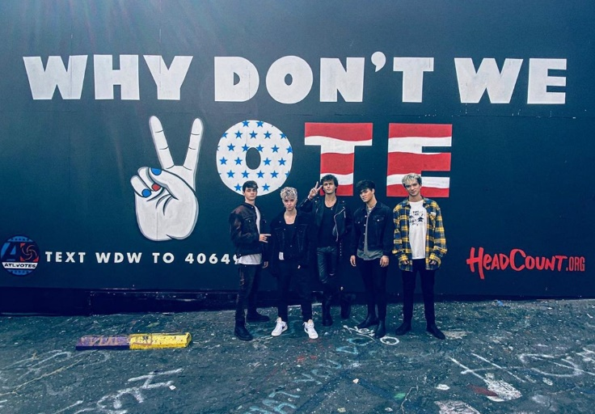

[DOWNLOAD HIGH-RES IMAGES](http://press.atlanticrecords.com/why-dont-we/)

Since their debut in 2016, **Why Don’t We** has amassed over 3 billion global career streams, 670 million YouTube views, 4.8 million Instagram followers, 5 RIAA Gold-certified singles, 2 Top 20 singles at Pop radio, and a Top 10 Billboard 200 debut on the with their inaugural full-length album *8 Letters*. They have sold out back-to-back North American and global headline tours, in addition to performing as part of the iHeartRadio Jingle Ball tour and on heralded stages such as Radio City Music Hall & more.

**WHY DON’T WE** is: Daniel Seavey, Zach Herron, Corbyn Besson, Jonah Marais, and Jack Avery

**CONNECT**:

[WHYDONTWEMUSIC.COM](http://whydontwemusic.com/) | [TWITTER](http://twitter.com/whydontwemusic) | [INSTAGRAM](https://www.instagram.com/whydontwemusic/) | [FACEBOOK](https://facebook.com/whydontwemusic) | [YOUTUBE](https://www.youtube.com/channel/UCgJMQU7JOIoP-YnrhH_P-bA) | [ASSETS](http://press.atlanticrecords.com/why-dont-we/)

**CONTACT:**

Sheila Richman (Atlantic Records) | [Sheila.Richman@atlanticrecords.com](mailto:Sheila.Richman@atlanticrecords.com)

Ted Sullivan (Atlantic Records) | [ted.sullivan@atlanticrecords.com](mailto:ted.sullivan@atlanticrecords.com)

Dvora Englefield (Lede Company) | [Dvora.Englefield@ledecompany.com](mailto:Dvora.Englefield@ledecompany.com)

Courtni Asbury (Lede Company) | [courtni.asbury@ledecompany.com](mailto:courtni.asbury@ledecompany.com)