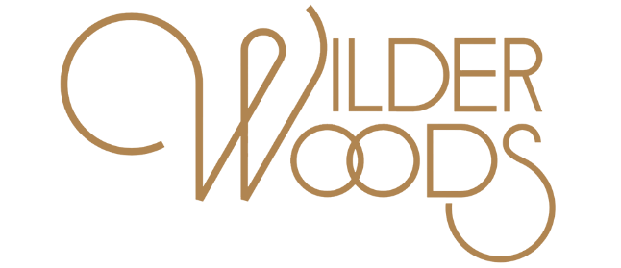
SELF-TITLED DEBUT STUDIO ALBUM AVAILABLE AUGUST 9TH
2019 NORTH AMERICAN HEADLINE TOUR DATES SET FOR FALL
NEW SINGLE “SUPPLY & DEMAND” OUT NOW
Check out the "Wilder Woods" album trailer here

Atlantic Records has announced the self-titled debut album from Wilder Woods – also known to many as Bear Rinehart, frontman and co-founder of GRAMMY® Award-nominated NEEDTOBREATHE. WILDER WOODS arrives everywhere on August 9th. Pre-order and pre-save here.
Fueled by stop-you-in-your-tracks vocals, the songs play out like a Wilder Woods manifesto, a stream of consciousness plea that sets the stage perfectly for an album all about understanding, forgiveness, and self-love in a world that’s conditioned us to feel like we’ll never be enough. WILDER WOODS is heralded by today’s premiere of new single, “Supply & Demand.”
"You always hear about bands ‘finding' their sound. I don’t know if I really understood how difficult, but important, that journey really is until I went on it myself. We ended up with a soul record that weaves its way between the classic soul artists that I love and a more modern alternative way of producing them. You can certainly hear influences from Marvin Gaye and Bob Marley, all the way to The Temptations and even Springsteen, but I’m proud of how different it actually is from all those things. The record was meant to be something you listen to on the weekends… either in the mornings on the back porch or late night dancing with the one you love.”
“Supply & Demand” follows last week’s release of the official video for “Sure Ain’t,” which saw its premiere via NPR Music, which declared, “…beautifully shot by Gus Black, (the Sure Ain’t video) captures the emotional and soulful intensity of the song.”

‘Wilder Woods’ is a new chapter in Bear Rinehart’s storied career. A timeless blend of classic soul, infectious R&B, and modern pop, WILDER WOODS is the sound of a veteran songwriter confidently breaking new ground, blazing his own distinctive trail through uncharted territory with comfort and style. Simultaneously vulnerable and self-assured many of the album’s tracks reflect both the rich well of experience from which they’re drawn and the bold leap that they represent, pairing intimate, introspective lyricism with effortless swagger and monster hooks. Recorded at Layman Drug Company studios in East Nashville with producer Gabe Simon (Dua Lipa, Gin Wigmore), the album sees backing by a top-shelf cohort of co-writers and supporting musicians, including The Watson Twins, Jesse Baylin, Trent Dabbs, Carson Cooley, Ian Fitchuk (Kacey Musgraves, Maren Morris), and more. A singular blend of old and new, like a vintage Eldorado retrofitted with a 21st century engine, WILDER WOODS uncovers a new side of Bear Rinehart, one that he’s more than ready to share.

“There are two distinct sides to this album,” says Wilder Woods. “There’s the Wilder side, which is all about love and flirtation and desire, and the Woods side, which is more serious and reflective. We all contain multitudes, and you have to recognize and honor all the different parts of yourself if you ever want to feel whole.”

Wilder Woods will celebrate the release of his debut LP by embarking on a full North American headline Fall tour, kicking off September 5th at Mod Club in Toronto, ON. Tickets go on presale starting on Monday, June 3 at 10:00 AM local time. Presale information can be found across all Wilder Woods’ channels — @iamwilderwoods. Tickets will be available to the general public starting Friday, June 7th at 10:00am local time. For more information visit iamwilderwoods.com. Full tour routing below.

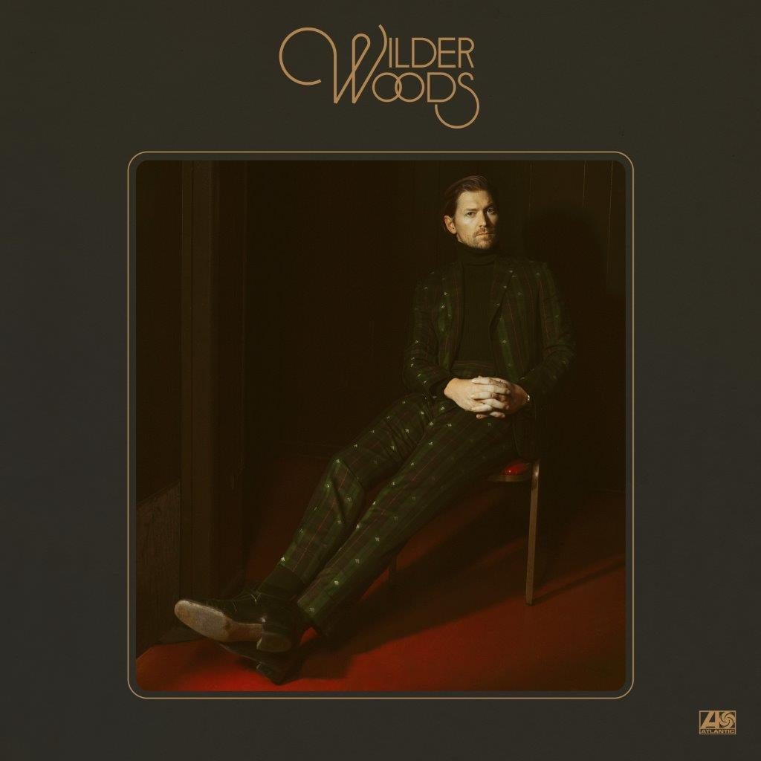

CONNECT WITH WILDER WOODS
IAMWILDERWOODS.COM
FACEBOOK
TWITTER
INSTAGRAM
YOUTUBE

WILDER WOODS
HEADLINE FALL TOUR 2019

SEPTEMBER
5 Toronto, ON Mod Club
7 Philadelphia, PA World Café Live
8 Cambridge, MA The Sinclair
9 Brooklyn, NY Music Hall of Williamsburg
11 Washington, DC 9:30 Club
13 Raleigh, NC Lincoln Theatre
14 Charlotte, NC The Underground
15 Birmingham, AL WorkPlay Theatre
18 Atlanta, GA Terminal West
19 Nashville, TN The Basement East
23 Chicago, IL Metro
24 Minneapolis, MN Fine Line Music Café
25 Madison, WI Majestic Theatre
27 Lawrence, KS The Granada Theater
28 Omaha, NE Slowdown
30 Denver, CO Bluebird Theater

OCTOBER
2 Salt Lake City, UT Metro Music Hall
4 Portland, OR Hawthorne Theatre
6 San Francisco, CA The Independent
7 West Hollywood, CA Troubador
20 Hamburg, DE Hakken
21 Cologne, DE Helios 37
23 Paris, FR 1999 Club
24 Amsterdam, NL Paradiso
25 Glasgow, UK King Tuts
27 Manchester, UK Deaf Institute
28 London, UK Camden Assembly

Contact Information
Christina Kotsamanidis
212.707.2241
Christina.Kotsamanidis@atlanticrecords.com

