

**RELEASES NEW VIDEO FOR “LIGHT SHINE IN”**

**SELF-TITLED DEBUT STUDIO ALBUM AVAILABLE AUGUST 9TH**

**2019 NORTH AMERICAN HEADLINE TOUR DATES SET FOR FALL**

[**Watch “Light Shine In” Here**](https://www.youtube.com/watch?v=2TP6p_NjcSU)

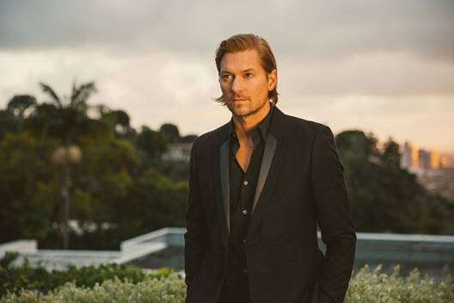

Atlantic recording artist Wilder Woods - known to many as Bear Rinehart, frontman and co-founder of GRAMMY® Award-nominated NEEDTOBREATHE – has released his latest video for “[Light Shine In](https://www.youtube.com/watch?v=2TP6p_NjcSU),” the lead track off his forthcoming debut album, *WILDER WOODS.*

“’‘Light Shine In’ is the first song on this record...and it acts as a sort of manifesto for what Wilder Woods is all about. Recording the track was easily the most spontaneous experience I’ve ever had in the studio. It’s in your face, which was important to convey in the video, and will likely be the first song in the Wilder Woods live set this fall as well.”

“Light Shine In” saw its premiere earlier today via [Billboard](https://www.billboard.com/articles/news/8523982/needtobreathe-bear-rinehart-wilder-woods), who declared "Light Shine In," whose swelling, spiritual chorus also nods to Hozier…" Wilder Woods recorded his debut album at Layman Drug Company studios in East Nashville with producer Gabe Simon (Dua Lipa, Gin Wigmore) and sees backing by a top-shelf cohort of co-writers and supporting musicians, including Austin Jenkins (Leon Bridges), The Watson Twins, Jesse Baylin, Trent Dabbs, Carson Cooley, Ian Fitchuk (Kacey Musgraves, Maren Morris), and more.

Wilder Woods will celebrate the release of his debut LP by embarking on a full North American headline Fall tour, kicking off September 5th at Mod Club in Toronto, ON. For more information visit [iamwilderwoods.com](https://protect-us.mimecast.com/s/ft9WC2k1W3c5zwOMCn9wat). Full tour routing below.

*“…beautifully shot by Gus Black, (the Sure Ain’t video) captures the emotional and soulful intensity of the song.*

*cid:image004.jpg@01D5409E.323719E0*

*“A sultry, sensual bit of classic Motown-soul that sounds straight out of 1972, it comes complete with dramatic strings, slinky wah-wah guitar, and an absolutely unstoppable hook. Lyrically, it’s about the healing power of true love – and there’s certainly nothing more we need right now than exactly just that.”*

***cid:image005.png@01D5409E.323719E0***

*“…while “Sure Ain’t” is a defiant declaration featuring raspy vocals and soulful horns, “Supply & Demand” is a laid-back pop tune that feels like drinking lemonade on your porch in the summertime.”*

**cid:image006.png@01D5409E.323719E0**

“…a powerful, funky modern soul train…”

cid:image007.jpg@01D5409E.323719E0

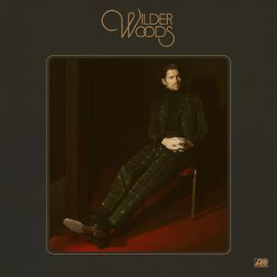

CONNECT WITH WILDER WOODS

[IAMWILDERWOODS.COM](https://iamwilderwoods.com/)

[FACEBOOK](https://www.facebook.com/iamwilderwoods/)

[TWITTER](https://twitter.com/iamwilderwoods)

[INSTAGRAM](https://www.instagram.com/iamwilderwoods/?hl=en)

[YOUTUBE](https://www.youtube.com/channel/UCc_CkeEQmzuDSM9zDA1BGUg)

**WILDER WOODS**

**HEADLINE FALL TOUR 2019**

**SEPTEMBER**

5              Toronto, ON                     Mod Club

7              Philadelphia, PA             World Café Live

8              Cambridge, MA               The Sinclair

9              Brooklyn, NY                    Music Hall of Williamsburg

11           Washington, DC               9:30 Club

13           Raleigh, NC                        Lincoln Theatre

14           Charlotte, NC                    The Underground

15           Birmingham, AL               WorkPlay Theatre

16           Nashville, TN                     The Basement East

18           Atlanta, GA                        Terminal West

19           Nashville, TN                     The Basement East

23           Chicago, IL                          Metro

24           Minneapolis, MN            Fine Line Music Café

25           Madison, WI                     Majestic Theatre

27           Lawrence, KS                    The Granada Theater

28           Omaha, NE                        Slowdown

30           Denver, CO                        Bluebird Theater

**OCTOBER**

2             Salt Lake City, UT             Metro Music Hall

4             Portland, OR                      Hawthorne Theatre

6             San Francisco, CA            The Independent

7             West Hollywood, CA      Troubador

10           Dallas, TX                            Trees

11           Mobile, AL                           Soul Kitchen

20           Hamburg, DE                     Hakken

21           Cologne, DE                       Helios 37

23           Paris, FR                              1999 Club

24           Amsterdam, NL               Paradiso

25           Glasgow, UK                     King Tuts

27           Manchester, UK              Deaf Institute

28           London, UK                       Camden Assembly

**Contact Information**

Christina Kotsamanidis

212.707.2241