FOR IMMEDIATE RELEASE
May 22, 2019

MEET THE MAN BEHIND WILDER WOODS
IN OFFICIAL VIDEO FOR “SURE AIN’T” OUT TODAY

“…beautifully shot by Gus Black, (the Sure Ain’t video) captures the emotional and soulful intensity of the song.” – NPR Music

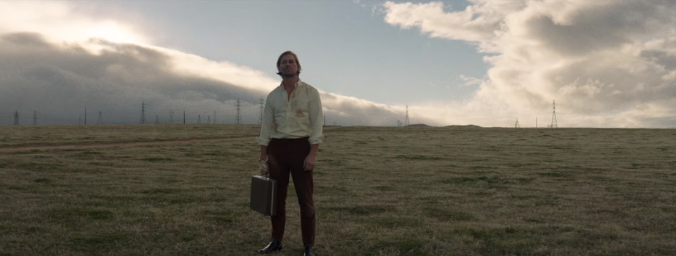

“I’ve heard that wisdom comes from two things: love and experience,” says Wilder Woods. “But I don’t think you can understand either unless you’re willing to take the first step out of the “comfortable” and dive headfirst into the unknown.”

Known to many as frontman Bear Rinehart, Wilder Woods’ takes that first step today, revealing his identity in the new video for “Sure Ain’t,” which saw its premiere on NPR Music. Shot in Los Angeles and directed by Gus Black (Phoebe Bridgers, Lennon Stella, Gary Clark Jr), “Sure Ain’t” is the latest installment in a series of Wilder Woods visuals with recurring characters and a narrative through line exploring the tensions an artist feels between his home and the stage, and the collateral damage that results. Rinehart’s wife, Mary Reames Rinehart, also appears in the video as his ongoing muse.

‘Wilder Woods’ heralds a new chapter in Bear Rinehart’s storied career, one that draws inspiration from his two sons, Wilder Rinehart and Woods Rinehart. Knowing he couldn’t expect his sons to see the value in taking bold, potentially life changing chances if he wasn’t willing to do it himself, he decided to take a leap and lead by example.

“I felt like they were growing up at light speed. I wanted to stop time, if only for a moment, and write this music as a letter to them. I wanted to show them that at this point in my life, I wasn’t afraid to step into the unknown.”

Looking back at his own childhood growing up in Possum Kingdom, South Carolina, his fifteen years with NEEDTOBREATHE, the band he co-founded with his brother and friends, their GRAMMY and other award nominations, chart-topping records, and sold out tours and other accomplishments, Rinehart found himself with a rare break from the road in 2017 to mull over some of the harder questions.

He began to ask himself: What would life look like if we strive to enjoy the journey as much as destination? What risks would we take if we could see our mistakes for the gifts that they really are?

“In that respect, Wilder Woods became as much about self-discovery as it was a letter to the ones I love,” Rinehart remarks. "It became a challenge to myself, to learn from my past, to turn my self-induced calamities into something I, and my family, could be proud of.”

“Sure Ain’t,” a timeless blend of classic soul, infectious R&B, and modern pop, grew out of this quest, as did the other songs on a full album planned for release on Atlantic Records later this year. More information will be revealed soon, including plans for a headline tour. In the meantime, find out more at iamwilderwoods.com.

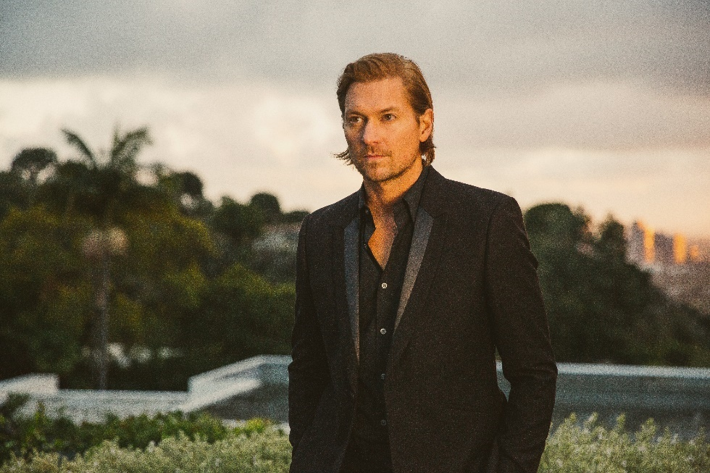

“… the powerhouse vocals indicate he will be here to stay.”
-L’OFFICIEL Magazine

“…a powerful, funky modern soul train…”
– MAGNET

“The music speaks for itself, hauntingly lovely with a delivery that ranges from intense to delicate. Wilder Woods’ quiet confidence is mesmerizing.”
-Parade Magazine
Contact Information:
Christina Kotsamanidis
212.707.2241
Christina.Kotsamanidis@atlanticrecords.com

