FOR IMMEDIATE RELEASE

JULY 17, 2019

UNVEILS OFFICIAL VIDEO FOR “SUPPLY & DEMAND”

NEW VIDEO HERALDS EAGERLY AWAITED SELF–TITLED DEBUT ALBUM
FROM GRAMMY®-NOMINATED NEEDTOBREATHE CO–FOUNDER BEAR RINEHART

2019 NORTH AMERICAN HEADLINE TOUR DATES SET FOR FALL

WILDER WOODS ARRIVES ON FRIDAY, AUGUST 9TH

Watch “Supply & Demand” Here



Enigmatic singer/songwriter Wilder Woods – a.k.a. GRAMMY® Award–nominated NEEDTOBREATHE frontman and co–founder Bear Rinehart – has unveiled a playful new companion video for “Supply & Demand,” featured on his upcoming self–titled debut album, WILDER WOODS. “Supply & Demand” is streaming now at YouTube HERE following its exclusive premiere earlier today via PEOPLE.com. WILDER WOODS arrives Friday, August 9th via Atlantic Records; pre–orders are available now HERE.

“’Supply & Demand’ is a cheeky way to tell someone you love that you want to give them what they need,” says Wilder Woods. “I wanted the music video to feel sexy and soulful, but not take myself too seriously while doing it.”

A timeless blend of classic soul, infectious R&B, and modern pop, WILDER WOODS is the sound of a veteran songwriter confidently breaking new ground, blazing his own distinctive trail through uncharted territory with comfort and style. Simultaneously vulnerable and self–assured, songs like “Sure Ain’t” and “Electric Woman” – the latter joined by a new official video co–starring Rinehart’s wife, Mary Reames, and streaming HERE – reflect both the rich well of experience from which they’re drawn and the bold leap that they represent, pairing intimate, introspective lyricism with effortless swagger and monster hooks. Recorded at Layman Drug Company studios in East Nashville with producer Gabe Simon (Dua Lipa, Gin Wigmore), the album sees backing by a top–shelf cohort of co–writers and supporting musicians, including The Watson Twins, Jesse Baylin, Trent Dabbs, Carson Cooley, Ian Fitchuk (Kacey Musgraves, Maren Morris), and more.

“The project is named after my two sons,” says Wilder Woods, “Wilder who is 4 years old and Woods who will be 2 in August. In so many ways, they were the catalyst that made me take the leap and explore this project fully. I wanted to make something that they would be able to look back on in 15–20 years and be proud of their father for taking a risk. Additionally, my wife Mary Reames is my muse in life. They are everything to me and there isn’t a song on this entire record that doesn’t have a piece of them in it.”

WILDER WOODS has already received a bounty of advance praise spanning NPR to Magnet, with Parade hailing “Sure Ain’t” as “hauntingly lovely with a delivery that ranges from intense to delicate. Wilder Woods’ quiet confidence is mesmerizing.” “Wilder Woods’ vocals are jaw-dropping,” raved Popdust, “the effortlessly and powerfully skates across scales, evoking goosebumps through his growling belts and soft falsetto.” “Named after his two sons (Wilder and Woods), it's a bold project committed to building a brand new sound from the ground up,” raved Earmilk in its exclusive “Electric Woman” premiere, “foregoing the comfort and security he’d built across a storied career in music thus far.”

Wilder Woods will celebrate the release of his debut LP by embarking on a full North American headline Fall tour, kicking off September 5th at Mod Club in Toronto, ON. For more information visit iamwilderwoods.com. Full tour routing below. For more details and ticket information, please visit IAMWILDERWOODS.COM.

# # #

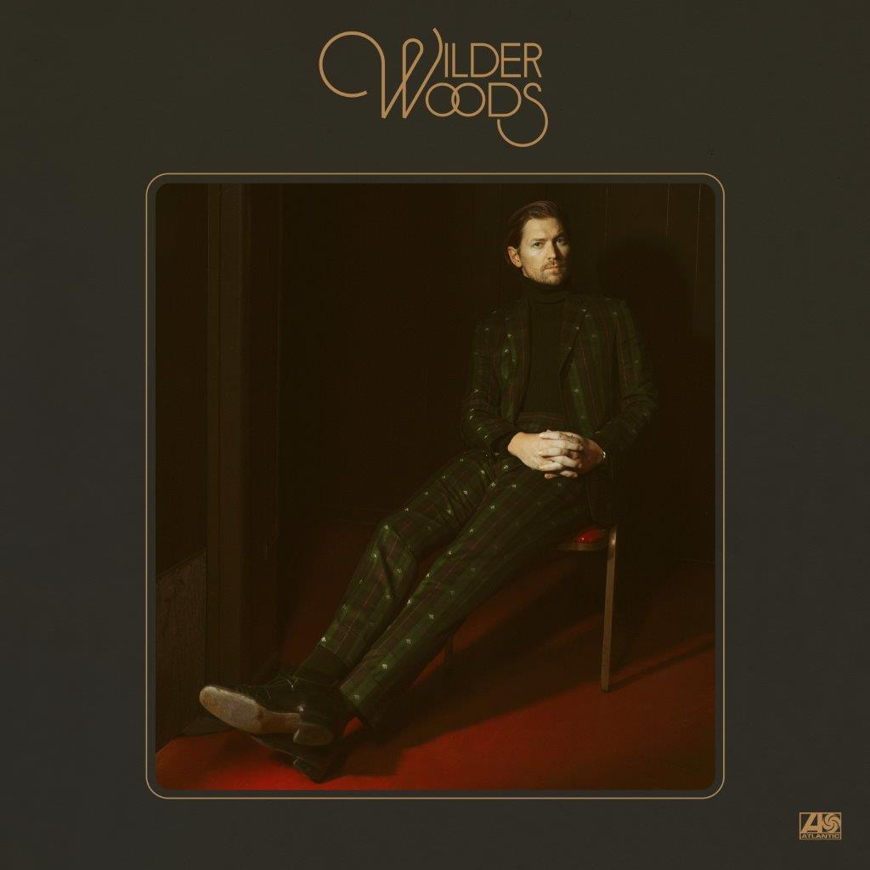

CONNECT WITH WILDER WOODS
IAMWILDERWOODS.COM
FACEBOOK
TWITTER
INSTAGRAM
YOUTUBE

WILDER WOODS
HEADLINE FALL TOUR 2019

SEPTEMBER
5 Toronto, ON Mod Club
7 Philadelphia, PA World Café Live
8 Cambridge, MA The Sinclair
9 Brooklyn, NY Music Hall of Williamsburg
11 Washington, DC 9:30 Club
13 Raleigh, NC Lincoln Theatre
14 Charlotte, NC The Underground
15 Birmingham, AL WorkPlay Theatre
16 Nashville, TN The Basement East
18 Atlanta, GA Terminal West
19 Nashville, TN The Basement East
23 Chicago, IL Metro
24 Minneapolis, MN Fine Line Music Café
25 Madison, WI Majestic Theatre
27 Lawrence, KS The Granada Theater
28 Omaha, NE Slowdown
30 Denver, CO Bluebird Theater

OCTOBER
2 Salt Lake City, UT Metro Music Hall
4 Portland, OR Hawthorne Theatre
6 San Francisco, CA The Independent
7 West Hollywood, CA Troubador
10 Dallas, TX Trees
20 Hamburg, DE Hakken
21 Cologne, DE Helios 37
23 Paris, FR 1999 Club
24 Amsterdam, NL Paradiso
25 Glasgow, UK King Tuts
27 Manchester, UK Deaf Institute
28 London, UK Camden Assembly

Contact Information
Christina Kotsamanidis
212.707.2241
Christina.Kotsamanidis@atlanticrecords.com

