FOR IMMEDIATE RELEASE
JANUARY 21, 2022

YOUNGBOY NEVER BROKE AGAIN IS BACK WITH COLORS

MULTI-PLATINUM RAP SUPERSTAR FOLLOWS LAST YEAR’S #1 SINCERELY, KENTRELL
WITH BRAND NEW MIXTAPE

HIGHLIGHTS INCLUDE SUCH MULTI-MILLION STREAMING HITS AS
“EMO ROCKSTAR,” “FISH SCALE,” “FOOLISH FIGURE,” “EMO LOVE,” “BRING THE HOOK”
AND THE #1 TRENDING “KNOW LIKE I KNOW”

THE OFFICIAL VIDEO FOR “BRING IT ON” IS OUT TODAY HERE

COLORS DROPS TODAY AT ALL DSPS AND STREAMING SERVICES

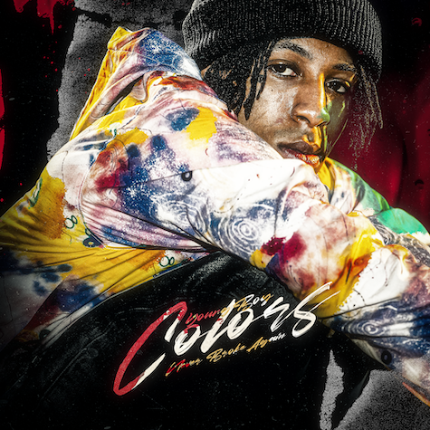
(DOWNLOAD HI-RES ARTWORK)

Multi-platinum certified rap superstar YoungBoy Never Broke Again has shared a brand new mixtape. COLORS is available everywhere now via Never Broke Again, LLC/Atlantic Records HERE.

COLORS – which follows last year’s chart-topping, RIAA gold certified album, SINCERELY, KENTRELL – includes an array of recent hit tracks, including “Emo Rockstar,” “Fish Scale,” “Foolish Figure,” “Emo Love,” “Bring The Hook,” “Know Like I know” and “Bring It On” all now available at DSPs and streaming services everywhere.

“Emo Rockstar” dropped last month alongside an official music video, now with over 12M individual views via YouTube HERE. “YoungBoy takes on the persona of a rock and roll frontman,” wrote The FADER, “enlisting a drummer, slinging a guitar around his shoulder, and wielding a mic. Occasionally, he even wears facepaint. But despite what the song title implies, it's not a total sonic overhaul: ‘Emo Rockstar’ has the kind of guitar-driven beat that's very in vogue with rappers right now, with YoungBoy trying his hand with it most recently on ‘Toxic Punk.’”

2022 kicked off with the premiere of “Fish Scale,” accompanied by an official music video (streaming HERE) which currently stands at #6 on YouTube’s “Trending 20” with over 12M views thus far. “Foolish Figure” followed, with its official video earning over 3M views HERE. “Emo Love” dropped just one day later, joined by an inventive Claymation video approaching 2M views HERE. “Bring The Hook” dropped next, its official audio quickly rising to #1 on YouTube’s “Trending 20” with over 6M views to date HERE. “Know Like I Know” marked YoungBoy's final drop before the release of the mixtape. Currently trending at #1, its official audio boasts over 3M views and is available HERE.

SINCERELY, KENTRELL made a triumphant chart debut upon its October 2021 release, entering the overall SoundScan/Billboard 200 at #1 with cumulative sales exceeding 137K – YoungBoy’s biggest sales week to date and fourth #1 project in less than two years. Furthermore, the album instantly debuted at #1 on both Apple Music’s “Top Albums” and iTunes’ “US Albums” charts while also being added to more than 55 top playlists across all major streaming platforms. The RIAA gold certified SINCERELY, KENTRELL is available everywhere now via Never Broke Again, LLC/Atlantic Records HERE.

Hailed by Lyrical Lemonade as “a certified masterpiece,” SINCERELY, KENTRELL follows a stunning six consecutive top 10 releases for YoungBoy, with three of the past five all debuting at #1 on the overall SoundScan/Billboard 200. All three of those chart-topping collections – including 2019’s AI YOUNGBOY 2 and 2020’s 38 BABY 2 and TOP – will be available on limited edition vinyl for the first time ever beginning Friday, January 28th; pre-orders are available now HERE.

# # #

FOR MORE INFORMATION, PLEASE VISIT:
INSTAGRAM | TWITTER | FACEBOOK

FOR ALL PRESS INQUIRIES, PLEASE CONTACT:
ARIANA.WHITE@ATLANTICRECORDS.COM

