**YBN CORDAE SHARES ENTICING NEW VIDEO FOR "RNP (FEAT. ANDERSON .PAAK)"**

**DEBUT PROJECT *THE LOST BOY*  OUT NOW VIA ART@WAR/ATLANTIC**

**CURRENTLY ON NORTH AMERICAN TOUR WITH LOGIC & J.I.D**

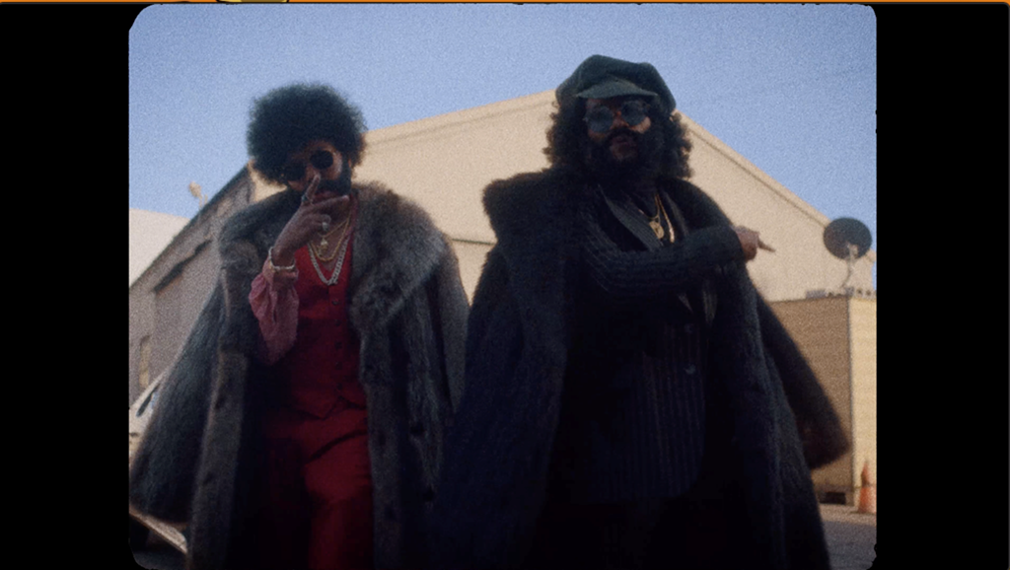

Today, YBN Cordae announced the release of a brand new visual for standout track "RNP (Feat. Anderson .Paak)" from his critically-acclaimed debut project, *The Lost Boy,* watch [HERE](https://nam04.safelinks.protection.outlook.com/?url=https%3A%2F%2Fwww.youtube.com%2Fwatch%3Fv%3Dkh5x_tMGEh0%26feature%3Dyoutu.be&data=02%7C01%7CAlyssa.Reddish%40atlanticrecords.com%7C4e717455ed8c498113e108d750d0cfa0%7C8367939002ec4ba1ad3d69da3fdd637e%7C0%7C0%7C637066730115642970&sdata=Fmc68QMMCFf18Rpgx654yUhm46CRLFBied6FXo6tXpI%3D&reserved=0).The Lost Boy is available now on all digital streaming platforms [HERE](https://nam04.safelinks.protection.outlook.com/?url=https%3A%2F%2Fybn.lnk.to%2FTheLostBoyPR&data=02%7C01%7CAlyssa.Reddish%40atlanticrecords.com%7C4e717455ed8c498113e108d750d0cfa0%7C8367939002ec4ba1ad3d69da3fdd637e%7C0%7C0%7C637066730115642970&sdata=bWv7pC0o6J0vwY%2BDg4A0f0oI5Dgb%2BsjyodeWFP%2FGdmQ%3D&reserved=0). The alluring visual follows the earlier release of the official video for the Maryland rapper’s “Broke as Fuck,” which now boasts over 4 MILLION views on YouTube; watch [HERE](https://nam04.safelinks.protection.outlook.com/?url=https%3A%2F%2Fybn.lnk.to%2FBrokeAsFuck&data=02%7C01%7CAlyssa.Reddish%40atlanticrecords.com%7C4e717455ed8c498113e108d750d0cfa0%7C8367939002ec4ba1ad3d69da3fdd637e%7C0%7C0%7C637066730115652978&sdata=1ABO3cQhCnhZELx%2FAEdw%2FEPVczG%2BW5dJoqovdTAVXV4%3D&reserved=0).

The video arrives in the midst of a wildly successful summer for Cordae. His debut project *The Lost Boy* debuted at #13 on Billboard's Top 200 and #8 on the Rap/R&B albums and he wrapped up the first leg of *The Lost Boy* tour including sold-out dates in LA and New York and an incendiary performance at Lollapalooza. He also performed at the [2019 BET Awards](https://nam04.safelinks.protection.outlook.com/?url=https%3A%2F%2Fwww.youtube.com%2Fwatch%3Fv%3DGipRLnGBfwI&data=02%7C01%7CAlyssa.Reddish%40atlanticrecords.com%7C4e717455ed8c498113e108d750d0cfa0%7C8367939002ec4ba1ad3d69da3fdd637e%7C0%7C0%7C637066730115652978&sdata=zV0%2BfbvgZdw5e6dE%2BUpF0RFgm1YZGIfw7K5ftorbfhU%3D&reserved=0) alongside H.E.R in addition to the [2019 BET Hip-Hop Awards](https://nam04.safelinks.protection.outlook.com/?url=https%3A%2F%2Fwww.bet.com%2Fvideo%2Fhiphopawards%2F2019%2Fperformances%2Fybn-cordae-ft-anderson-paak-rnp.html&data=02%7C01%7CAlyssa.Reddish%40atlanticrecords.com%7C4e717455ed8c498113e108d750d0cfa0%7C8367939002ec4ba1ad3d69da3fdd637e%7C0%7C0%7C637066730115662993&sdata=9GynJKwyHW08VP3SF0fRmU560YQEWvZKnqkOz5VnQiQ%3D&reserved=0), made his [late-night television debut](https://nam04.safelinks.protection.outlook.com/?url=https%3A%2F%2Fwww.youtube.com%2Fwatch%3Fv%3D-bOAyCft_sM&data=02%7C01%7CAlyssa.Reddish%40atlanticrecords.com%7C4e717455ed8c498113e108d750d0cfa0%7C8367939002ec4ba1ad3d69da3fdd637e%7C0%7C0%7C637066730115662993&sdata=G3KVHU%2FxrbS2oeC9gyrC%2BtCawurGSYVlmYk3zzWMdDk%3D&reserved=0) on *The Tonight Show Starring Jimmy Fallon*, and XXL Magazine honored him as a member of the [2019 Freshman Class](https://nam04.safelinks.protection.outlook.com/?url=https%3A%2F%2Fwww.xxlmag.com%2Fnews%2F2019%2F06%2F2019-xxl-freshman-cover%2F&data=02%7C01%7CAlyssa.Reddish%40atlanticrecords.com%7C4e717455ed8c498113e108d750d0cfa0%7C8367939002ec4ba1ad3d69da3fdd637e%7C0%7C0%7C637066730115672981&sdata=MW200uiqMFbQX4tS%2BQgaNSFd0HuooGW0ItJ%2FV3xT6aI%3D&reserved=0). Cordae also launched his online maze game, [*Get Lost with YBN Cordae*](https://nam04.safelinks.protection.outlook.com/?url=https%3A%2F%2Fybn.lnk.to%2FLostNFound&data=02%7C01%7CAlyssa.Reddish%40atlanticrecords.com%7C4e717455ed8c498113e108d750d0cfa0%7C8367939002ec4ba1ad3d69da3fdd637e%7C0%7C0%7C637066730115672981&sdata=hIEyYsp2j95agvr7EZxUJJrpU6uv7Iopc1ojSaKNaRg%3D&reserved=0), where fans get a chance to win a trip to see the rapper on the New York stop of Logic's tour, *The Confessions of a Dangerous Mind.* Cordae is currently on the road with Logic on his North American tour alongside J.I.D this Fall. All tickets are available [here](https://nam04.safelinks.protection.outlook.com/?url=https%3A%2F%2Fy-b-n.com%2FYBNCordae%2F&data=02%7C01%7CAlyssa.Reddish%40atlanticrecords.com%7C4e717455ed8c498113e108d750d0cfa0%7C8367939002ec4ba1ad3d69da3fdd637e%7C0%7C0%7C637066730115683005&sdata=0y4l57yu4ZQF2rEeLCOtlCzIyKxXQI668o%2FsqVwrnyA%3D&reserved=0).

**Upcoming Tour Dates:**

10/15 - West Valley City, UT @ Maverik Center+

10/16 - Morrison, CO @ Red Rocks Amphitheater+

10/18 - Irving, TX @ The Pavilion at Toyota Music Factory+

10/19 - Sugar Land, TX @ Smart Financial Centre+

10/22 - Miami, FL @ American Airlines Arena+

10/23 - Orlando, FL @ Addition Financial Arena+

10/25 - Duluth, GA @ Infinite Energy Center+

10/26 - Greensboro, NC @ Greensboro Coliseum Complex+

10/27 - Norfolk, VA @ Ted Constant Convocation Center+

10/29 - Philadelphia, PA @ The Met Philadelphia+

11/1 - Uncasville, CT @ Mohegan Sun Arena +

11/2 - Fairfax, VA @ Eaglebank Arena+

11/3 - Allentown, PA @ PPL Center+

11/7 - Pittsburgh, PA @ Petersen Events Center+

11/8 - Brooklyn, NY @ Barclays Center+

11/10 - Ypsilanti, MI @ EMU Convocation Center+

11/12 - Cleveland, OH @ Wolstein Center+

11/13 - Toronto, ON @ Scotiabank Arena+

11/15 - Rosemont, IL @ Allstate Arena+

11/16 - Madison, WI @ Coliseum at Alliant Energy Center+

+ = w/ Logic

**CONNECT WITH YBN CORDAE**

[Instagram](https://nam04.safelinks.protection.outlook.com/?url=https%3A%2F%2Fwww.instagram.com%2Fybncordae%2F&data=02%7C01%7CAlyssa.Reddish%40atlanticrecords.com%7C4e717455ed8c498113e108d750d0cfa0%7C8367939002ec4ba1ad3d69da3fdd637e%7C0%7C0%7C637066730115683005&sdata=Kzvq7cHYN7XRNdR%2FKfyNgi8vtY%2BjBHDM2B%2FXys6pds8%3D&reserved=0)**|**[Twitter](https://nam04.safelinks.protection.outlook.com/?url=https%3A%2F%2Ftwitter.com%2FYbnCordae&data=02%7C01%7CAlyssa.Reddish%40atlanticrecords.com%7C4e717455ed8c498113e108d750d0cfa0%7C8367939002ec4ba1ad3d69da3fdd637e%7C0%7C0%7C637066730115693012&sdata=3gomz5chI2gJ0e7%2BJsb2mMnfqOaiJ5XchDuACvqmXVY%3D&reserved=0) **|** [Facebook](https://nam04.safelinks.protection.outlook.com/?url=https%3A%2F%2Fwww.facebook.com%2Fybncordae%2F&data=02%7C01%7CAlyssa.Reddish%40atlanticrecords.com%7C4e717455ed8c498113e108d750d0cfa0%7C8367939002ec4ba1ad3d69da3fdd637e%7C0%7C0%7C637066730115693012&sdata=QtsThF6w2%2FHkSFJ2m6BcHwvgwIopOkCcuN2fa4d5JB0%3D&reserved=0) **|** [Website](https://nam04.safelinks.protection.outlook.com/?url=https%3A%2F%2Fy-b-n.com%2FYBNCordae%2F&data=02%7C01%7CAlyssa.Reddish%40atlanticrecords.com%7C4e717455ed8c498113e108d750d0cfa0%7C8367939002ec4ba1ad3d69da3fdd637e%7C0%7C0%7C637066730115703115&sdata=JAUtAAsaE03IPuOW7kHQqp3ydT7Qu%2FImBBEO1vTQ3DE%3D&reserved=0)

**PRESS CONTACTS**

Sydney Margetson // [Sydney.Margetson@atlanticrecords.com](mailto:Sydney.Margetson@atlanticrecords.com)

Duncan Will // [Duncan@orienteer.us](mailto:duncan@orienteer.us)