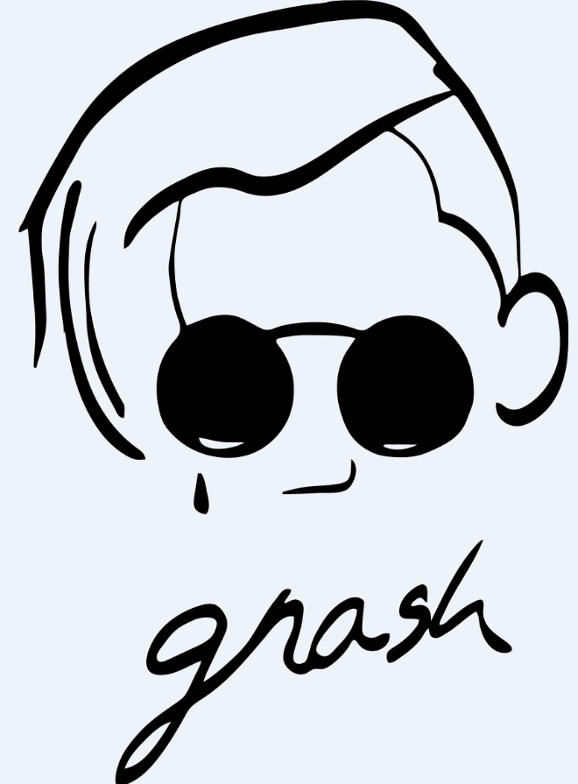

hi! my name’s garrett, but a lot of people call me gnash, & i’m here to let you know you’re not alone. in gnash, the g is silent, but my feelings aren’t. simply put, i was raised that it’s okay to have feelings, as long as you aren’t afraid to talk about them. so i’ve chosen to do that by documenting the feelings i have in my heart in my art, & lately, more specifically, in my music.

when i have a feeling, to get it off my chest, i find it’s most therapeutic for me to make a song about it. what’s even more redeeming is that nowadays when i release a song, an open-minded & constantly growing group of people from all around the world (who have come together over my music & call themselves the dreamers) let me know they have felt, currently feel, or will eventually feel the same. that makes us both feel better, & they help me just as much as i help them. so really, what i’m creating isn’t a fan base, it’s a support group & a movement, & it’s filling with people who let each other know that whatever it is, however you feel, it’s going to be okay.

everything in life is about balance. that’s the number one thing i’ve learned while growing up in a big city like los angeles. my first single, “i hate u you i love u”, & my label, happysad, spelled :): , both, in the titles alone, tackle balancing emotional issues everyone faces daily, but most people are afraid to (or don’t find the time to) discuss. so i’ve found the best answer to this problem is for me to do the talking so the listener can focus on thinking.

my music has become a sort of emotional guide book for those who are open to experiencing life’s up’s & down’s, but who are also committed to an overall positive outlook on life. the 3 ep’s i’ve released, “u”, “me”, & “us”, serve as a walk through a break up, finding yourself, & finding something new, but also the universality of that journey (& the harmony that comes from learning how to co-exist with other people in this often self-centered world we live in). eventually, i want to make a song for every feeling, & i felt this 3-part, 21-song series was a great place to start.

i make music that connects with people. i think that’s because my music is as real as i am. i produce & write it all in my garage, which is why my production stays simple & clean - to my listeners & i, it’s not about how it sounds, it’s about what i’m saying. being honest isn’t always easy (or pretty), but it’s usually what’s best, & honestly my favorite music has always been about the lyrics to me anyway. that’s why i draw inspiration from songwriters like cisco adler, jack johnson, & ben gibbard - they’re nothing but themselves in every way.

for me, music is just one way of being creative, & so far has been the easiest way to get my feelings out. i’ll never be afraid to express myself, & i feel that’s where my biggest strength lies. i don’t see myself as just a musician, or as a songwriter, or as a producer/dj. i’m an artist in all ways, & i will use any means necessary to help people feel, & know in their hearts, minds, & souls that they are not alone.

thanks for reading this & wanting to learn more about me!
…& remember, it’s gonna be okay tonight, because tomorrow’s just a dream away :):
<3 - g

