FOR IMMEDIATE RELEASE
JANUARY 15, 2021

ATLANTIC RECORDS WELCOMES LIL EAZZYY

CHICAGO RAPPER CELEBRATES SIGNING WITH G HERBO FEATURE ON “ONNA COME UP REMIX”
STREAM: LILEAZZYY.LNK.TO/ONNACOMEUPREMIX

ON THE HEELS OF THE “FEELING DIFFERENT” NO MORE HEROES PREMIERE HERE
+ “KICK DA DOOR” VISUAL HERE

DEBUT PROJECT FROM RISING CHICAGO RAPPER NOW STREAMING
LILEAZZYY.LNK.TO/UNDERRATED

LIL EAZZYY FEATURED IN THE HAWKS TALON GAMING CLUB
WATCH HERE

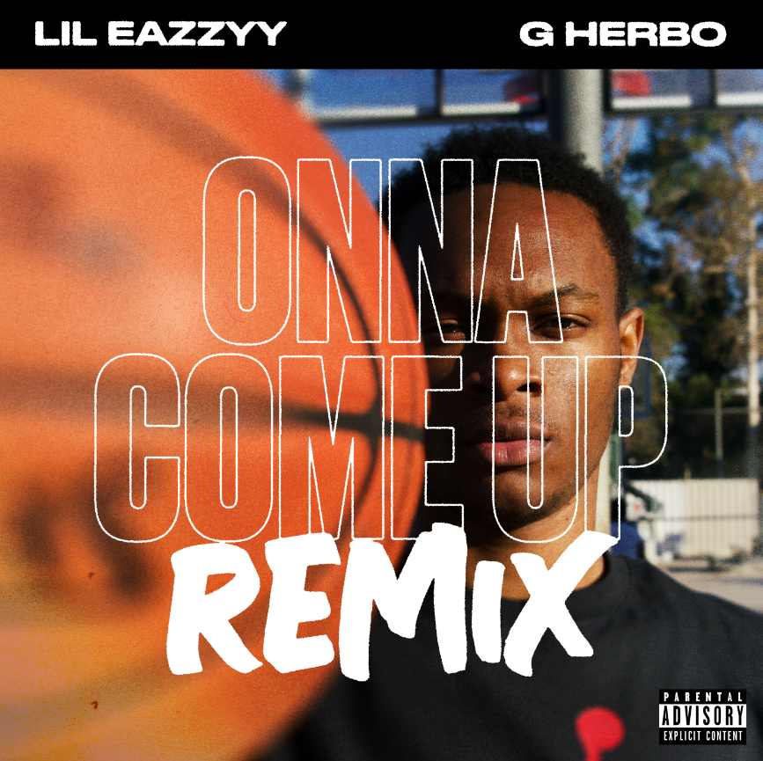

Atlantic Records welcomes rising Chicago rapper Lil Eazzyy to its historic roster. Lil Eazzyy celebrates signing by recruiting fellow Chicago native G Herbo for “Onna Come Up Remix,” available now to stream at all DSPs and streaming services HERE. Reaching 1 million streams per week in September 2020, the original “Onna Come Up” has continued to grow steadily: trending upward on the Spotify US Top 200 chart, amassing over 35M streams in the US to date and its official video garnering 3.3M views on YouTube.

Lil Eazzyy rang in the new year with his debut live virtual performance at Cyberwurld, where Playboy Carti headlined. The “Feeling Different” official video premiered last month on the No More Heroes official YouTube, the hit single from Underrated. The Chicago rapper also released a companion visual to “Kick Da Door” as an early Christmas present to his fans. His debut project, Underrated, available to stream and download at all streaming services HERE.

Hawks Talon Gaming Club, the official NBA 2K League affiliate of the Atlanta Hawks, hosted Lil Eazzyy on their one-of-a-kind content series called Talon Takeover. The Chicago rapper played the popular video game NBA 2K21 online with the team’s Head Coach Wesley Acuff. The series is available for viewing for free on the team’s official Twitch channel HERE.

Sporting an ironclad flow, razor sharp wordplay, spellbinding storytelling, and no shortage of ambition, Chicago rapper Lil Eazzyy tells the story of “a kid who came from selling drugs to doing shit he had no business doing in the matter of a year.” After dropping “Finesse” in 2019, he gained traction with “MIKEAMIRI” and “Handy Mandy.” Throughout 2020, he picked up even more steam via “Listen Up,” “Letter To Tracy,” and “Yerk Attack.” He also posted freestyles on Instagram and hit the studio daily. Around the time of his high school graduation, a freestyled snippet of “Onna Come Up” exploded to the tune of 155K views.

Meeting fan demand head-on, he finished the track, and it would be touted in video montages by top Fortnite players such as Chronic Hazard, Cultures, Yusa, Keeny, Fakeify, and more. “Onna Come Up” scaled the Spotify US Viral Chart, breaking him into Rolling Stone’s Breakthrough 25 Chart and into the Spotify Top 25 and Daily Top 100 while claiming real estate on premiere playlists, including the #5 spot on RapCaviar, debuting at #2 on Most Necessary, and prominent placement on Get Turnt, Radar US, and more. On Apple Music, he’s recently hit #2 on The Plug and #4 on The New Chicago. Reaching 1 million streams per week in September 2020, the song has continued to grow steadily: trending upward on the Spotify US Top 200 chart, amassing over 35M streams in the US to date. The official “Onna Come Up” video has over 3.3M views on YouTube.

Racking up 15 million streams worldwide in under six months and receiving looks from RapCaviar, HipHopDX, and more, Lil Eazzyy infuses intensity into a viscerally versatile signature style on a series of singles. Furthermore, his social presence is growing exponentially. Both his Instagram and Spotify follower growth has been doubling week over week, with his Instagram followers sitting at over 150k and Spotify at over 3 million monthly listeners.

UNDERRATED TRACKLISTING:
- Onna Come Up
- Feeling Different
- Finally Rich
- Activated
- For33
- Kick Da Door (Produced by SephGotWaves & Iceberg)
- Big Dog (Produced by Tee Romano)

DOWNLOAD HIGH-RES PRESS PHOTOS HERE
PHOTO CREDIT: thatgoodwork productions

CONNECT WITH LIL EAZZYY
TWITTER | INSTAGRAM | SPOTIFY | YOUTUBE | SOUNDCLOUD

PRESS CONTACT
BRITTANY BELL | BRITTANY.BELL@ATLANTICRECORDS.COM

