FOR IMMEDIATE RELEASE
JANUARY 21, 2021

WORLD STAR HIP HOP PREMIERE’S LIL EAZZYY’S “BIG DOG”
WATCH VIA WSHH YOUTUBE HERE

CHICAGO RAPPER CELEBRATES HIS ATLANTIC RECORDS SIGNING
WITH G HERBO FEATURE ON “ONNA COME UP REMIX”
STREAM: LILEAZZYY.LNK.TO/ONNACOMEUPREMIX

DEBUT PROJECT FROM RISING CHICAGO RAPPER NOW STREAMING
LILEAZZYY.LNK.TO/UNDERRATED

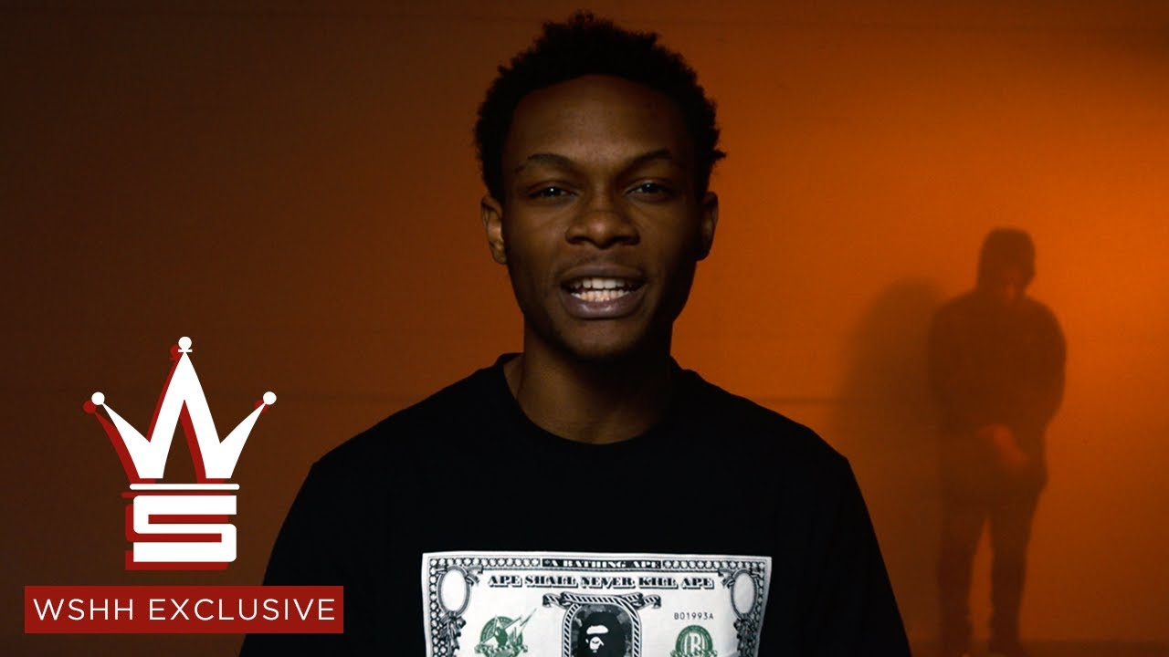

On the heels of announcing his Atlantic Records signing and recruiting fellow Chicago native G Herbo for the remix to standout track “Onna Come Up,” Lil Eazzyy exclusively premiered his “Big Dog” music video on World Star Hip Hop – now streaming via WSHH’s official YouTube channel HERE. Check out the “Onna Come Up Remix,” available now to stream at all DSPs and streaming services HERE. Reaching 1 million streams per week in September 2020, the original “Onna Come Up” has continued to grow steadily: trending upward on the Spotify US Top 200 chart, amassing over 37.9M streams in the US to date and its official video garnering 3.3M views on YouTube.

“Onna Come Up Remix” featuring G Herbo covered Amazon Music’s popular Hype Music playlist and was featured on Fresh Hip-Hop. It also saw incredible support from Apple playlists, featured on New Music Daily, The Plug, #GYMFLOW, and New in Hip-Hop. It was also featured on the premiere Spotify playlist Rap Caviar, as well as Most Necessary, Get Turnt, Off the Strength, and CST. Pandora also highlighted “Onna Come Up Remix” featuring G Herbo on Trendsetters Hip-Hop, New Hip-Hop Now and New Music Now. Further, YouTube supported with placement on Clout Rising, The Block is Hot, On Everything, Straight Out the Studio, and The Chicago El.

Lil Eazzyy has seen much success with his debut project, Underrated, available to stream and download at all streaming services HERE. Lyrical Lemonade named his EP the 8th best Chicago project of 2020. Complex included the Chicago rapper in their Rappers to Watch in 2021 list, noting that the “new movement of voices for the Chicago streets is in full swing, and Lil Eazzyy is chief among them.” UPROXX also included Lil Eazzyy in their Rappers to Watch in 2021, admiring how “His drill-influenced style combined the bouncy, chatter-box rhyme style of DaBaby or Chicago’s Midwestern cousins in Detroit with the moody, menacing beats favored by fellow Windy City native Polo G into something singular and captivating.” The official video for hit single “Feeling Different” premiered on the No More Heroes official YouTube and Eazzzyyy released a companion visual to “Kick Da Door” as an early Christmas present to his fans as well. He rang in the new year with his debut live virtual performance at Cyberwurld, where Playboy Carti headlined.

After dropping “Finesse” in 2019, he gained traction with “MIKEAMIRI” and “Handy Mandy.” Throughout 2020, he picked up even more steam via “Listen Up,” “Letter To Tracy,” and “Yerk Attack.” Around the time of his high school graduation last year, a freestyled snippet of “Onna Come Up” exploded to the tune of 155K views. “Onna Come Up” scaled the Spotify US Viral Chart, breaking him into Rolling Stone’s Breakthrough 25 Chart and into the Spotify Top 25 and Daily Top 100 while claiming real estate on premiere playlists, including the #5 spot on RapCaviar, debuting at #2 on Most Necessary, and prominent placement on Get Turnt, Radar US, and more. On Apple Music, he’s recently hit #2 on The Plug and #4 on The New Chicago. Reaching 1 million streams per week in September 2020, the song has continued to grow steadily: trending upward on the Spotify US Top 200 chart, amassing over 35M streams in the US to date. The official “Onna Come Up” video has over 3.3M views on YouTube.

Racking up 15 million streams worldwide in under six months and receiving looks from RapCaviar, HipHopDX, and more, Lil Eazzyy infuses intensity into a viscerally versatile signature style on a series of singles. Furthermore, his social presence is growing exponentially. Both his Instagram and Spotify follower growth has been doubling week over week, with his Instagram followers sitting at over 150k and Spotify at over 3 million monthly listeners.

UNDERRATED TRACKLISTING:
- Onna Come Up
- Feeling Different
- Finally Rich
- Activated
- For33
- Kick Da Door (Produced by SephGotWaves & Iceberg)
- Big Dog (Produced by Tee Romano)

DOWNLOAD HIGH-RES PRESS PHOTOS HERE
PHOTO CREDIT: thatgoodwork productions

CONNECT WITH LIL EAZZYY
TWITTER | INSTAGRAM | SPOTIFY | YOUTUBE | SOUNDCLOUD

PRESS CONTACT
BRITTANY BELL | BRITTANY.BELL@ATLANTICRECORDS.COM

