FOR IMMEDIATE RELEASE

January 26, 2022

**WATCH JOSH LEVI’S LIVE PERFORMANCE OF “NASA”** [**HERE**](https://JoshLevi.lnk.to/NASALive)

**JOSH LEVI BLASTS OFF IN “NASA”**

[**WATCH HERE**](https://nam04.safelinks.protection.outlook.com/?url=https%3A%2F%2Fwww.youtube.com%2Fwatch%3Fv%3De-jmnuDZ8DY&data=04%7C01%7CChandler.Owen%40atlanticrecords.com%7Ce82674c4f9524931514908d9699bae87%7C8367939002ec4ba1ad3d69da3fdd637e%7C0%7C0%7C637656939638229053%7CUnknown%7CTWFpbGZsb3d8eyJWIjoiMC4wLjAwMDAiLCJQIjoiV2luMzIiLCJBTiI6Ik1haWwiLCJXVCI6Mn0%3D%7C1000&sdata=qA8eDPnq95k5XkGdjnuetynE%2FLq8O1EcAckQI32AffI%3D&reserved=0)

[**STREAM HERE**](https://nam04.safelinks.protection.outlook.com/?url=https%3A%2F%2Fjoshlevi.lnk.to%2FNasa&data=04%7C01%7CChandler.Owen%40atlanticrecords.com%7Ce82674c4f9524931514908d9699bae87%7C8367939002ec4ba1ad3d69da3fdd637e%7C0%7C0%7C637656939638219097%7CUnknown%7CTWFpbGZsb3d8eyJWIjoiMC4wLjAwMDAiLCJQIjoiV2luMzIiLCJBTiI6Ik1haWwiLCJXVCI6Mn0%3D%7C1000&sdata=zaxmc6neHxd4TpIO%2FrHQ6ALy9ceWuidRn1oUW%2BQjCuQ%3D&reserved=0)

**WATCH JOSH LEVI’S LIVE PERFORMANCE OF “WHAT’S THE USE” FROM**

**THE SOUNDTRACK OF HBO’S *INSECURE: SEASON 5* [HERE](https://www.youtube.com/watch?v=lDZYU9Z_SkA)**

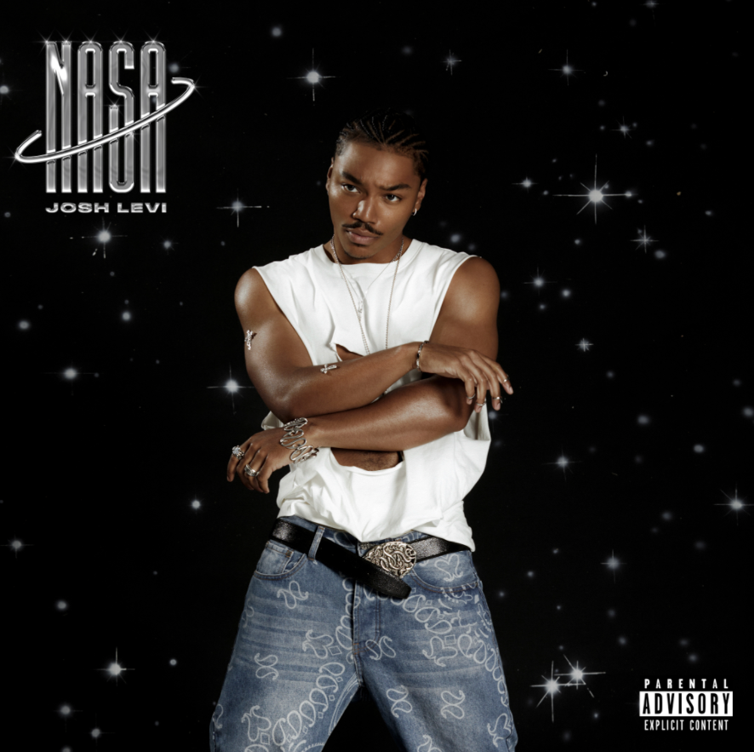

[*HIGH-RES ARTWORK*](https://nam04.safelinks.protection.outlook.com/?url=https%3A%2F%2Fwarnermusicgroup.box.com%2Fs%2Fvu2de5u1lbzzjh33lqeer2dwz0j1zc72&data=04%7C01%7CChandler.Owen%40atlanticrecords.com%7Cc95c34603dd84ebbba1d08d96693228a%7C8367939002ec4ba1ad3d69da3fdd637e%7C0%7C0%7C637653604386301871%7CUnknown%7CTWFpbGZsb3d8eyJWIjoiMC4wLjAwMDAiLCJQIjoiV2luMzIiLCJBTiI6Ik1haWwiLCJXVCI6Mn0%3D%7C1000&sdata=rvHHjIq2EkY6fzRCDeaiyPDsLL0N0l%2F761a%2Fdg30nyc%3D&reserved=0) *|* [*PRESS PHOTOS*](https://nam04.safelinks.protection.outlook.com/?url=https%3A%2F%2Fwarnermusicgroup.box.com%2Fs%2Fb1jwq88dykuu3i0zr2zta31sgx6fodbp&data=04%7C01%7CChandler.Owen%40atlanticrecords.com%7C019f67c0a8dd4b59263108d968b1f281%7C8367939002ec4ba1ad3d69da3fdd637e%7C0%7C0%7C637655935909768484%7CUnknown%7CTWFpbGZsb3d8eyJWIjoiMC4wLjAwMDAiLCJQIjoiV2luMzIiLCJBTiI6Ik1haWwiLCJXVCI6Mn0%3D%7C1000&sdata=2hkix0xVtkwl833NITIllfFsZQKOjxtB58%2F0xiGNClU%3D&reserved=0)*, CRED: Blair Caldwell*

With his soulful spirit, and attesting to his singular creative vision, Josh Levi gifts us with a [live performance](https://JoshLevi.lnk.to/NASALive) of his single [“NASA](https://joshlevi.lnk.to/Nasa)”. Beginning his performance with an intimate approach while showing off his R&B cadence, Levi escapes the song using the black ambiance to his advantage and centering himself with high energy choreography.

Levi’s anticipated R&B sound, acoustic inspiration and layered harmonies landed his most recent single~~,~~ “[What’s The Use](https://www.youtube.com/watch?v=lDZYU9Z_SkA)” on the soundtrack of critically acclaimed HBO Series, *Insecure: Season 5*. [Billboard/Tunefind’s Top TV/Movie Syncs of 2021](https://www.billboard.com/music/chart-beat/ted-lasso-hello-tops-tunefind-tv-movie-syncs-2021-1235012275/) recognized [“ What’s The Use”](https://www.youtube.com/watch?v=lDZYU9Z_SkA) as the #6 top song of the year. He wrapped 2021 by coming in at #7 on People’s list of [*25 Emerging Musical Artists You Should Add to Your Playlist This Fall*](https://people.com/music/emerging-musical-artists-fall-2021/)*.*

“With my music, shows, or anything I do, my goal is to always create an escape,” he affirms. “Life can be overwhelming. So, I try to make art people can be healed by. My sound is free to live in whatever emotion you need it to. I’m trying to provide everyone a perspective on happiness, sadness, honesty, vulnerability, and strength. I hope you escape for a minute, live in that, be inspired, take away something helpful, and return back to your world—or don’t.”

**ABOUT JOSH LEVI:**

The Houston-raised and Los Angeles-based singer, songwriter, and actor immediately captivates with each inhale of experience and exhale of emotion. His teen years moved at a whirlwind pace. Mom recognized his dreams and agreed to move the family to Los Angeles where Josh broke into film and television. Along the way, he appeared as a regular on series such as Friday Night Lights. He further developed his fan base through a series of viral covers on YouTube and consistent touring. During 2020, he made a statement with his proper debut EP, DISC ONE, impacting the culture in the process. Among many highlights, “IF THE WORLD” posted up 1.3 million Spotify streams and counting. V Magazine crowned him “your classic triple threat,” and Earmilk hailed the EP as “an all-encompassing showcase of how much of an anomaly he is.” Billboard crowned his song “Don’t They” as a pop song you need to get you through the week. Meanwhile, he graced the cover of Wonderland. Along the way, he caught the attention of Raedio, Issa Rae's label imprint, and Atlantic Records, scoring a deal in 2021. Now, he presents a multi-dimensional experience on a series of singles for Raedio/Atlantic Records led by “NASA”.

|  |  |
| --- | --- |
|  |  |

[*DOWNLOAD HIGH-RES HERE*](https://nam04.safelinks.protection.outlook.com/?url=https%3A%2F%2Fwarnermusicgroup.box.com%2Fs%2Fb1jwq88dykuu3i0zr2zta31sgx6fodbp&data=04%7C01%7CChandler.Owen%40atlanticrecords.com%7C019f67c0a8dd4b59263108d968b1f281%7C8367939002ec4ba1ad3d69da3fdd637e%7C0%7C0%7C637655935909768484%7CUnknown%7CTWFpbGZsb3d8eyJWIjoiMC4wLjAwMDAiLCJQIjoiV2luMzIiLCJBTiI6Ik1haWwiLCJXVCI6Mn0%3D%7C1000&sdata=2hkix0xVtkwl833NITIllfFsZQKOjxtB58%2F0xiGNClU%3D&reserved=0) *| CRED: Blair Caldwell*

**CONNECT WITH JOSH LEVI:**

[TWITTER](https://twitter.com/JoshLeviWorld?ref_src=twsrc%5Egoogle%7Ctwcamp%5Eserp%7Ctwgr%5Eauthor) | [INSTAGRAM](https://www.instagram.com/joshlevi/?hl=en) | [YOUTUBE](https://www.youtube.com/user/JoshLevi55)

**PRESS CONTACT:**

Brittany Bell | [Brittany.Bell@atlanticrecords.com](mailto:Brittany.Bell@atlanticrecords.com)