FOR IMMEDIATE RELEASE
FEBRUARY 11, 2020

THE T.R.U. CREW IS ON THAT “JEFE SHIT”

WATCH THE LATEST #TRUSDAY VISUAL FROM 2 CHAINZ’S T.R.U. COMPILATION
NO FACE NO CASE HERE

NEW ALBUM SHOWCASES UPCOMING TALENT FROM ATLANTA’S VARIOUS ZONES:
HOTT LOCKEDN, SKOOLY, SLEEPY ROSE & WORL

NO FACE NO CASE AVAILABLE EVERYWHERE HERE

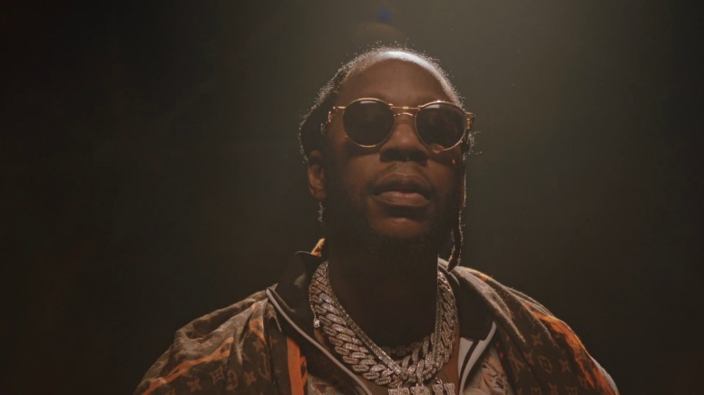
DOWNLOAD HIGH-RES ALBUM COVER ART HERE

The T.R.U. crew are keeping #TRUsdays alive with the video drop to “Jefe Shit,” a breakout single off their debut compilation No Face No Case. The visual, directed by Darius Turbak, features the whole crew plus label boss 2 Chainz; watch HERE. No Case No Face is available now at all music retailers and streaming services HERE.

No Face No Case arrived amidst a wave of positive reception, including praises from Complex, XXL, Rap Radar, and more. Hot New Hip Hop notes how the crew “joined together to introduce a sonic vision that highlights the Atlanta sound. “ No Face No Case features the #TRUsday series of singles released each Tuesday since the start of 2020, including 2 Chainz & Skooly’s “Virgil Discount,” Sleepy Rose’s “Woo,” Skooly’s “How I Feel (Remix) (Feat. NoCap & Quando Rondo),” and Worl’s “New Levels New Devils.” The 15-track release features additional appearances from NLE Choppa, Quavo and Bear1boss, and also includes the previously released posse-cut “Shoot It Out,” Skooly’s bubbly “Pop Off,” Sleepy Rose & 2 Chainz’ hometown anthem “Georgia” and Hott LockedN’s menacing “G-Wagon.”

Following a busy Super Bowl Weekend in Miami, the crew debuted their album during a free concert at Atlanta’s Center Stage at 8pm. The crew recently taped an episode of Family Feud alongside 2 Chainz in celebration and support of the album to air this spring. Recently, the collective sat down for Genius’ “For The Record” series to discuss the compilation while taking viewers on a journey of their body art with GQ’s “Tattoo Tour” series.

ABOUT T.R.U. (THE REAL UNIVERSITY)
Founded by GRAMMY® Award-winning multiplatinum rapper and Atlanta trailblazer 2 Chainz in 2019, T.R.U. (The Real University) posits a platform for personal success while providing a home to a rising vanguard of hip-hop talent from Atlanta’s various zones. In partnership with Atlantic Records, the Atlanta-based label imprint includes flagship artists Hott LockedN, Skooly, Sleepy Rose and Worl. The whole crew made a splash on a number of 2019 singles, including Sleepy Rose’s “Shoot It Out” (Feat. 2 Chainz, WORL, & Hott LockedN), 2 Chainz’s “Virgil Discount” (Feat. Skooly), and more. Now, with NO FACE NO CASE, the lessons of T.R.U. will ultimately ring out through the culture for a long time to come.

NO FACE NO CASE TRACKLIST
- Shoot It Out -T.R.U., 2 Chainz, Sleepy Rose (feat. Worl & Hott LockedN)
- Virgil Discount -T.R.U., 2 Chainz, Skooly
- Pop Off -T.R.U., Skooly
- Woo -T.R.U., Sleepy Rose
- Rock Out –T.R.U., Hott LockedN (feat. NLE Choppa)
- Brick On My Face -T.R.U., Worl (feat. 2 Chainz)
- G Wagon -T.R.U., Hott LockedN
- Georgia -T.R.U., Sleepy Rose (feat. 2 Chainz)
- New Levels New Devils -T.R.U., Worl
- What’s Going On -T.R.U., Worl (feat. 2 Chainz)
- Reliable -T.R.U., Skooly (feat. Quavo & 2 Chainz)
- How I Feel (Remix) –T.R.U., Skooly (feat. NoCap & Quando Rondo)
- Fake Beef -T.R.U., Hott LockedN (feat. 2 Chainz)
- Jefe Shit -T.R.U., Hott LockedN, Skooly, Sleepy Rose, Worl
- Vote -T.R.U., Skooly, Worl (feat. Bear1boss)

CONNECT WITH T.R.U. – THE REAL UNIVERSITY
OFFICIAL | INSTAGRAM | TWITTER | YOUTUBE | SOUNDCLOUD

T.R.U. PRESS CONTACT
Fairley McCaskill | Fairley.McCaskill@atlanticrecords.com

