FOR IMMEDIATE RELEASE
FEBRUARY 21, 2020

BANKROL HAYDEN ANNOUNCED AS LIL MOSEY TOUR SUPPORT
ON CERTIFIED HITMAKER NORTH AMERICAN TOUR 2020

EXPANSIVE 38-DATE TOUR BEGNS MARCH 11TH IN SAN FRANCISCO &
TRAVELS THROUGH MAY 5TH IN SACRAMENTO
FULL TICKET DETAILS HERE

ARRIVES ON THE HEELS OF THE VIRAL HIT “COSTA RICA” WITH OVER 20M COMBINED STREAMS
WATCH HERE
STREAM / DOWNLOAD HERE

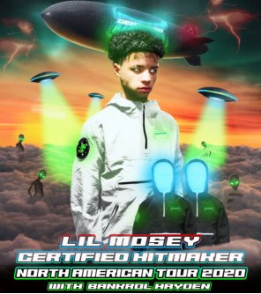

Today, Atlantic recording artist Bankrol Hayden announced his support on Lil Mosey’s Certified Hitmaker North American Tour 2020, which follows the European leg that recently wrapped. The expansive 38-date tour begins in San Francisco, CA (3/11) and finishes in Sacramento, CA (5/30). See below for tour dates and click HERE for ticket details and further information.

The tour announcement arrives on the heels of Bankrol Hayden’s latest single and video release, “Costa Rica.” The successful single has recently reached over 20 million combined streams. “Costa Rica” is available now via Atlantic Records at all DSPs and streaming services HERE; an official companion video premiered on the Modesto, CA-based artist’s wildly popular YouTube channel HERE. The track is featured on popular Spotify playlists such as Hip Hop Central (745k followers), Shisha Lounge (721k followers), Clout Culture (563k followers), and more. It’s also featured on popular Apple Music playlists The Plug, The New Bay, and Gymflow. “Costa Rica” debuted on Spotify’s US and Global viral charts this month, seeing placement on Germany Viral 50, UK Viral 50, Netherlands Viral 50 and more.

Bankrol Hayden heralded “Costa Rica” with an exclusive preview on his hugely influential Instagram page, joined by fellow social media sensation/artist Einer Bankz. The track marks the latest in a series of increasingly well-liked singles for Bankrol Hayden, following such viral smashes as “B.A.N.K.R.O.L.,” “29,” and “Brothers (Feat. Luh Kel),” the latter now boasting over 70 million worldwide streams thus far.

At just 18 years old, Bankrol Hayden is fast proving a phenomenon, earning fans around the globe with his positive brand of soulful, pop-forward hip-hop. The talented teen broke out in 2017 with a series of viral YouTube videos, including the breakthrough hit, “Drumsticks” feat. MBO ZAY. Along with his musical efforts, Bankrol Hayden is also a major digital influencer and entrepreneur with a combined social media reach exceeding 1.5 million, including a tremendously popular Instagram earning over 150,000 likes per post.

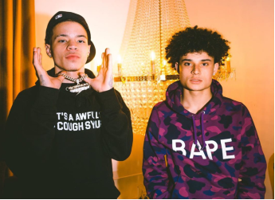
LIL MOSEY + BANKROL HAYDEN

CERTIFIED HITMAKER TOUR ITINERARY

MARCH  11 SAN FRANCISCO, CA  13 VANCOUVER, BC  14 PORTLAND, OR  16 SALT LAKE CITY, UT  17 DENVER, CO  19 LAWRENCE, KS  20 MINNEAPOLIS, MN  21 MILWAUKEE, WI  22 CHICAGO, IL  23 INDIANAPOLIS, IN  25 DETROIT, MI  26 TORONTO, ON  27 SILVER SPRING, MD  28 NEW YORK, NY  29 NEW HAVEN, CT  31 SOUTH BURLINGTON, VT | APRIL  01 BOSTON, MA  02 PHILADELPHIA, PA  03 SAYREVILLE, NJ  04 LONG ISLAND, NY  07 CHARLOTTE, NC  08 ATLANTA, GA  10 ST.PETERSBURG, FL  11 FORT LAUDERDALE, FL  12 ORLANDO, FL  15 HOUSTON, TX  16 DALLAS, TX  17 OKLAHOMA CITY, OK  18 AUSTIN, TX  21 ALBUQUERQUE, NM  22 PHOENIX, AZ  23 SAN DIEGO, CA  24 LOS ANGELES, CA  25 SANTA ANA, CA  29 SANTA CRUZ, CA  30 ST. LUIS OBISPO, CA  MAY  01 SACRAMENTO, CA

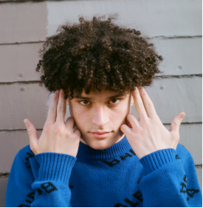
DOWNLOAD HIGH RES PRESS PHOTO HERE
PHOTO CREDIT AIDEN CULLEN

CONNECT WITH BANKROL HAYDEN
INSTAGRAM | TWITTER | YOUTUBE

For additional press assets, please visit his press site HERE.

PRESS CONTACT
FAIRLEY.MCCASKILL@ATLANTICRECORDS.COM

