FOR IMMEDIATE RELEASE
FEBRUARY 26, 2021

BRELAND PREMIERES PERSONAL & POWERFUL NEW SINGLE
“CROSS COUNTRY”

STREAM/DOWNLOAD: BRELAND.LNK.TO/CROSSCOUNTRY
WATCH: BRELAND.LNK.TO/CROSSCOUNTRYVIDEO

FOLLOWS PLATINUM-CERTIFIED, CRITICALLY-PRAISED DEBUT “MY TRUCK”

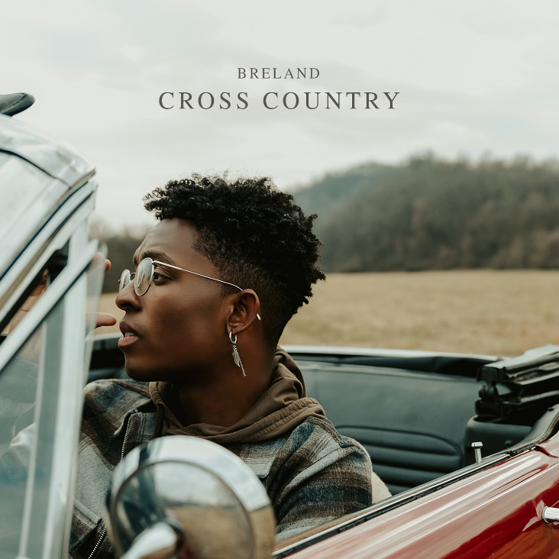
DOWNLOAD HIGH-RES COVER ART HERE

Riding high with scoring his first PLATINUM record, “My Truck,” breakout talent BRELAND today shares his autobiographical follow-up single “Cross Country” plus accompanying video. Released via Bad Realm Records/Atlantic Records, the soul-baring and storytelling-fueled track is available to stream/download HERE.
“Cross Country” serves as a statement of purpose for BRELAND — a boundary-shattering singer/songwriter/producer praised by Rolling Stone for merging “elements of Country, Hip-Hop, R&B, Gospel, and Pop – in a way that many have not experienced before.” True to the double meaning of its title, the acoustic-guitar-laced track finds BRELAND reflecting on the action-packed journey to this point in his career – an adventure that’s taken him from New Jersey to Atlanta to Hollywood to his current home of Nashville – while boldly stating his refusal to conform to any genre or style. With a vocal delivery that’s both vulnerable and triumphant, BRELAND perfectly captures that sentiment in the soul-stirring chorus: “I won’t stop running/Till I find where I belong/I’m going cross country/Know they might judge me/I ain’t gotta prove them wrong.” The fresh track is written by BRELAND, Sam Sumser, Sean Small, and Will Gittens and produced by Sumser and Small (whose shared credits include Keith Urban, Jason Derulo, and Austin Mahone).

“‘Cross Country’ the song is my personal story about how I became an artist, but Cross Country the movement is about redefining genre to dismantle music boundaries and inspire dialogue,” shared BRELAND with Spotify’s Hot Country.

Directed by James Larese (an award-winning filmmaker who’s directed videos for artists like Alicia Keys, Kanye West, and Imagine Dragons), the video for “Cross Country” features BRELAND living in a split screen dichotomy of two separate lives: one he lives now as a fast-rising artist, and what could have been had he not followed his dream to pursue music. Check out the “Cross Country” video HERE.

Stacking high-profile collaborations with artists including Lauren Alaina, Chase Rice and Keith Urban, BRELAND continues to make headlines, partnering with Chevrolet for the launch of the brand’s TikTok channel, which released a rebooted music video for “My Truck,” while starring in Tommy Jeans’ Spring ‘21 campaign in Macy’s stores across the country that features musicians, poets, and activists from diverse walks of life sharing their unique perspectives on utilizing music to drive social change.

Since the release of “My Truck” in early 2020, BRELAND has emerged as a phenomenal new force in the music world. By the year’s end, “My Truck feat. Sam Hunt [Remix]” had placed prominently on The New York Times’ “Best Songs of 2020” list, Rolling Stone’s “10 Best Country Collaborations of 2020,” and the “100 Best Songs of 2020” from NPR (who noted BRELAND’s “stylistic dexterity, and strategy, for working across genre boundaries”). To date, “My Truck” has racked up more than 200 MILLION streams, with its music video amassing over 40 MILLION views.

ABOUT BRELAND
New Jersey-born BRELAND began writing songs as a teenager, inspired by a diverse collection of sounds and such eclectic artists as the Beatles, Rascal Flatts, Prince, and his number-one influence, Stevie Wonder. While attending Georgetown University, BRELAND knocked on every possible music-industry door and eventually broke through as a songwriter, landing a number of high-profile cuts with rappers like Elhae and YK Osiris. As he continued to work on his own music, BRELAND posted “My Truck” on social media as a challenge to determine whether he could elicit 500 comments – and, after smashing that goal, self-released the track to multi-platform success. Along with paving the way for BRELAND’s signing to Bad Realm Records/Atlantic Records, the “My Truck” official video sparked headline-worthy streaming success, including hitting #1 on Spotify’s Global Viral 50 and US Viral 50 charts. Praised by Rolling Stone as “1,000 percent the whole package,” BRELAND has been featured in leading press outlets like Genius, Paper, USA TODAY and on Billboard’s “Emerging Artists Spotlight.” His self-titled debut EP arrived May 2020 featuring the “My Truck” remix with country superstar Sam Hunt, followed by a two-song compilation in honor of Juneteenth, Rage & Sorrow. BRELAND is kicking off 2021 with his brand-new single "Cross Country," along with its official music video.

CONNECT WITH BRELAND
INSTAGRAM | FACEBOOK | TWITTER | YOUTUBE | SOUNDCLOUD

MEDIA CONTACTS:
Fairley McCaskill / Fairley.McCaskill@atlanticrecords.com
Jensen Sussman / jensen@sweettalkpr.com

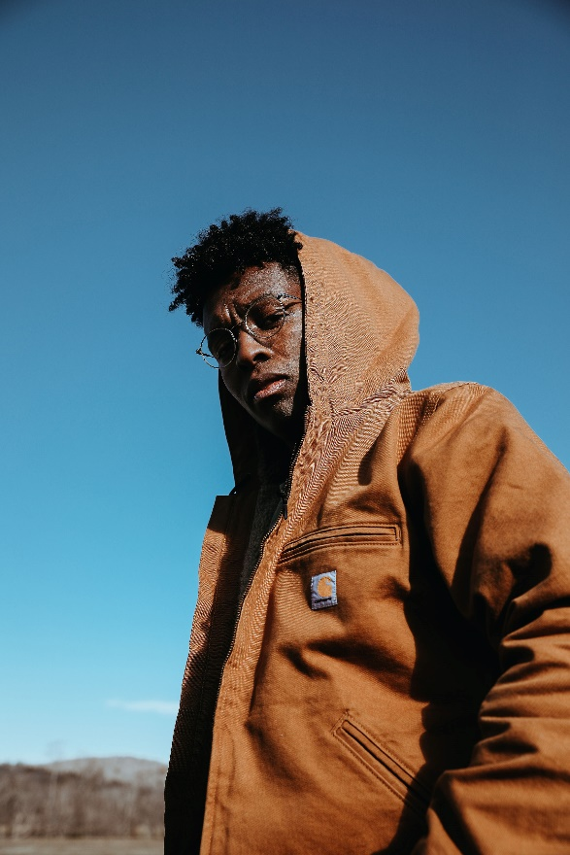
PRESS PHOTO CREDIT: ALAINA MULLIN

